**Generational Links: An Exploration of Social & Systemic Injustice and Community Narratives in Baltimore and Beyond Unit Guide**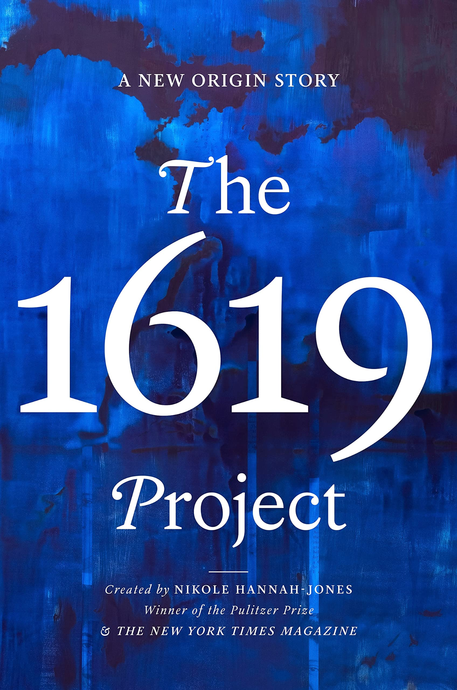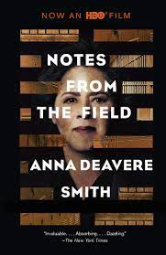

**Timeline:** This Interdisciplinary Unit is a collaboration between Government and English. Its goal is to help students use the tools of narrative and storytelling to interrogate, consider, and critique the role and function of the United States’ legal system.

**Objective:** Students will be able to implement their understanding of the features of dramatic monologue (imagery, characterization, diction, point of view, and perspective) built in the analysis of *Notes From the Field* in order to craft individual dramatic monologues which highlight and explore issues raised by *The 1619 Project* based on the oral history developed in Government.

**Statement of Inquiry:** Government policy directly and indirectly impacts communities and individuals, which can be discovered through data as well as personal narrative.

**Key Concept:** Communities

**Related Concepts:** Identities and Systems

## Texts:

1. Monologues from *Notes From the Field* by Anna Deavere Smith
2. Monologues from *Twilight* by Anna Deavere Smith
3. Essays from “The 1619 Project” edited by Nikole Hannah-Jones
4. [*The 1619 Project* Podcast](https://www.nytimes.com/2020/01/23/podcasts/1619-podcast.html)

## Summative:

Write a monologue based on an oral history that responds to one of the issues presented by the 1619 Project and *Notes From the Field,* in the style of Anna Deavere Smith’s work. Reflect on the process of incorporating knowledge and skills from multiple classes through a rationale and reflection.

There are **three** components to the Interdisciplinary Unit Summative:

1. A **rationale** (Criterion A, Evaluating):
   * 1. Explain how you conducted your oral history and how you developed that into a monologue. Explain the policy or inequity that you focused on for your oral history, and why. Then explain which elements of dramatic monologue you want to emphasize, and then explain how you did that. You will have an outline to help you with this process.
2. An **oral history and monologue** (Criterion B, Synthesizing)
   1. The oral history is **insert assignment here**
   2. The dramatic monologue will take the oral history as a **draft.** You will then take the elements of dramatic monologue (diction, characterization, dialogue, perspective, and imagery) to turn
3. A **reflection** (Criterion C, Reflecting)
   * 1. This reflection will use the framework of a Personal Project reflection to determine what students learned from this project as an interdisciplinary endeavor and what students can take away moving forward. The journal entries from English will be a core part of this work, which will be finished after the oral histories are complete.

Components 1 and 3 (the rationale and reflection) will be completed in **both** English and Government. Component 2 is split: you will complete the **monologue** portion of the Interdisciplinary Unit Summative in English, and you will complete the **oral history** part of Component 2 in Government.

## Formative Process:

1. PEAL paragraph about diction or characterization
2. Socratic Seminar on equity and “Walk On A Leaf”
3. PEAL paragraph on imagery
4. Oral history questions (Reading Check on the same day)
5. In-class discussion of how and why we tell restorative narratives
6. Practice writing the oral history narrative

## Unit Timeline:

| **Week 1** | **Lesson 1**  ***In Class:***  Anticipation Guide & Restorative Narratives  ***Homework:***  **Read** ‘Introduction’ and ‘Just A Glance’ from *Notes From the Field*  **Write**: **Journal #1**: What do you already know that will help you in this unit? | **Lesson 2**  ***Due:***  ‘Just A Glance’ from *Notes From the Field*  ***In Class:***  Close Read for **Diction**  ***Homework:***  **Read** ‘Runnin’ from ‘Em’ and ‘Breaking the Box’ from *Notes From the Field* | **Lesson 3**  ***Due:***  ‘Runnin’ from ‘Em’ and ‘Breaking the Box’ from *Notes From the Field*  ***In Class:***  Close Read for **Characterization**  ***Homework:***  **Read** ‘Tupac’ from *Notes From the Field* and ‘July 27, 1816: poem’ by Tyehimba Jess from *The 1619 Project*  **Write: Formative 1:** PEAL Paragraph | **Lesson 4**  ***Due:***  ‘Tupac’ from *Notes From the Field* and ‘July 27, 1816: poem’ by Tyehimba Jess from *The 1619 Project*  ***In Class:***  Discuss the Relationship Between **Diction** and **Characterization;Journal #2**  ***Homework:***  **Read** ‘Walk On A Leaf’ from Notes From the Field  **Write**: Journal Entry: Come up with at least one question to ask in our Socratic Seminar. |
| --- | --- | --- | --- | --- |
| **Week 2** | **Lesson 5**  ***Due:***  ‘Walk On A Leaf’ from *Notes From the Field*  Socratic Seminar Question  ***In Class:***  **Formative 2:** Socratic Seminar on Equity; discuss and answer questions raised by Baldwin in “Walk on a Leaf.”  **Journal #3**  ***Homework:***  **Read** the following monologues from *Notes From the Field*: ‘The Baddest,’ ‘Broken,’ and ‘The Geese’ and August 1619: poem by Clint Smith from *The 1619 Project*  **Write:** Complete **Journal Entry #3** | **Lesson 6**  ***Due:***  ‘The Baddest,’ ‘Broken,’ and ‘The Geese’ from *Notes From the Field* and August 1619: poem by Clint Smith from *The 1619 Project*  ***In Class:***  Close Read for Imagery  **Formative 3:** PEAL paragraph on imagery  ***Homework:***  **Read ‘**The Shakara Story’ from *Notes From the Field* andmake sure you are caught up with all the readings that have been assigned so far  **Write:** No New Writing | **Lesson 7**  ***Due:***  ‘The Shakara Story’ from *Notes From the Field*  ***In Class:***  Close Read for Perspective and First Person Narrator  ***Homework:***  **Read ‘**The Birth of American Music’ by Wesley Morris from *The 1619 Project.* Alternatively, you may listen to [‘The Birth of American Music’](https://www.nytimes.com/2020/01/23/podcasts/1619-podcast.html) Episode of the *1619* Podcast.  **Write:** Curate a list of questions you might ask someone about American music, to get an oral history about music. | **Lesson 8**  ***Due:***  ‘The Birth of American Music’ from *The 1619 Project*  ***In Class:***  Close Read Blues Songs  ***Homework:***  **Read**  [James Baldwin’s Interview with Jordan Elgrably](https://www.theparisreview.org/interviews/2994/the-art-of-fiction-no-78-james-baldwin)  **Write:** No New Writing |
| **Week 3** | **Lesson 9**  ***Due:***  [James Baldwin’s Interview with Jordan Elgrably](https://www.theparisreview.org/interviews/2994/the-art-of-fiction-no-78-james-baldwin)  ***In Class:***  **Reading Check**  **Formative 4:** students practice adapting an oral history into a monologue  ***Homework:***  **Read**  the Photo Essay from *The 1619 Project*  **Write:** Complete Formative 4; Journal 4 | **Lesson 10**  ***Due:***  The Photo Essay from *The 1619 Project*  ***In Class:***  Image Analysis of Photo Essay from *The 1619 Project*  ***Homework:***  **Read** ‘[“Feb. 12, 1793: poem” by Reginald Dwayne Betts](http://pulitzercenter.org/sites/default/files/inline-images/zhisq2Tqwc0okiHcRc3c0zIJInvVus12i4lkccNvq1kcIGprX8.pdf)and ‘That, That Was It and That Was All’ from *Notes From the Field*  **Write:** No New Writing | **Lesson 11**  ***Due:***  ‘[“Feb. 12, 1793: poem” by Reginald Dwayne Betts](http://pulitzercenter.org/sites/default/files/inline-images/zhisq2Tqwc0okiHcRc3c0zIJInvVus12i4lkccNvq1kcIGprX8.pdf)and ‘That, That Was It and That Was All’ from *Notes From the Field*  ***In Class:***  Close Read for Imagery  ***Homework:***  **Read** ‘Brother,’ and ‘DNA’ from *Notes From the Field*  **Write:** Prepare for Formative 5 | **Lesson 12**  ***Due:***  ‘Brother,’ and ‘DNA’ from *Notes From the Field*  ***In Class:***  **Formative 5:**  Socratic Seminar on how and why we tell restorative narratives.  ***Homework:***  **Read** ‘Injury’ from *Notes From the Field;* Read any of the monologues you have not yet read.  **Write:** Complete the Formative 5 Seminar Sheet |
| **Week 4** | **Lesson 13**  ***Due:***  ‘Injury’ from *Notes From the Field*  ***In Class:***  Close Read for **diction** and **perspective**. How do these elements work together to create coherent stories?  ***Homework:***  **Read** ‘Sugar’ by Khalil Gibran Muhammad from *The 1619 Project*  **Write:** No New Writing | **Lesson 14**  ***Due:***  ‘Sugar’ by Khalil Gibran Muhammad from *The 1619 Project*  ***In Class:***  Discuss ‘Sugar’ by Khalil Gibran Muhammad from *The 1619 Project;* Monologue Writing Activity  ***Homework:***  **Read:** ‘A Tree Out of the Ground’ from *Notes From the Field*  **Write:** Finish Drafting Monologue | **Lesson 15**  ***In Class:***  Adapting an Oral History into a Monologue Activity; Analysis of ‘A Tree Out of the Ground’; Revisit Formative 4  ***Homework:***  **Read:** No New Reading  **Write:** Complete **Journal #5** |  |
| **Week 5** | **Lessons 16-17**  ***In Class:***  Monologue Writing Workshop; **Formative 6** | **Lesson 18-19**  ***In Class:***  Rationale Writing Workshop | **Lesson 20**  ***Due:***  Summative  ***In Class:***  Student Monologue Performance (Optional) |  |