**Document A: Poetry**

**Inaugural poet Amanda Gorman delivers rousing remarks on the state of America**

POLITICO By BEN LEONARD 01/20/2021

Amanda Gorman became the youngest inaugural poet in U.S. history on Wednesday at President Joe Biden’s swearing-in, using the historic moment to call for unity and to ask “where can we find light in this never-ending shade.”

She weaved words of **affirmation** and hope in her poem when she said, “Somehow we’ve weathered and witnessed a nation that isn’t broken, but simply unfinished. We, the successors of a country and a time where a skinny black girl descended from slaves and raised by a single mother can dream of becoming president, only to find herself reciting for one,”

Gorman also said. “And, yes, we are far from polished, far from pristine, but that doesn’t mean we are striving to form a union that is perfect. We are striving to forge our union with purpose, to compose a country committed to all cultures, colors, characters and conditions of man.”

**“At Standing Rock” by Karenne Wood**

In April 2016, youth from the Standing Rock tribe and surrounding Native American communities organized a campaign to stop the Dakota Access Pipeline. Many members of the Standing Rock tribe and surrounding communities consider the pipeline to be a serious threat to the region's water. The construction also directly threatens ancient burial grounds and cultural sites of historic importance. The Dakota Access Pipeline Protests opposed the construction of the Dakota Access Pipeline and ended on February 23, 2017 when National Guard and law enforcement officers evicted the last remaining protesters. Native American participants of Standing Rock identify as Water Protectors rather than protestors.

The poem, “At Standing Rock” by Karenne Wood, is a **resistance** poem highlighting the struggle of the Standing Rock tribe and what Water Protectors faced from police:

He walked to the frontline in his Army combat shirt.

On it, his sergeant badge, name tape, US Army tape, and flag.

*They were praying together*

Behind him stood hundreds of water protectors.

He walked up alone. Police took their positions. Armed and defensive.

*Protecting the water*

In front of him, concertina razor wire. Around him, ashes, wet abandoned clothes.

*A song to heal water*

A few sheriff captains and officers approached. He said to them,

“I am a ten-year, two-time war veteran. I am not a protester, I am Ogichidaa.”

*Let our earth cleanse itself*

“I am here to protect these people from you. To defend the Constitution.

**Document B: Textile Art**

**The enduring significance of Harriet Powers’ quilts**

Artstor, July 7, 2017

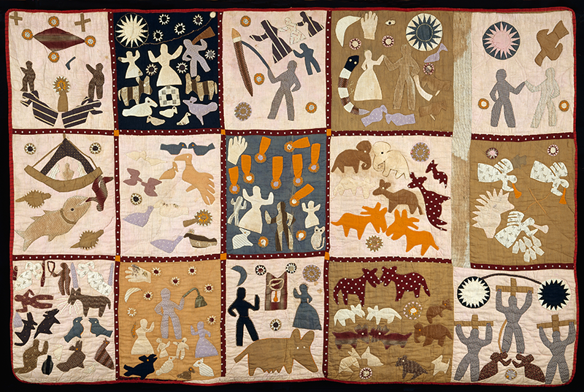

**Harriet Powers. Pictorial quilt. 1895-98. Museum of Fine Arts, Boston**

Harriet Powers was born a slave in Athens, Georgia in 1837. It was illegal to teach slaves to read and write - Powers was illiterate in her early life when she began to learn to sew. However, she decided to communicate tales through the medium of thread, sewing stories together depicting life around her, from astrological and historical events to local legends and daily life on the plantation.She created the quilts she is famous for after she was emancipated. She made use of appliqué techniques and storytelling often found in the textiles of Western Africa. While these textiles had typically been created by men, once the tradition was picked up in the United States women became the primary creators.

Harriet Powers died on January 1, 1910. She is buried in Athen’s Gospel Pilgrim Cemetery. Her quilts dropped into obscurity for six decades before being rediscovered in the 1970’s. Powers became significant in academic circles more than half a century after her death as an exemplar of the influence and power of women’s domestic art and art inspired by traditions outside the Western canon, showing not only this type of art’s historical purpose and importance but its aesthetic influence and significance.

Many consider Harriet Power’s work to be works of **affirmation** because she chose to express her history, voice, and experiences via art. She also validated West African artistic traditions in her choice of style.

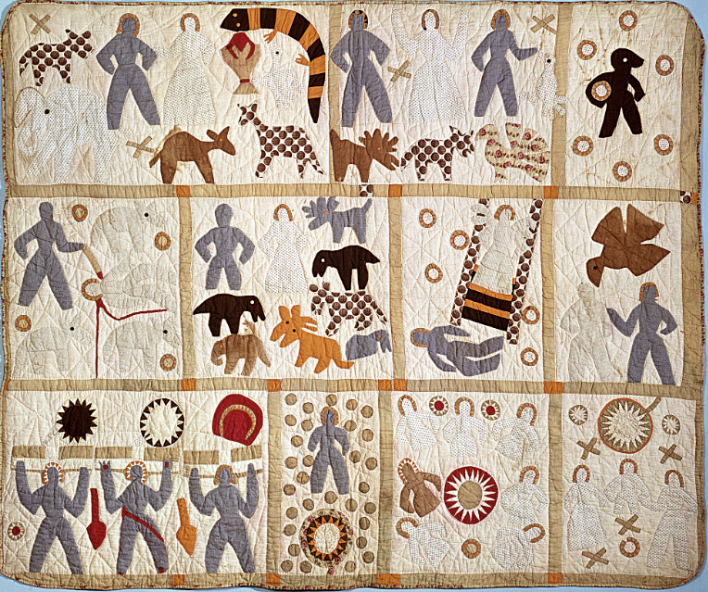

**Harriet Powers. Bible quilt. 1885-86. Smithsonian**

**Document C: Visual Arts**

**Gun violence at the heart of collaborative exhibit with Floyd D. Tunson**

rmpbs.org by Kate Perdoni Published on June 15, 2022

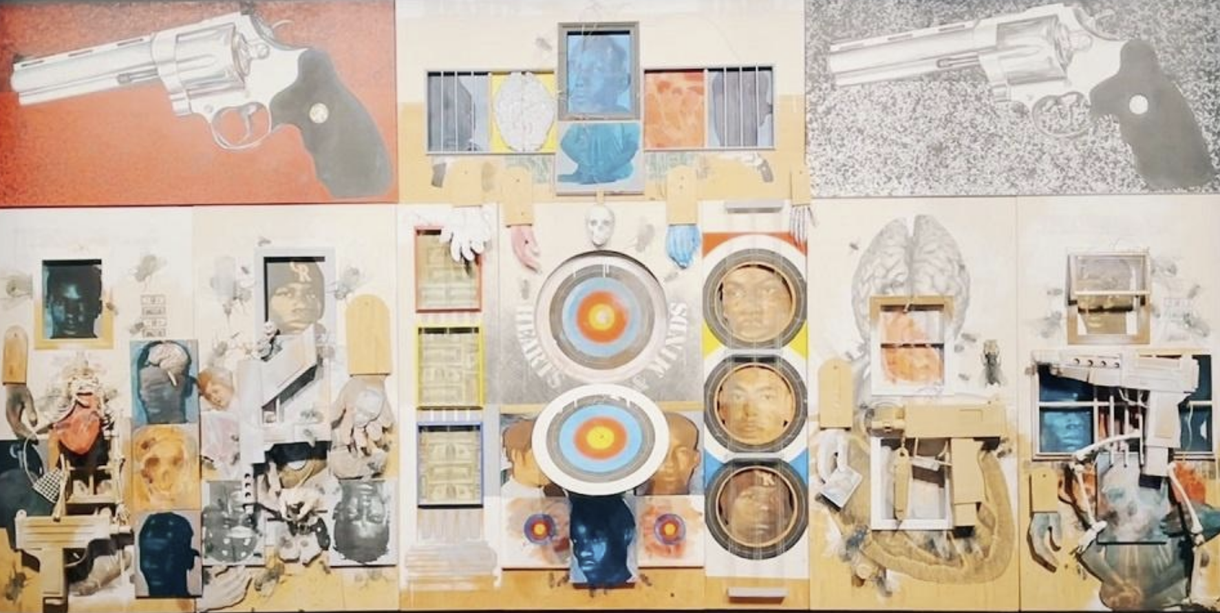

**“Floyd D. Tunson: Hearts and Minds” at the Colorado Springs Fine Arts Center at Colorado College**

“Hearts and Minds” was created as part of Tunson’s Endangered series,a larger body of work addressing gun violence and “the endangerment of being in this society as a young Black male,” said Tunson.

The massive “Hearts and Minds” materialized over time in response to the killing of the artist’s youngest brother, Randolph Tunson.

“‘Hearts and Minds’ started after the shooting of my brother by the Denver Police in City Park in 1974,” Tunson said.

Experiencing the repercussions of his brother’s death and seeing its effects on his family and community, Tunson concentrated his **resistance** art on the principles of endangerment.

Bold colors relay the panic, urgency and definitive loss of endangerment. Handguns lord over scenes depicting hearts, minds, lives, internal and external strife, prison bars, and surface and subsurface impacts.

Museum Director Michael Christiano said discussions about how to display “Hearts and Minds” led to expanding the show to highlight student and community voices.

Colorado College and Colorado Springs School District 11 students were introduced to Tunson’s work, held discussions, engaged in collaborative processes and met the artist. Student artwork, including collage, diorama, visual and found art, were installed directly reflecting Tunson’s “Hearts and Minds” on adjacent gallery walls.

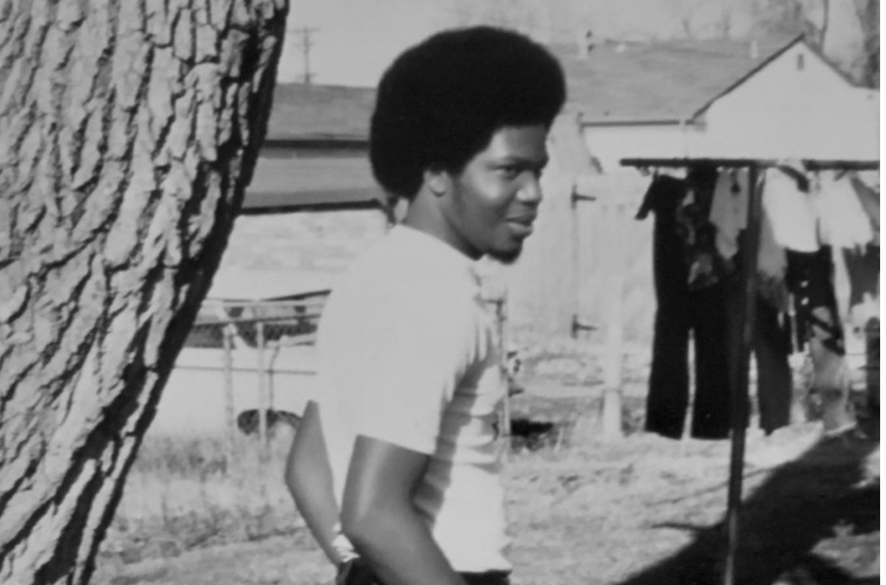

**Denver police officers killed Tunson’s brother, Randolph, in 1974 in Denver's City Park. In Colorado, Black men ages 18–24 are more than 12 times more likely than white men the same age to be killed in a gun homicide.**

**Document D: Graffiti**

**The street art that expressed the world's pain**

BBC By Arwa Haider13th December 2020

In 2020, murals in cities all over the globe gave voice to black protest and **resistance**. A portrait recurred on city walls across the world: an image of the black American George Floyd, who was brutally suffocated to death by police officer David Chauvin on 25 May, 2020. Most of these portraits were based on Floyd's 2016 selfie, taken from his own Facebook account; many referred to the torment of his killing, and his final words. Thousands of miles from the US, numerous graffiti tributes to Floyd appeared in European cities and in Asia, Africa and Australia.

These portraits are a testimony to human empathy, and the reach of the Black Lives Matter movement. Independent graffiti and commissioned public art have brought vivid focus to BLM. The very public horror of Floyd's killing (captured on videocam) lingers, but he is rarely an isolated figure; mural memorials also say the names of generations of innocent black US victims: among them, Breonna Taylor (killed by the police in her own home, 13 March, 2020); 12-year-old Tamir Rice (fatally shot by the police, 22 November, 2014); 14-year-old Emmett Till (lynched by racists, 28 August, 1955).

Graffiti is both an ancient form (traced back to writing on the wall in Ancient Greece and Rome) and a vital contemporary statement about society. Graffiti has enduring power. Writing in the LA Times*,* academic and author Susan A Philips recently argued: "...graffiti is a critical intervention in urban space, especially as municipalities and police attempt to shut down the streets. Even after protests have dispersed, graffiti stands as a testament to the protestors' collective voice… The graffiti may soon be washed away, but not before it is documented, becoming part of history."

In South Minneapolis, US, the Cup Foods convenience store, where a 911 call led to George Floyd's police killing, is now emblazoned with memorial art. One particularly moving piece was created by local illustrator, muralist and teacher Melodee Strong; entitled “Mama” after Floyd's dying plea, it depicts grieving black mothers, against a backdrop of the US flag.

"I am a mother, and when George cried out for his 'mama' as he was taking his last breaths, I also cried," Strong tells BBC Culture. "That's what we do when we are in trouble or scared, we cry out for God or our mothers. My son has been harassed and mistreated by the police. I have witnessed numerous times how the people I love have been abused by police. The anguish we feel from the fear and the experiences of those too many incidences is what I feel in the faces I painted… Even though this piece is about George Floyd, it's more a dedication to all the mothers that have lost their child to police violence."

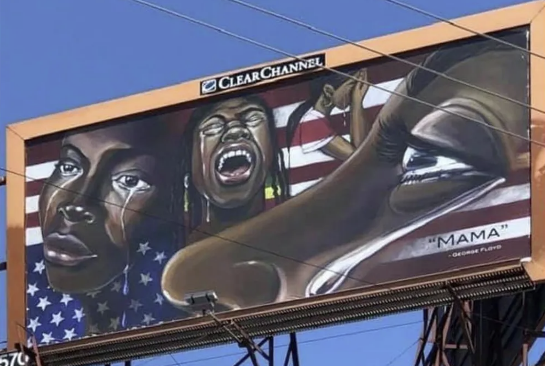

***In South Minneapolis, an artwork by Melodee Strong, Mama, portrays grieving mothers***

**Document E: Music**

**Anthems of Black Pride and Protest Through American History**

History Channel by Thaddeus Morgan May 8, 2023

**‘Swing Low, Sweet Chariot’—Unknown**

Throughout the antebellum South, spirituals became a vital form of folksong among enslaved people. Some were also used as a form of **resistance** through coded communication to plan escape from slavery. As abolitionist Harriet Tubman guided Black people to freedom along the Underground Railroad, she sang certain spirituals to signal it was time for escape. Among Tubman’s favorites was reportedly “Swing Low, Sweet Chariot.”

*“Swing low, sweet chariot,  
Coming for to carry me home,  
Swing low, sweet chariot,  
Coming for to carry me home”*

The melody was a signal that the time to escape had arrived. The “sweet chariot” represented the Underground Railroad, swinging low—to the South—to carry them to the North. The song, which is still commonly sung in Black churches, was performed at Tubman’s funeral in 1913.

**James Brown’s “Say It Loud, I’m Black and I’m Proud” - James Brown**

The song was released at a time when Black Americans were feeling particularly raw and enraged, following the assassination of Martin Luther King, Jr. on April 4, 1968. Four months after his murder, Brown released a song that boldly celebrated Black culture through **affirmation**. In the call-and-response number, Brown declares:

*“Say it loud! I'm black and I'm proud!  
Say it louder! I'm black and I'm proud!”*

In the early to mid-60s, “negro” was the preferred term for African Americans, while “Black” was sometimes taken as an insult. But Brown’s song helped remove the stigma around the term “Black” and it became preferred by the end of the 1960s. While most anthems of the civil rights movement spoke to the challenges that Black Americans faced in the form of white supremacy and racism, “Say It Loud” instilled a sense of pride and power within the community.

**‘Fight the Power’—Public Enemy, 1989**

Spike Lee’s 1989 film, *Do the Right Thing*, depicted racial tensions reaching a boiling point during a hot Brooklyn summer. Lee enlisted Public Enemy to write a song for the movie. The title “Fight the Power” encapsulated the strained race relations between characters in the movie and provided words of **resistance** for communities of all kinds as they spoke out against oppression and injustice.

*“Got to give us what we want,  
Gotta give us what we need,  
Our freedom of speech is freedom of death,  
We got to fight the powers that be,  
Lemme hear you say,  
Fight the power!”*