**Day 1 Essential Question: What is Disenfranchisement?**

**Standard:** SS8H7 Evaluate key political, social, and economic changes that occurred in Georgia during the New South Era.

b. Analyze how rights were denied to African Americans or Blacks through Jim Crow laws, Plessy v. Ferguson, disenfranchisement, and racial violence, including the 1906 Atlanta Race Massacre

**Name:**

Throughout the lesson, you may have thoughts, feelings, and wonderings about the topics and themes we encounter. There is space to jot them down with each source. ---------------------------------------------------------------------------------------------------------------------

**OPENER**

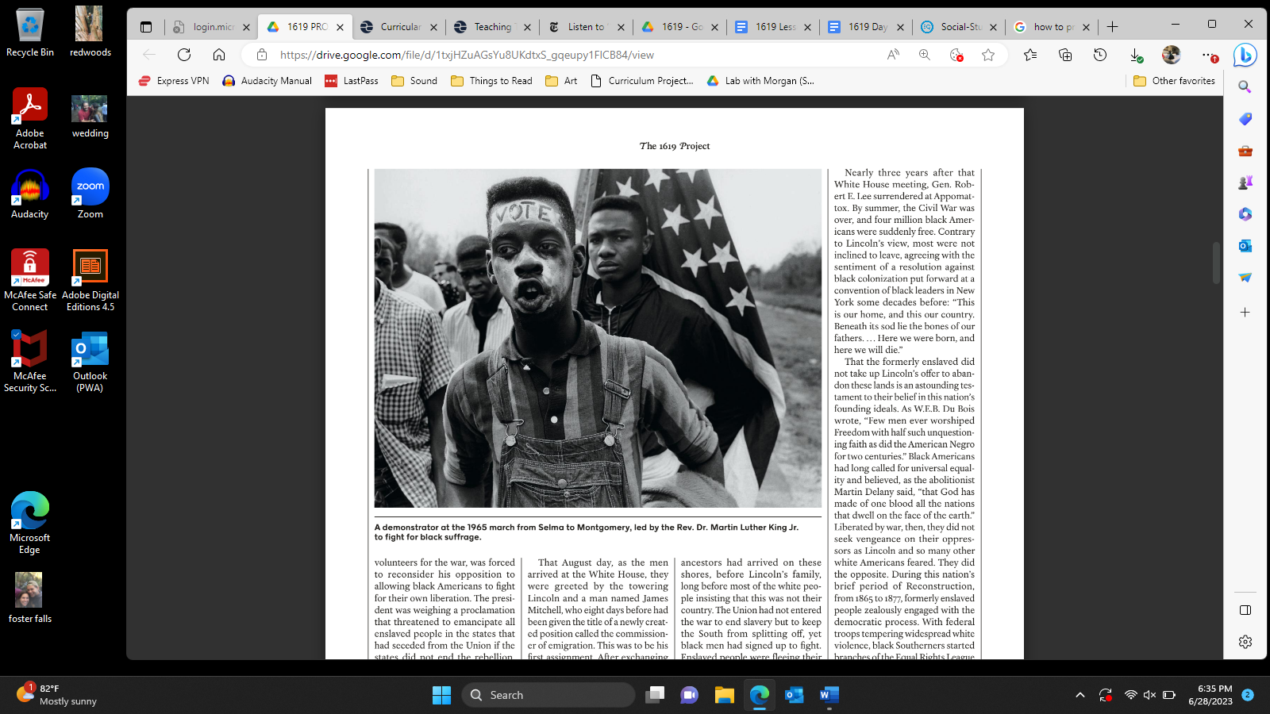

*Credit: Bruce Davidson/Magnum Photos*

| 1. What’s going on in this picture? 2. What makes you say that? 3. What else can we find? |
| --- |
| Thoughts, feelings, wonderings: |

---------------------------------------------------------------------------------------------------------------------

**INQUIRY**

**Source 1: *1619* Podcast Episode 1 (from 25:55-30:22)**

[Episode 1: The Fight for a True Democracy - *The New York Times* (nytimes.com)](https://www.nytimes.com/2019/08/23/podcasts/1619-slavery-anniversary.html)

*Directions: Please listen to the segment. While you are listening, please think about the following questions. During or after, please respond to the questions.*

| 1. Who gained the right to vote with the 15th Amendment? 2. Why do you think there were federal troops in the southern United States during Reconstruction? 3. Do you think that the United States was reconstructed or ‘fixed’ when Reconstruction ended? Why, or why not? | **Terms**   * Amendments - changes to the Constitution * Abolish - get rid of * 14th Amendment - legally made Black Americans citizens * Clause - law * Federal - national government * Legislation - laws * Withdraw - take back * Implement - put into effect * Suppression - attempt to stop or reduce * The Great Nadir - The Second Slavery |
| --- | --- |
| Thoughts, feelings, wonderings: | |

**Class Discussion of Terms**

**Enfranchise:**

1. ***to set free (as from slavery)***
2. ***to endow with a franchise: such as*** 
   1. ***a : to admit to the privileges of a citizen and especially to the right of suffrage***
   2. ***b : to admit (a municipality) to political privileges or rights***

**Disenfranchise:**

| **Please write your definition here.** |
| --- |

**Source 2: Excerpt from *The 1619 Project: A New Origin Story (p. 114-115)***

*Directions: Please read the excerpt and answer the questions in the text boxes.*

*“With the passage of the Reconstruction Act in 1867, followed by the Fifteenth Amendment… an era of rising Black power began. For nearly a decade (10 years), Black people voted in huge numbers across the South, electing a total of sixteen Black men to serve in the U.S. Congress (legislative branch), including two in the Senate. Literacy (reading) rates climbed, and educated Black people began to populate state legislatures, open schools, and initiate (start) successful businesses.*

| 1. How did the law (Reconstruction Act of 1867) help Black Americans? Use one piece of evidence from the excerpt to support your answer. |
| --- |

*Tragically, the Black freedom dreams that propelled (motivated) swift progress toward equality were arrested by the late 1870s, as a fierce (intense) white backlash against Black freedom succeeded in turning back the clock on racial progress. Southern white people effectively nullified (got rid of) the post-Civil War amendments (laws) that were intended to dismantle (undo) [racism] in the South, including the Fourteenth Amendment,... and the Fifteenth Amendment. The Freedmen's Bureau-an agency created by Congress in 1865 and charged with the responsibility of providing food, clothing, and other forms of assistance to destitute (poor) former enslaved people-was dismantled (undone), and a plethora (many) of discriminatory practices, such as poll taxes (paying a tax to vote) and literacy (reading) tests, were employed to prevent Black people from exercising their right to vote and gaining political power. When those efforts proved insufficient (not enough) to maintain complete control, white Southerners wielded their most effective weapon: vigilante (outside of the law) violence and terrorism…*

| 1. How did white supremacists (attempt to) disenfranchise (take away rights and privileges of citizens) Black Americans? Use one piece of evidence from the excerpt to support your answer. |
| --- |

*Throughout the South, local police forces were often made up of former slave patrollers and members of the Ku Klux Klan (KKK), … using the excuse of nightly curfews and vagrancy (unemployed/unhoused) laws to control, harass, detain (stop and hold), and punish Black citizens for daring to behave as though they were free." The Klan, operating extralegally, openly murdered Black people who violated the written and unwritten rules of white supremacy.*

| 1. Do you think it was just/fair that former slave patrollers and KKK members could become police officers? Why, or why not? |
| --- |

*Often the precise causes and triggers of white fear and rage were mixed or unclear, but the consequences were always devastating. Between 1877 and 1950, more than four thousand Black men, women, and children lost their lives to lynching. Fleeing violence, harsh segregation laws, and exploitative (harmful) economic ($$$) conditions, many Black Americans headed north, in what would become known as the Great Migration, to take advantage of the need for industrial workers that arose during the First World War and to achieve some modicum (small amount) of safety. Unfortunately, many soon realized that white mob violence reigned there as well…*

| 1. Did moving from the South to the North end Black Americans with disenfranchisement (take away rights and privileges of citizens)? |
| --- |

| Thoughts, feelings, wonderings: |
| --- |

**CLOSER: Public Service Announcement**

*Directions: Create a flier or social media post in the style of Instagram. The PSA must include:*

* *A description of disenfranchisement,*
* *One piece of evidence from the sources about disenfranchisement*
* *One image related to disenfranchisement*

*Remember, this must be original work, in your words. If time permits, prepare to share your hard work!*

**