Long Beach Station Activity

Teacher directions:

(can cut this out before giving this document to students)

Students will work in groups to review sources in a different theme; each theme has 3 sources

Students will read each source in their theme using the four essential questions to guide their reading (below chart)

Students will discuss their findings with their group, and take notes based on their discussion

Students will use the information they learned from the Long Beach sources to help them with their museum exhibit

Directions: In a small group, choose a theme from the left-hand column to explore and review each of the three sources in the right-hand column. To review each source, use the four essential questions below and take note of your discussion on a separate sheet of paper.

Station Theme | Sources
Education and Student Activism/Agency | - Photo, Long Beach Polytechnic student being searched for weapons, 1969  - Excerpt, Set the Night on Fire- LA in the Sixties  - Summarized interview with Leticia Hernandez
Migration | - Charts of Long Beach population data from the US Census  - City of Long Beach Cultural Maps  - Aerial Photographs of CSULB, 1941 and 1965
Power | - Homeowners Loan Corporation redlining map of Los Angeles, 1939  - Los Altos Association, “Protective Restrictions,” 1956  - Trymaine Lee, “The Wealth Gap,” The 1619 Project, 2020
Economy and Environment | - Socio-Economic Index of Long Beach, 2010  - City of Long Beach Community Health Assessment Charts, July 2013  - City of Long Beach Community Health Assessment Report, July 2013

Essential Questions for each source:
- How does this source help you understand Long Beach history?
- How does this source help you understand your origin story and/or your place in Long Beach history?
- Who is represented in the source?
- What additional questions do you have about this source? What information is left out?

Education and Student Activism/Agency
Source: Los Angeles Times Photographic Archives, “Long Beach Polytechnic High School student being searched for weapons at gate of school in Long Beach,” 1969
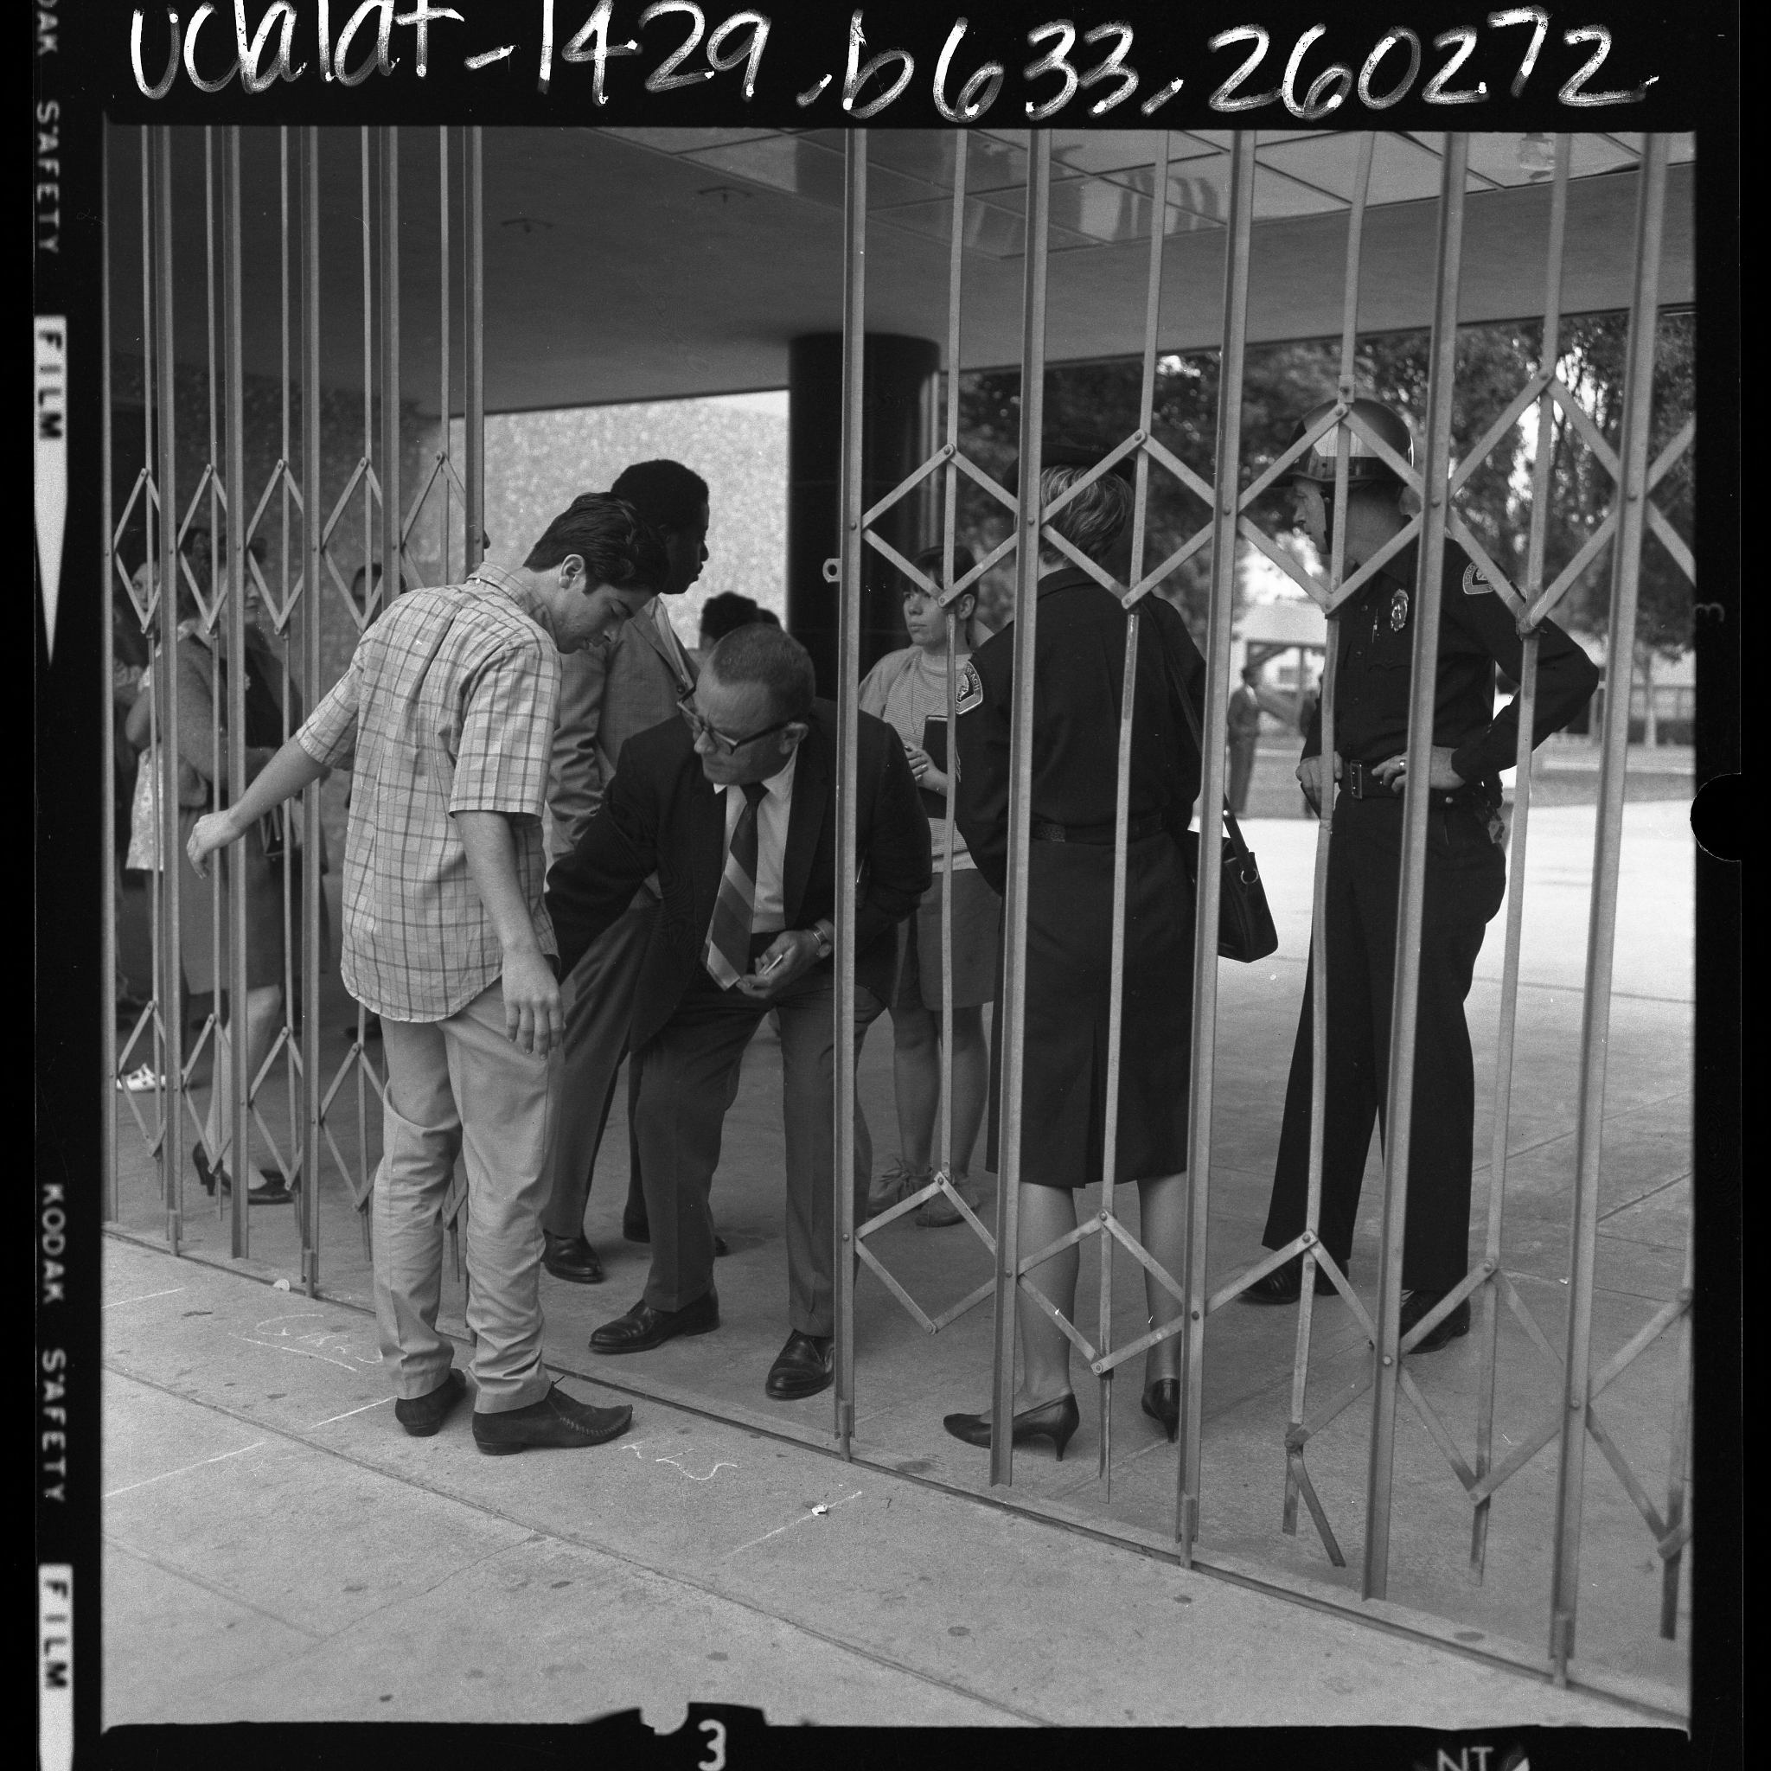

Photo from Calisphere
Permalink: https://calisphere.org/item/ark:/21198/zz0002vrks/

Source: Mike Davis & Jon Wiener, “The Children of Malcolm X: Black High School Activists (1968-69)” in Set the Night on Fire: Los Angeles in the Sixties.

The impressive demonstrations of student power on Los Angeles campuses inspired similar protests in nearby cities with Black minorities….
In Long Beach a few weeks later, a similar racist pamphlet at Poly High incited attacks on Blacks, who responded with a boycott. Two days later, with Black students rumored to be returning to campus, a large crowd of white teenagers assembled at a nearby park and marched to the school. “More than 200 white students,” reported the Times, “shouting “Get the [n-words]!” charged onto campus en masse Thursday morning.” But Black parents, warned of the ambush, had diverted their kids to the Martin Luther King Recreation Center, six blocks away. Chicano students showed up to express their solidarity, and the subsequent alliance between the two minorities quelled further mob attacks….

Source: Summarized interview with Leticia Hernandez, student activist at Cal State Long Beach in the 1970s.

Leticia Hernandez was born in Los Angeles to a mother from Mexico and a father from El Paso, Texas… In twelfth grade, Hernandez was recruited by the Educational Outreach Program at California State University, Long Beach, which was created in Fall 1969. She joined the second group of EOP students, and received full financial aid and lived in the dorms… Before entering college, Hernandez was not aware of discrimination based on race or sex. She was more complacent and did not question the status quo. After going to college, hearing about discrimination, and then experiencing it firsthand, she became aligned with student activist groups…
While at CSULB, Hernandez was involved with numerous events, marching in protests, organizing Folklorico dances, fundraising for projects, and traveling to different schools. Yet she and other women involved in United Mexican American Students (UMAS) and Movimiento Estudiantil Chicano de Aztlán (MEChA) felt that male students would not give them credit for their work. Many female minorities wanted to join these activist groups, however, because they experienced blatant racism… While in UMAS and MEChA, Hernandez and other students established links with the greater Long Beach Community. Many students worked part-time at the Long Beach Neighborhood Center and organized thrift stores, food drives, and dances… The Chicano Studies Department was established during Hernandez's time at CSULB. She took many courses in Chicano Studies with friends in EOP. She felt these were some of her best classes…Hernandez was involved in launching the Hijas de Cuauhtemoc newspaper… In addition to the name Hijas, the Chicanas at CSULB were also called Las Mujeres de Longo - the Women of Long Beach. Even before forming Hijas, within MEChA, Hernandez and the other women members would help educate each other on political issues… the women's group served as a support network, but also helped women become more politically involved.

Full interviews at CSULB Oral History Program Archival Collections

Migration
Source: Charts of Long Beach population data from the US Census

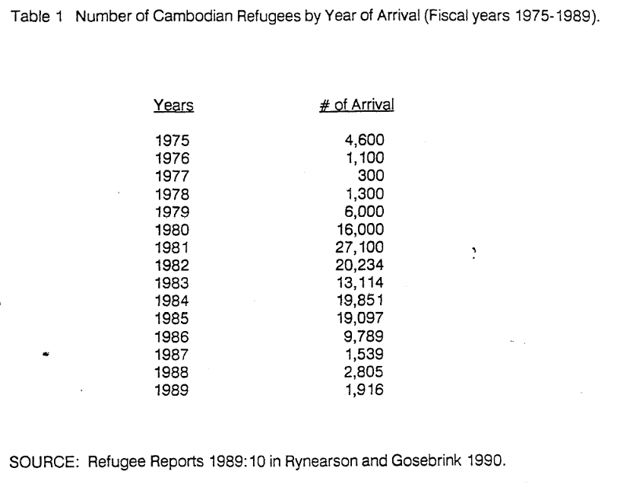 | 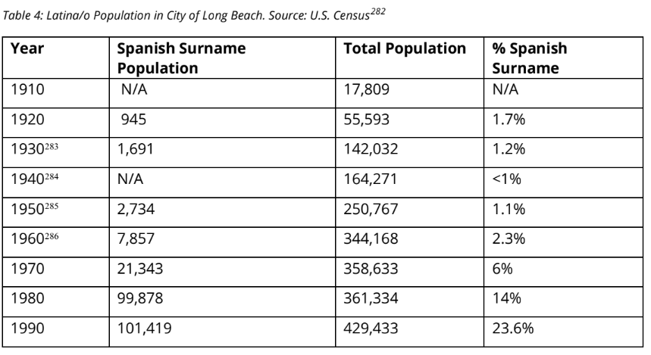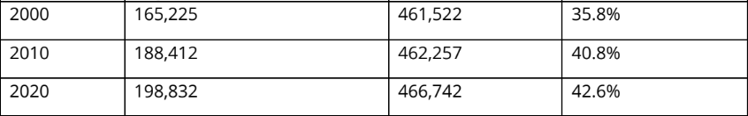
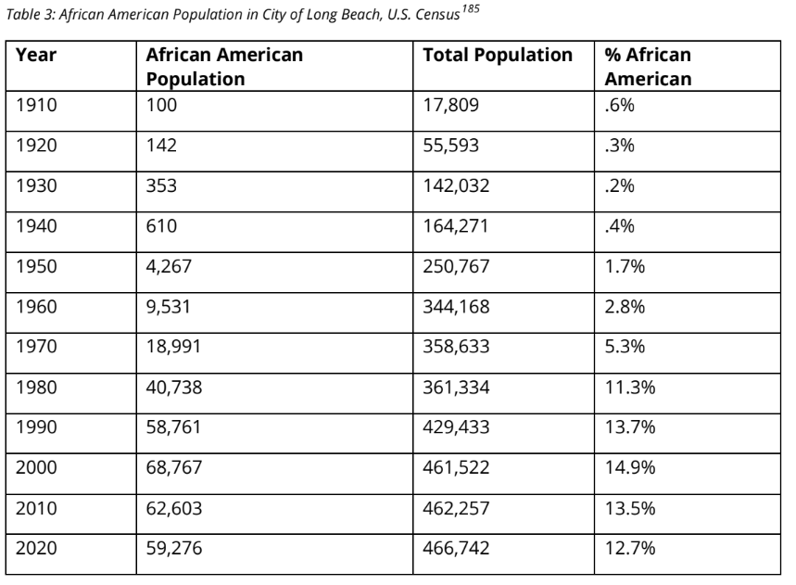

Source: Source: City of Long Beach, “Cultural Maps,” from Long Beach Suburbanization and Race Report, 2022.

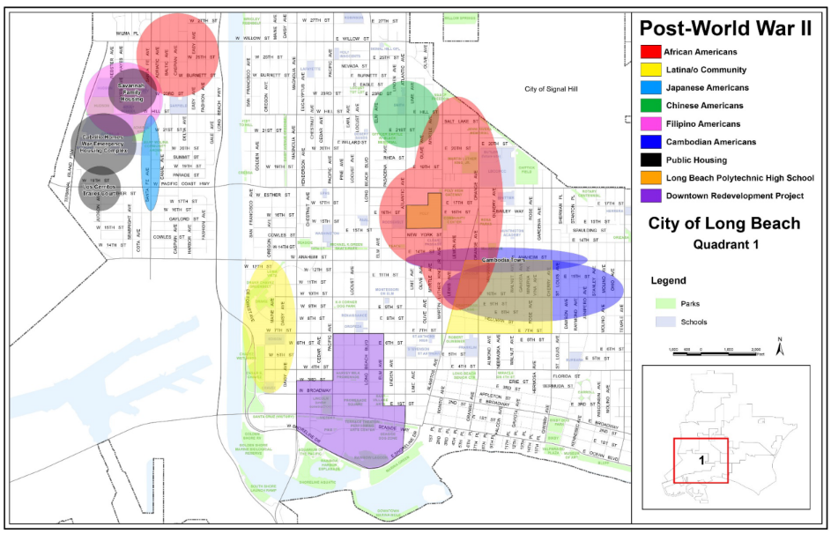 | 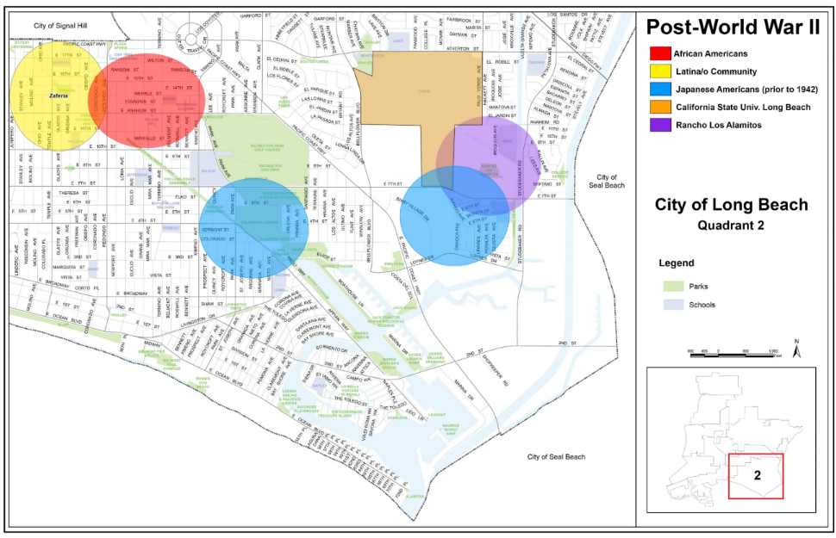
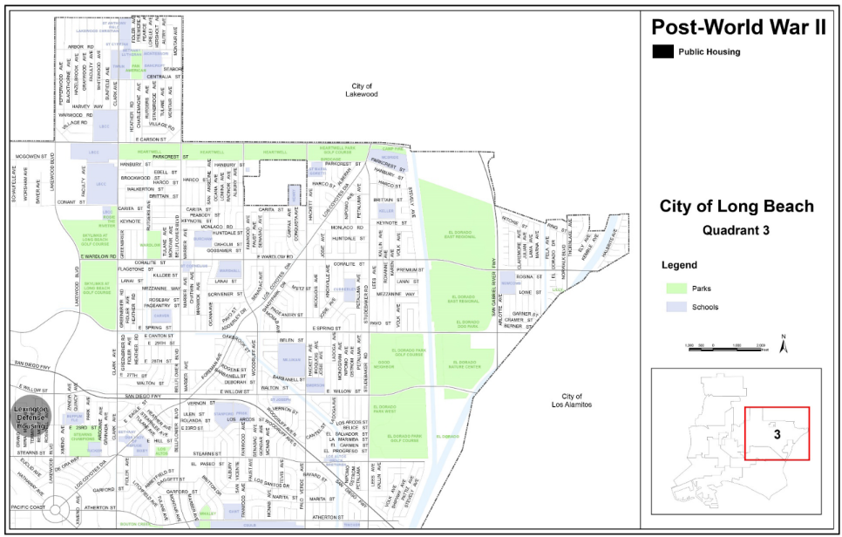 | 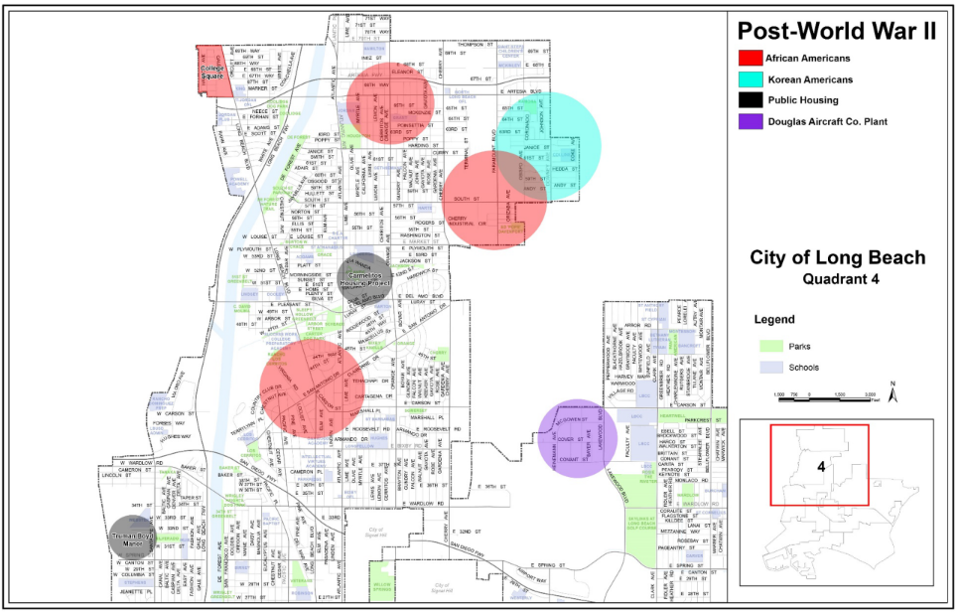

Source: Aerial Photographs of Long Beach near CSULB, 1941 and 1965

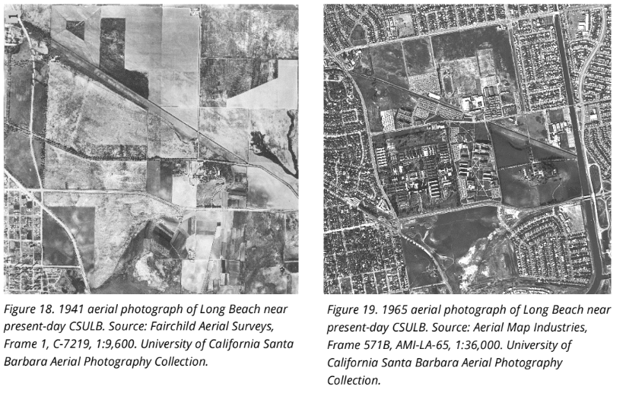

Power
Source: Home Owners Loan Corporation redlining map of Los Angeles County, 1939

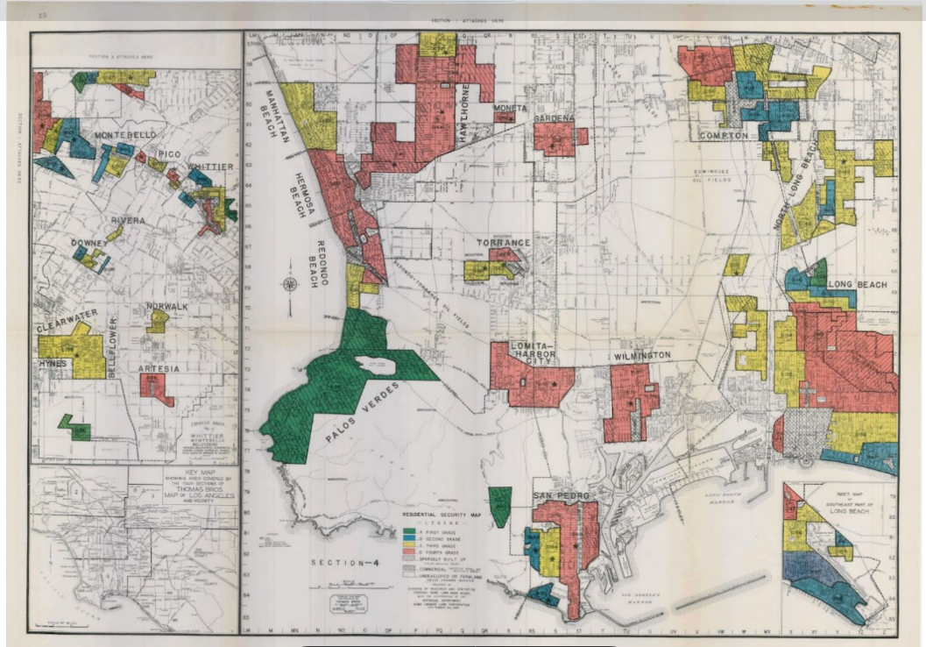
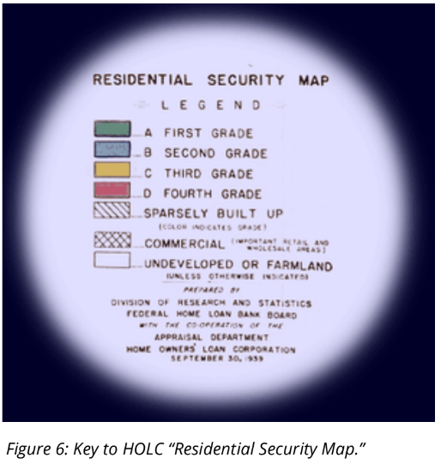
Key note: Homes in the green and blue zones were designated as reliable and good to give mortgage loans out. Homes in yellow were considered in disrepair and to use caution when giving out mortgage loans. Homes in the red zone were not to be given mortgage loans.

Source: Los Altos Association, “Protective Restrictions,” 1956

2. Limitation of Occupancy and Ownership:
- No part of said property shall be sold, conveyed, rented, or leased in whole or in part to any person of African or Asiatic descent or any person not of the white or Caucasian race, except as provided in paragraph (b) hereof.
- No part of said property shall be used or occupied or permitted to be used or occupied in whole or in part by any person of African or Asiatic descent or by any person not of the white or Caucasian race except that of domestic servants, cleaners, or gardeners of other than the white or Caucasian race may live in or occupy the premises where their employer resides.

Source: Trymaine Lee, “The Wealth Gap,” The 1619 Project, 2020, p. 82
The post-Reconstruction plundering of black wealth was not just a product of spontaneous violence, but etched in law and public policy. Through the first half of the 20th century, the federal government actively excluded black people from government wealth-building programs. In the 1930s, President Franklin Roosevelt’s New Deal helped build a solid middle class through sweeping social programs, including Social Security and the minimum wage. But a majority of black people at the time were agricultural laborers or domestic workers, occupations that were ineligible for these benefits. The establishment of the Home Owners Loan Corporation in 1933 helped save the collapsing housing market, but it largely excluded black neighborhoods from government-insured loans. Those neighborhoods were deemed “hazardous” and colored in with red on maps, a practice that came to be known as “redlining.”
The G.I. Bill is often hailed as one of Roosevelt’s most enduring legacies. It helped usher millions of working-class veterans through college into new homes and the middle class. But it discriminatorily benefited white people. While the bill didn’t explicitly exclude black veterans, the way it was administered often did. The bill gave veterans access to mortgages with no down payments, but the Veterans Administration adopted the same racially restrictive policies as the Federal Housing Administration, which guaranteed bank loans only to developers who wouldn’t sell to black people. “The major way in which people have an opportunity to accumulate wealth is contingent on the wealth positions of their parents and grandparents,” [William] Darity [professor of public policy and African-American studies at Duke University] says. “To the extent that blacks have the capacity to accumulate wealth, we have not had the ability to transfer the same kinds of resources across generations.

Economy and Environment
Source: Socio-Economic Index of Long Beach from US Census, 2010

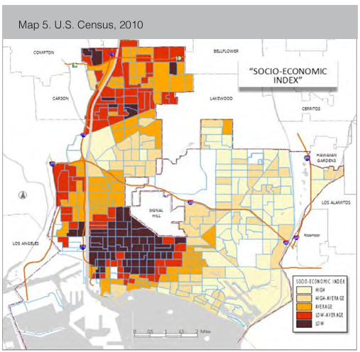

Source: City of Long Beach Community Health Assessment Charts, July 2013

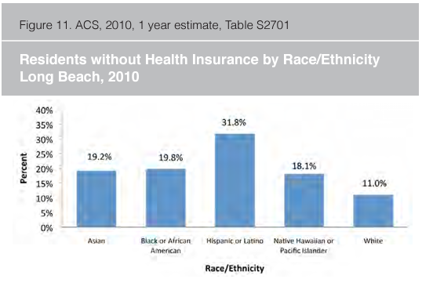 | 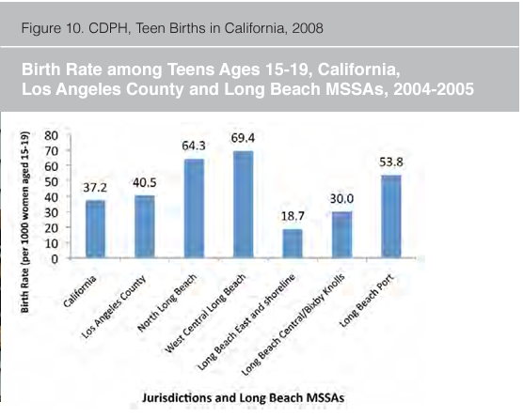
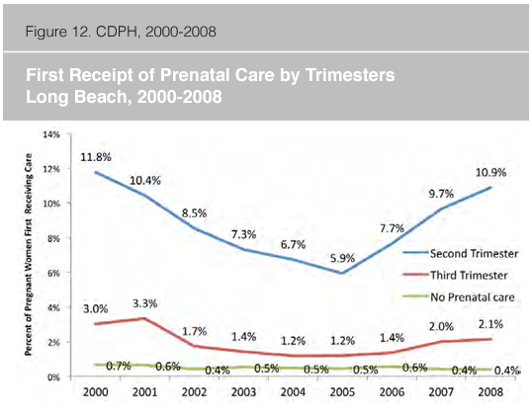

Source: City of Long Beach Community Health Assessment Report, July 2013

The social problems that are associated with poor health such as high unemployment, low education, and high crime are prevalent in different geographical sections of Long Beach. Long Beach consists of a higher percent of individuals living in poverty (19.1%) than either Los Angeles County (15.7%) or the State of California (13.7%). The effects of living below the poverty line are exacerbated in Long Beach, given the high cost of housing and the high percentage of income that must be used for housing…
Within Long Beach, the median income ranges from $19,815 in the 90813 zip code to $64,242 in zip code 90803. The discrepancy, where one zip code has more than 3 times the average income of another, illustrates the challenges that affect the achievement of positive health outcomes for all Long Beach community members…
The disparities continue in the North (90805), West Central and Southwest sections of Long Beach as even though the number of childhood lead poisoning cases has declined, 91 percent of the cases since 2005 have occurred in these areas. These areas also have the largest numbers of hazardous waste generators and the lowest amount of green space. A lack of green space not only impacts air quality, but also makes access to recreation open space problematic for much of the youth population in these areas. Although air quality and the designation of unhealthy days impacts all of Long Beach, the higher incidence of asthma, obesity and other health issues in the North, West Central, and Southwest are exacerbated by the 94 days (2011) that were considered “Unhealthy for Sensitive Populations” within Los Angeles County. (Full report found here.)

