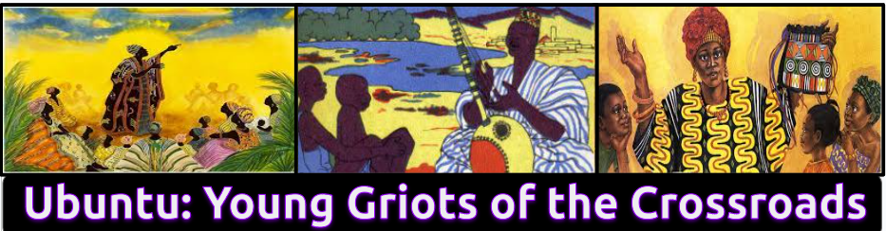
Ubuntu: Young Griots of the Crossroads Culminating Performance Task

Essential Questions:

- How can we use our knowledge of the historical inequities faced by people of color to determine the most effective way(s) to bring equity to urban education?
- Which strategies are best for bringing about the revolutionary changes we wish to see in education?

New Jersey Student Learning Standards:

- 6.1.5.CivicsCM.5: Investigate the lives of New Jersey individuals with diverse
experiences who have contributed to the improvement of society.
- 6.1.12.D.13.a: Determine the impetus for the Civil Rights Movement, and explain why national governmental actions were needed to ensure civil rights for African Americans.
- NJSLSA.R2: Determine central ideas or themes of a text and analyze their development; summarize the key supporting details and ideas.
- NJSLSA.W4: Produce clear and coherent writing in which the development, organization, and style are appropriate to task, purpose, and audience.

Project Task: After collaboratively engaging in research, oral history interviews, and data compilation, scholars will create a culminating project that answers the aforementioned essential questions.

Imagine that you’ve been hired by Learning for Justice to facilitate a creative presentation at an education conference based on your historical knowledge of educational inequities. Learning for Justice, also known by the acronym LFJ, is an organization based in Alabama that “seeks to uphold the mission of the Southern Poverty Law Center: to be a catalyst for racial justice in the South and beyond, working in partnership with communities to dismantle white supremacy, strengthen intersectional movements and advance the human rights of all people.” This unique opportunity will allow you to facilitate your creative presentation in front of an audience of educational professionals, including but not limited to: administrators, Learning for Justice staff, educators, parents and educational policymakers.

You are required to submit your presentation as a 3-5 minute video recording that answers the two essential questions above. Your presentation must include one or more of the catalysts for educational equity featured throughout the unit-Robert L. Carter, Vickie Donaldson, or Sylvia Mendez. You will also include evidence from at least 2 primary sources in your project.

Audience:
Imagine that your audience consists of teachers, administrators, local community members, Learning for Justice staff members and community activists.

Project Based Assessment Requirements:

Please select only ONE of the following project ideas below to fulfill the visual requirement:

- Podcast (Technology)
- Mini-Documentary (Technology)
- Investigative Journalism Report (Technology)
- Musical (Instrumental)
- Spoken Word/Poetry - (Vocal)
- Interior Monologue Portraying One of the Catalysts for Educational Equity (Robert L. Carter, Vickie Donaldson, a Bordentown School alumnus, or Sylvia Mendez) - (Drama)
- Dance Activism (Dance)
- Visual Artivism - Animation, Portrait, Painting or Graphic Design (Visual Arts)

1. Written Component: Submit a 1-page typed detailed project reflection that answers the following questions:

- What inspired the idea for your project?
- In what ways did the activist that you selected impact society? How did they impact education in New Jersey and/or the United States?
- What personal connections were they able to make to the research process and the development of their project?

Important Note: Please note that this is a two-part project. First, you are required to create a 3-5 minute video that contains all of the required information above. Secondly, you are required to submit a 1-page typed reflection that answers the questions above. The third requirement is that you must present your project to your school community. Be creative, think outside of the box, learn something new and try your best!
Scholar Name: _______________________________________

Date: ___________________________
Teacher Name: ______________________________________

Period: ____________

Culminating Performance Task Rubric

CATEGORY | 4 | 3 | 2 | 1
Oral Presentation | This presentation exceeded expectations. The audience could easily understand the presentation. | The audience could understand the presentation. | This presentation was approaching proficiency. | This presentation was difficult for the audience to understand.
Project Visual-Required Elements | The project visual includes all required elements as well as additional information. | All required elements are included on the project visual. | All but 1 of the required elements are included on the project visual. | Several required elements were missing.
One-Page Typed Reflection | Two-page typed reflection is original, no evidence of plagiarism, and includes all project requirements. The reflection is well-written, edited, and contains no grammatical errors. | Two-page typed reflection is original, no evidence of plagiarism, and includes all project requirements but contains 1-2 grammatical errors. | The reflection is typed and original with no evidence of plagiarism, but it does not meet the requirement of 2-typed pages and it doesn't include all project requirements. The reflection contains 3 or more grammatical errors and insufficient information. | The scholar did not complete this component of the project.
Historical  Connection | The scholar demonstrates a thorough understanding of the historical content, presents a logical interpretation of historical events grounded in evidence, and incorporates both primary and secondary sources into analysis, establishing a strong argument. | The scholar demonstrates a  strong  understanding  of the historical  content, presents a logical  interpretation  of historical  events mostly  grounded in  evidence, and incorporates  both primary  and secondary  sources into  analysis,  establishing a  reasonable  argument. | The scholar demonstrates some understanding of the historical content, presents an inconsistent interpretation of historical events weakly grounded in evidence, incorporates either primary and secondary sources into analysis, establishing a weak argument. | The scholar demonstrates little understanding of the historical content, and presents an inconsistent interpretation of historical events, not grounded in evidence, does not incorporate either primary or secondary sources.
Total Score=_______/16 Grade=_________

Teacher Comments:

