Name: ____________________________________

Date: ___________________

Lesson 1

DO NOW: Watch the following interview with Nikole Hannah-Jones that describes the founding of The 1619 Project:

https://www.youtube.com/watch?v=YaeqpMi-pJE

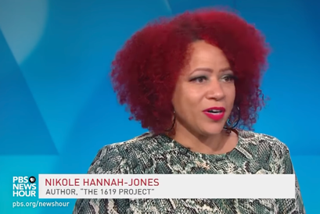

Consider the purpose of The 1619 Project:
- Annotate the text for keywords or phrases that resonate with you from the following excerpt from Nikita Stewart’s article Why Can’t We Teach This? for The New York Times Magazine
- Pick 3 quotes that resonate with you the most, and jot them down on your post-it

Why Can’t We Teach This?
By Nikita Stewart

In the preface to ‘‘The Geographical Reader for the Dixie Children,’’ Marinda Branson Moore, a teacher who founded a girls’ school in North Carolina, noted that she wanted to teach children about the world without it going over their heads. ‘‘The author of this little work, having found most of the juvenile books too complex for young minds, has for some time intended to make an effort to simplify the science of Geography,’’ she wrote. ‘‘If she shall succeed in bringing this beautiful and useful study within the grasp of little folks, and making it both interesting and pleasant, her purpose will be fully accomplished.’’ The book was published in 1863, the same year as the Emancipation Proclamation and in the midst of the Civil War. Teachers could review the lessons with suggested questions in the back of the book.

Part of Lesson IX’s suggestions read:

Q. Which race is the most civilized? A. The Caucasian.
Q. Is the African savage in this country? A. No; they are docile and religious here.
Q. How are they in Africa where they first come from? A. They are very ignorant, cruel and wretched.

More than a century and a half later, textbooks no longer publish such overt racist lies, but the United States still struggles to teach children about slavery. Unlike math and reading, states are not required to meet academic content standards for teaching social studies and United States history. That means that there is no

consensus on the curriculum around slavery, no uniform recommendation to explain an institution that was debated in the crafting of the Constitution and that has influenced nearly every aspect of American society since. Think about what it would mean for our education system to properly teach students — young children and teenagers — about enslavement, what they would have to learn about our country. It’s ugly. For generations, we’ve been unwilling to do it. Elementary-school teachers, worried about disturbing children, tell students about the ‘‘good’’ people, like the abolitionists and the black people who escaped to freedom, but leave out the details of why they were protesting or what they were fleeing. Middle-school and high-school teachers stick to lesson plans from outdated textbooks that promote long-held, errant views. That means students graduate with a poor understanding of how slavery shaped our country, and they are unable to recognize the powerful and lasting effects it has had.
In 2017, the Southern Poverty Law Center, a nonprofit organization that researches and monitors hate groups, pored over 12 popular U.S. history books and surveyed more than 1,700 social-studies teachers and 1,000 high-school seniors to understand how American slavery is taught and what is learned. The findings were disturbing: There was widespread slavery illiteracy among students. More than a third thought the Emancipation Proclamation formally ended slavery. (It was actually the 13th Amendment.) Nearly 60 percent of teachers did not believe their textbook’s coverage of slavery was adequate. A panel made up of the center’s staff, an independent education researcher with a background in middle- and high-school education and a history professor with expertise in the history of slavery looked at how the books depicted enslavement, evaluating them with a 30-point rubric. On average, the textbooks received a failing grade of 46 percent.
Maureen Costello, director of Teaching Tolerance, a program at the Southern Poverty Law Center that promotes diversity education, said the rubric used to analyze the textbooks was about seeing how the history of enslavement was integrated throughout a book and exactly what those contents were. In most teachings, she said, slavery is treated like a dot on a timeline. ‘‘The best textbooks maybe have 20 pages, and that’s in an 800-page textbook,’’ Costello told me. ‘‘At its best, slavery is taught because we have to explain the Civil War. We tend to teach it like a Southern problem and a backward economic institution. The North is industrialized; the South was locked in a backward agricultural system.’’ About 92 percent of students did not know that slavery was the war’s central cause, according to the survey.
So how did we get here? How have we been able to fail students for so long? Almost immediately after the Civil War, white Southerners and their sympathizers adopted an ideology called ‘‘the lost cause,’’ an outlook that softened the brutality of enslavement and justified its immorality. One proponent of the ideology was Edward A. Pollard, whose book ‘‘The Lost Cause’’ transformed many Confederate generals and soldiers into heroes and argued that slavery was proper, because black people were inferior. The ‘‘lost cause’’ theory buried the truth that some 750,000 people died in a war because large numbers of white people wanted to maintain slavery. Over time, the theory became so ingrained in our collective thinking that even today people believe that the Civil War was about the South’s asserting its rights against the North, not about slavery.
About 80 percent of this country’s 3.7 million teachers are white, and white educators, some of whom grew up learning that the Civil War was about states’ rights, generally have a hand in the selection of textbooks, which can vary from state to state and from school district to school district. ‘‘These decisions are being made by people who learned about slavery in a different way at a different time,’’ Costello told me. The law center’s study focused on high-school students, but the miseducation of children generally begins much earlier. Teachers bungle history as soon as children are learning to read. Because teachers and parents are often so afraid to frighten children, they awkwardly spin the history of this country. They focus on a handful of heroes like Harriet Tubman, whose picture is tacked to bulletin boards during Black History Month and Women’s History Month. Elementary-school students learn about our nation’s founders but do not learn that many of them owned slaves.

Hasan Kwame Jeffries is an associate professor of history at the Ohio State University and chair of the Southern Poverty Law Center’s Teaching Hard History advisory board, which guided the 2017 survey. He is an expert on how slavery is taught and has watched the dynamics play out in his own household. He recalled how his 8-year-old daughter had a homework assignment that listed ‘‘fun facts’’ about George Washington, and it noted his love of rabbits. Jeffries corrected the assignment. ‘‘He loved rabbits and owned rabbits,’’ Jeffries said. ‘‘He owned people, too,’’ he told his daughter. The assignment said he lost his teeth and had to have dentures. ‘‘Yes, he had teeth made from slaves.’’ Jeffries and teachers in upper grades I talked to around the country say they spend the beginning of their presentations on slavery explaining to students that what they learned in elementary school was not the full story and possibly not even true. ‘‘We are committing educational malpractice,’’ Jeffries told me. A report published last year by the Brookings Institution’s Brown Center on Education Policy, a research institute focused on K-12 issues in American public schools, examined social-studies teachers and found that there is limited testing accountability. Social studies is ‘‘largely absent from federal education law and policy,’’ the report found, which arguably makes it a ‘‘second-tier academic’’ subject. More than half the high-school seniors surveyed reported that debate in the classroom — a proven practice of good teaching — was infrequent.
I was lucky; my Advanced Placement United States history teacher regularly engaged my nearly all-white class in debate, and there was a clear focus on learning about slavery beyond Tubman, Phillis Wheatley and Frederick Douglass, the people I saw hanging on the bulletin board during Black History Month. We used ‘‘The American Pageant,’’ a textbook first published in 1956 and now in its 17th edition. It’s a book that, although not failing, was still found to be lacking by the Southern Poverty Law Center’s survey. It graded books based on how they treated 10 different key concepts, such as establishing that slavery was the central cause of the Civil War or explaining that the country’s founding documents are filled with protections for slavery. A modern edition of the book I used received a 60 percent mark, barely adequate.
Thomas A. Bailey, a professor of history at Stanford University, was the textbook’s original author. Bailey was influenced by what is known as the Dunning School, a school of thought arguing that the period of Reconstruction was detrimental to white Southerners and that black people were incapable of participating in democracy. This theory, along with the older ‘‘lost cause’’ ideology, helped to reinforce Jim Crow laws. In the 1970s, David M. Kennedy, a colleague of Bailey’s at Stanford, was brought in to revise the book. ‘‘It was clear that the textbook needed to be updated in alignment with current scholarship,’’ Kennedy said. Now he and a third co-author, Lizabeth Cohen, revisit three or four topics whenever they work on a new edition. He pointed to their efforts to show the impact of slavery on modern anti-black racism.
And yet Costello points at troubling language that continues to appear in the book. Thomas Jefferson’s relationship with Sally Hemings, who was enslaved by him, is described as ‘‘intimacy’’ and an ‘‘affair.… This section has since been edited, but the 15th edition remains in print. It’s a reminder that although textbooks like ‘‘The American Pageant’’ are evolving, it’s a slow process, and in the interim, misinformation about slavery persists.
Tiferet Ani, a social-studies specialist for the public-school system in Montgomery County, Md., is in charge of shaping the curriculum for her colleagues. She recommends using textbooks lightly and teaching students to challenge them. Ani, like so many teachers around the country, has been influenced by the law center’s report. ‘‘The textbook is not an authoritative document,’’ she told me. She and other teachers rely more on primary sources. Montgomery County is just outside Washington, so Ani can take her students to the National Museum of African American History and Culture. Many black children learn the fuller history at home, listening to the stories passed down to us or reflecting on what was never shared. Earlier this year, while looking up some information about my grandmother, I stumbled upon her father, my great-grandfather Nap McQueen. There he was in a black-and-white photo, looking straight into the camera, in a long-sleeve shirt, slacks and a hat. He was enslaved as a boy, and he was one of more than 2,300 formerly

enslaved people interviewed for the Federal Writers’ Project’s Slave Narratives. He was vivid in his recollection — how he was born in Tennessee and taken to Texas by wagon. His enslaver, he said, ‘‘was a good massa,’’ in part because he allowed McQueen to go fishing and hunting on the weekends, and his enslaver wouldn’t draw blood during whippings. His enslaver treated his property so well, he said, that they were the envy of enslaved people on other plantations.

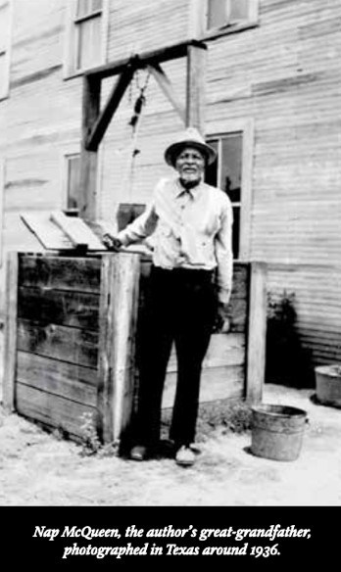
Nap McQueen’s words disappointed me. I was embarrassed. My great-grandfather had echoed the ‘‘lost cause’’ ideology. He talked about how his enslaver lined up all the enslaved people and announced that they were free. They could leave, his enslaver said, or they could stay, and he would give them some land. My family stayed, making a life in Woodville, Tex.
But then my great-grandfather shifted his attention to telling a story about a monkey owned by an enslaver on another plantation. The monkey, which was allowed to roam freely throughout the plantation, imitated everything humans did. It was annoying. Once, the monkey was used to play a prank on an enslaved man who thought the monkey, dressed in a white tablecloth, was a ghost. The man could not kill the monkey because it was ‘‘de massa’s pet,’’ but knowing that the monkey copied everything, the man shaved in front of it. The monkey picked up the razor ‘‘and cut he own throat and killed hisself,’’ McQueen said. That’s exactly what the man wanted, my great-grandfather said. ‘‘He feel satisfy dat de monkey done dead and he have he revengence.’’
It’s a crazy story, seemingly so off the subject and so out of character for a man who obviously tried to present himself as a good, law-abiding Negro, the kind of man who would not steal the cotton he picked on your behalf. Why tell a story about the gratification of killing something the enslaver loved? My great- grandfather’s words are my primary source. A whipping without blood is still a whipping. And I believe my great-grandfather shared the story of the monkey because he admired the other man for finding a way to get a little bit of justice. He wanted listeners to understand the horror of the institution, even if he was too afraid to condemn it outright. For me, it’s a reminder of what our schools fail to do: bring this history alive, using stories like these to help us understand the evil our nation was founded on.

Lesson 2
Write your responses to the following:

- Who founded the 1619 Project? _______________________________________________________________

- In your own words, for what purpose? _________________________________________________________________

_____________________________________________________________________

_____________________________________________________________________

_____________________________________________________________________

_____________________________________________________________________

_____________________________________________________________________

_____________________________________________________________________

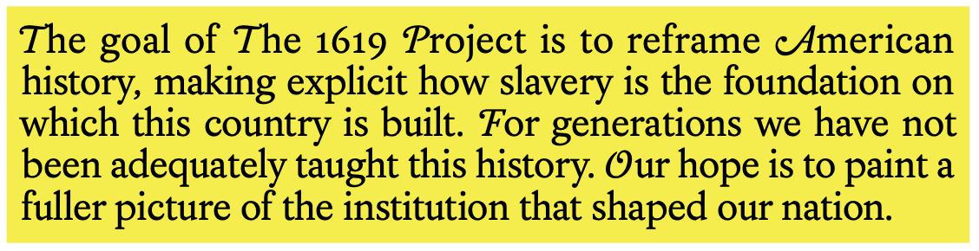

Group Work Norms:

- Everybody speaks: step up, step back
- Respect others by listening & building upon their opinions
- Disagree with ideas, not people
- Build consensus
- Anything else to add?

In groups of 4:
- Article in hand, debate your chosen quotes on your post-it(s):
  - Which ones feel most important to you as elementary school scholars in America, and why?
  - Which ones may be more impactful for Americans who do not work in schools, and why?
  - Which ones best illuminate the truth?
- Pick one and write it on your chart paper. Include:
  - Citations (as applicable)
  - Supporting graphics, illustrations, and/or symbols

Present!
🗣🗣🗣🗣

Lesson 3
Meet historian & Harvard professor Annette Gordon-Reed:

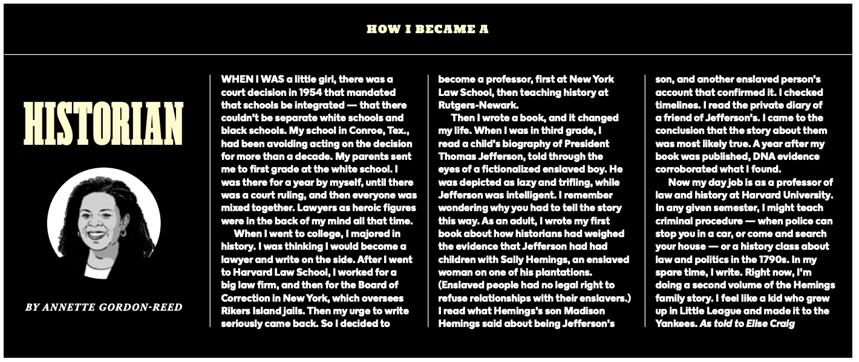

Review the infographic she created for The New York Times Magazine.

Self-Assess:

- What dates, facts, and figures were you already familiar with regarding the founding of America? Annotate with a ☑️ and margin notes elaborating on where you learned this.

- What were you not? Annotate with an ❎ and add margin notes with any further questions you have.

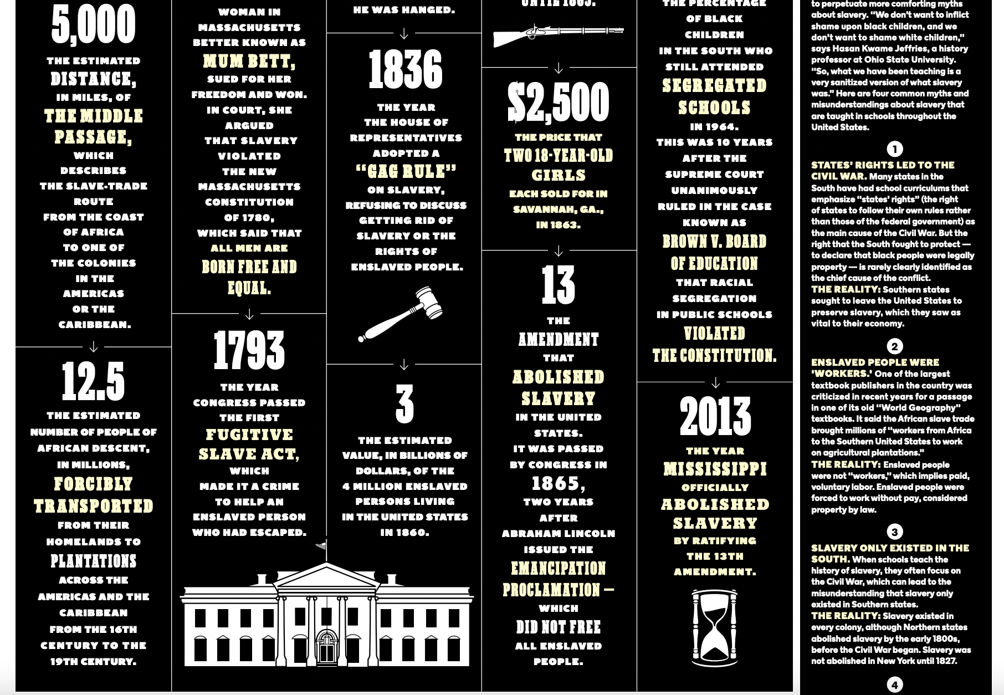
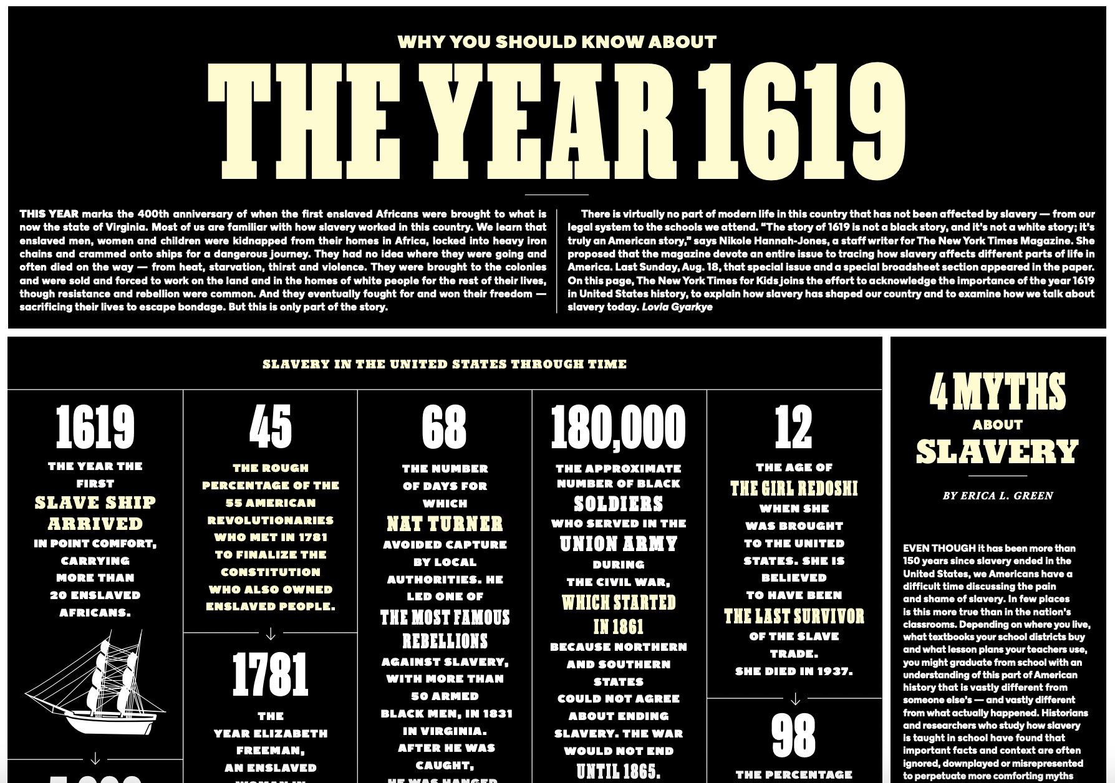

Revisit this excerpt from Nikita Stewart’s “Why Can’t We Teach This”:

“Tiferet Ani, a social-studies specialist for the public-school system in Montgomery County, Md., is in charge of shaping the curriculum for her colleagues. She recommends using textbooks lightly and teaching students to challenge them. Ani, like so many teachers around the country, has been influenced by the law center’s report. ‘‘The textbook is not an authoritative document,’’ she told me. She and other teachers rely more on primary sources… many black children learn the fuller history at home, listening to the stories passed down to us or reflecting on what was never shared.”

What is the impact of documenting primary source knowledge?

Lesson 4

Review Ms. Russell’s 2020 lecture from the Zinn Education Project’s ‘Illegal Lesson Teach-In.’
- Which historical aspects were you familiar with?
- Which were you not?
- What information do we need to find to tell the story of Promise Land to others in your community?

Lesson 5

Name: _________________________________________________________________

DO NOW: Review the key terms below, and add any relevant connections to prior readings or films from our unit so far.

- Chattel Slavery: (N) Noun. The legal practice of humans owning other humans and their offspring forever; the racialized labor system that founded the United States of America. See also: American slavery, transatlantic slave trade.

- Abolition: (N) Noun. The total elimination or stoppage of something. See also: abolitionist, eradication.

- Illiteracy: (N) Noun. The inability to read or write. See also: education, literacy.

- Autonomous: (ADJ) Adjective. Describes when a country, people, or region have the freedom to govern itself or control its destiny. See also: self-determination.

- Primary Source: (N) Noun. A first-hand or direct account of people who were present during a time or event. See also: secondary source, testimony, original.

After viewing Ms. Russell’s 2020 lecture from the Zinn Education Project’s ‘Illegal Lesson Teach-In,’ what questions would help us document the true history of Promise Land? Craft at least five.

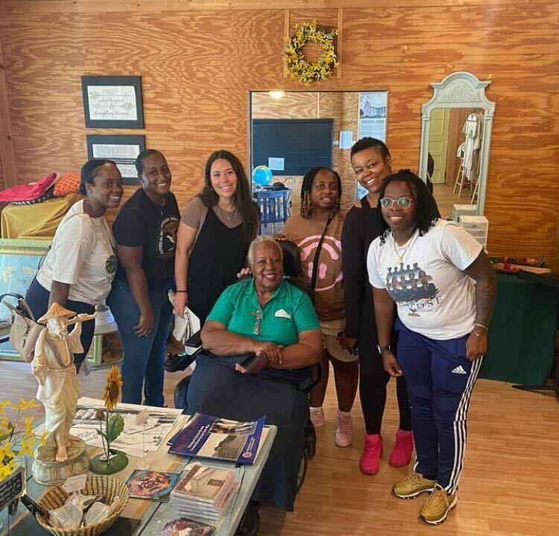

Lesson 8

What questions do you have for primary source guest Ms. Serina Gilbert that would help us document the true history of Promise Land? Craft at least five.

Lesson 9

Primary Source Interview:
Ms. Serina Gilbert – Founder of the Promise Land Heritage Association

- Ezra: Why did you want to support the Promise Land and its heritage?

- Elijah R. & Tyrone: Where was Promise Land founded? What influenced people to make a school on Promise Land?

- Eric T. & London B.: Who were the first Black Americans in Promise Land, and who founded the school?

- Carlos: Who were the supporters of Promise Land?

- Harmony H.: Did Promise Land value education?

- Ava & Elizabeth: How did the 13-year teacher teach? What was her experience like?

- Jamia: Did the amount of enrolled scholars grow or decrease over the years?

- Chase & Cam’ron: How did teachers teach up to 90 children at the same time, and how did they fit in one classroom?

- Elijah: How did Promise Land evolve over time, other than the school and the church?

- Quin’Niya: Did Promise Land scholars wear uniforms? Did they have morning motivation like Purpose Prep?

- Jayseon & Kayln & Carleah: How did Reconstruction affect Promise Land, and were there any happy moments there besides all the violence that happened across the South?

- Layla: Did the government ever try to shut Promise Land down?

- Ryah: Were there Black and white children that were friends at Promise Land?

- Jarvis: Why isn’t there a book for children about Promise Land?

- Kye & Elijah C.: What do you think is most important for 5th Graders to know about Promise Land?

Lesson 10

Name: _____________________________________________________________________

- What characteristics or features do you notice about the textbook genre?

- Draft a textbook chapter that tells the story of Promise Land, and be sure to include the following:

- Set the Stage: Background information about Reconstruction.

- Secondary Source Information on Promise Land: Who, what, when, where, why and how?

- Primary Source Information on Promise Land: What did you learn from Ms. Serina Gilbert, founder of the Promise Land Heritage Association?

- At least one text feature:

