STORY CARD: Walker and Enoch Lewis – Lowell House Hotel
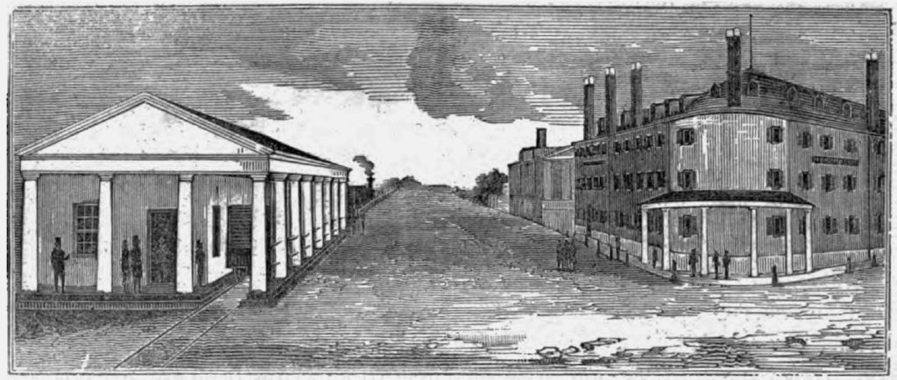The Merrimack House (right) and Boston and Lowell Railroad (left) were located across the street from one another, attracting business from travelers. (1836)

Walker Lewis, a committed abolitionist, had a barbershop at the Merrimack House Hotel in the 1830s. This barbershop was managed by Lewis and his brother-in-law John Levy. Lewis was one of the founding members of the Massachusetts General Colored Association, the first all-black organization in the country. With support from the MGCA, Lewis arranged for Boston to print David Walker’s 76-page Appeal to the Coloured Citizens of the World in 1829, demanding unconditional and immediate emancipation of all slaves in the USA.
Walker’s son Enoch ran a used clothing store, mainly to assist escaping slaves to change their appearances with new and better clothing. Walker would cut and style their hair to assist in their disguise.
When Nathaniel Booth came back to Lowell from Canada, it was the Lewis family who sheltered him from “manstealers” trying to return him to slavery.

(Source; Lowell National Historical Park)

