STORY CARD: The Underground Railroad – St. Anne’s Church
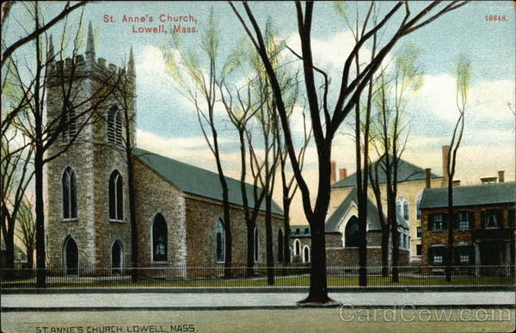

The Underground Railroad wasn’t an actual railroad. It was a group of people, African American as well as White, offering shelter and help to escaped enslaved people from the South. This group relied on the work of enslaved and formerly enslaved people to free themselves. People on the “Underground Railroad” helped them along the way - by hiding them, giving them rides, and housing them to try to protect them until they made it to the North or to Canada. The exact dates of operation are not known, but it existed from the late 18th century to the Civil War. Research shows that there were at least 33 sites in Lowell on the Underground Railroad, including the St. Anne’s Church.
Saint Anne’s first minister was anti-slavery activist Reverend Theodore Edson. In 1838, he wrote about how he helped a man named Robert escape:
“Thro N York he came to Boston where he was very sick of pleurisy from exposure in traveling lying out in the woods day and night in northern climate. Mr (continued) The Underground Railroad in Massachusetts, 1783-1865 MPS Garrison befriended him But one day in Boston Cornhill he met unexpectedly Kentuckian slaveholder whom he knew James Coburn and who recognized him at once saying “Aye Bob what are you doing here” He made himself strange–But he felt that he must leave Boston—A Mr. Leonard from Ludlow Vt had seen him in Boston and had said to him that if he wd come to him he would take care of him and he gave him some directions–Mr G sent him to Salem to a Mr. Wm A Dodge But his story getting wind he was afraid to stay there and came on to Andover where he was directed to Smiths the Scotchmen’s at Frye Village— Smiths directed him to come to me—which he did by the railroad.
Source: Kathryn Grover, “The Underground Railroad in Massachusetts,” with an excerpt from Journal of Rev. Theodore Edson, entry for 19 March 1839, Center for Lowell History, Lowell, Mass.

