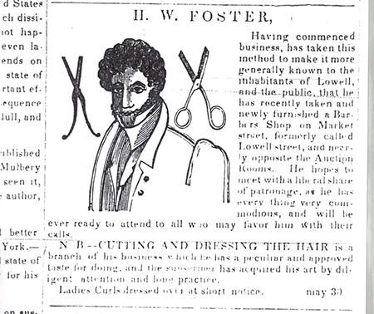

Horatio W. Foster was one of the most dedicated abolitionists in Lowell. Foster was a mixed race man living in Lowell during the 1840s. He was a barber. Foster spent much of his time spreading the ideas of abolitionism throughout the city and state. An active supporter of William Lloyd Garrison’s “The Liberator” as well as Frederick Douglass’ “The North Star”, Foster sold subscriptions and wrote articles for both papers
When women from Lowell were interested in forming an anti-slavery society, they went to Foster for help. He used his connections to help them get guidance from Maria Weston Chapman, an abolitionist organizer in Boston. Foster also served the community by organizing events and fundraisers. Before a large abolitionist picnic in 1843 he invited “all the abolitionists in the county and roundabout” to come to “a great day of jubilee and thanksgiving.”
The woodcut we use in our logo accompanied advertisements for his business in a regional newspaper. In addition to styling and barbering, Foster also made a hair compound that he sold. It is unknown whether this is a “stock” image or a woodcut of Foster himself, but regardless, advertising in the papers with any kind of possible likeness was a major move for a Black entrepreneur. The representation of him in the paper that we have emphasizes his skill and humanity—what he chose to offer the world.
Adapted From: https://diylowell.org/vlbh/blackhistorytrail/ and Lowell National Historical Park

