**STORY CARD: NATHANIEL BOOTH** 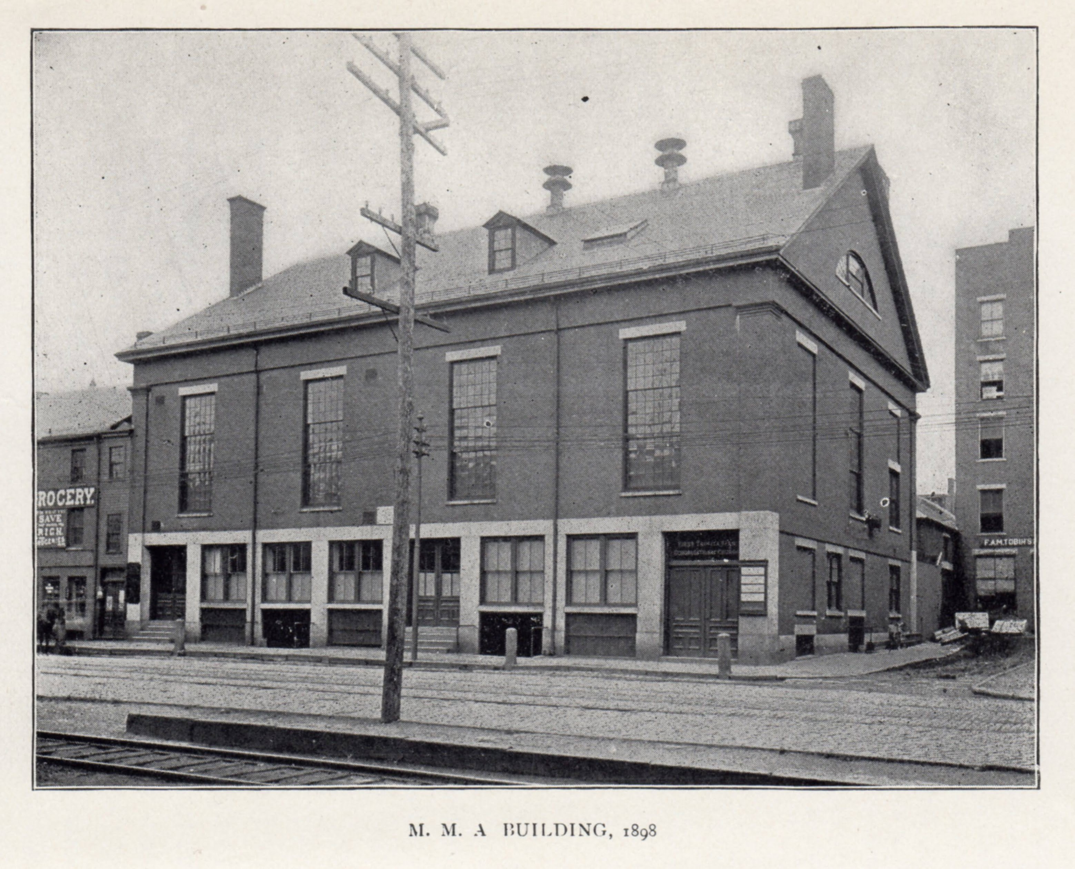

**Nathaniel Booth (1826 - 1901), Freedom Seeker**

Middlesex Mechanics Association Building, *Contributions of the Old Residents' Historical Association, Lowell, Mass. : organized December 21, 1868. by Old Residents' Historical Association of Lowell (Mass.) v. VI, 1904,* opp. p. 283. LC F74.L904 VOL.6 University of Massachusetts Lowell, Center for Lowell History.

**Nathaniel Booth** was born enslaved on a Virginia plantation in February 1826. When he was 17, he escaped to the North so he could be free. In 1844 he opened a barbershop on the first floor of the Middlesex Mechanics Association Block on Dutton Street in Lowell, Massachusetts.

Booth became active in the abolition and anti-slavery movement in Lowell. Black barbers and hairdressers in New England were often active in the abolition and anti-slavery movement. Black and white abolitionists would meet in barbershops to make plans to end slavery. They planned fundraising fairs, arranged for people to give anti-slavery speeches, and helped freedom seekers[1] escape from slavery.

In 1850, the United States passed a law called the Fugitive Slave Act. This law made it legal for people to chase after escaped freedom seekers and bring them back to their enslavers. It made it illegal for officials or citizens in any state to help freedom seekers. Any elected official who did not help “slave catchers” might have to pay a fine of $1,000. That’s about $30,000 today! Any citizen who helped enslaved people escape could spend as much as six months in jail. The law didn’t stop the abolitionists in Lowell though; they continued to help freedom seekers, including Nathaniel Booth.

One day, soon after the Fugitive Slave Act was passed, "one or two slave catchers" were seen in Lowell. Nathaniel Booth fled Lowell and went to Canada so he could be safe. The local **Free Soil Party[2]**, led by Chauncey Knapp, asked Booth if he would come back to Lowell. They told him they would protect him from the slave catchers. One member said that he was willing "to suffer death rather than let a fugitive slave be caught” if he could prevent it. So, Booth returned to Lowell and moved in with the Walker Lewis family. The Walkers and Lewises were free Black people living and working in Lowell. They worked in the Massachusetts anti-slavery movement and were very important in the local underground railroad. The anti-slavery activists protected Nathaniel Booth from the slave catchers. They raised money to pay Booth’s ex-enslaver, and he was given his freedom papers.

**Later Life**

As a free man, Booth continued to live and work in Lowell. In 1855, the Massachusetts Legislature passed the comprehensive Personal Liberty Laws. These new laws protected people in Massachusetts, and kept slave catchers from coming to Massachusetts. Tensions between the North and the South grew more intense.

In the late 1850s, Nathaniel Booth moved to Boston. In 1858, he traveled to Philadelphia where he met Frances (Fanny) LeCount Johnson. They married on August 24, 1858 in Philadelphia. In 1859, he returned to Boston with his wife and opened a new barbershop. Also living in his home at this time were Henry Williams, his wife Elizabeth, and their daughter Mary, who were freedom seekers.

In 1864, Nathaniel Booth, his wife Frances and his three oldest daughters - Ida, Mary, and Ellen, moved back to Philadelphia. There Nathaniel and Fanny had seven more children- Walter, Bertha, Nathaniel Jr., Guy, Blanche, Daisy, and Robert. According to *Philadelphia City Directories*, Nathaniel Booth continued to work as a barber until 1881, when his occupation was listed as nurse. He died on December 25, 1901.

Booth's son Guy Bryan Booth (b: 1872, Philadelphia - d: 1925, Washington, DC) graduated from Howard University and worked for the US Government in Washington, DC. Here is his picture:

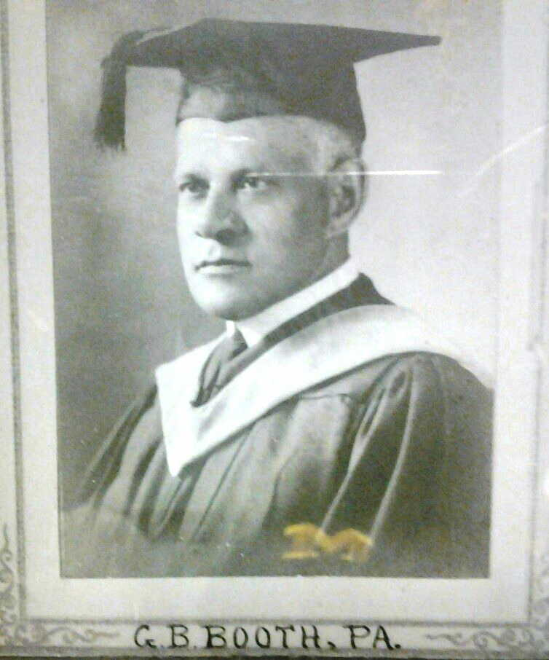

**Primary Document Excerpts:**

**Nathaniel Booth in the News**

From the *American Citizen*, Lowell, October 2, 1850

***MANSTEALERS IN LOWELL!***

*“We understand that one or more persons were in the city yesterday for the purpose of capturing Mr. Nathaniel Booth, the barber, who has a shop near the Washing House, a very respectable man, who has been in this city for some years. Mr. Booth was formerly a slave in Virginia. He is now in Montreal and his friends yesterday telegraphed to him that he had better remain there for the present. We hope, however, he will return to the city, for we think there are MEN enough in Lowell who believe in the “higher law,” to protect him against all efforts of the manstealers.”*

From the *Weekly Journal and Courier*, Lowell, April 7, 1851

***PURCHASE OF SLAVE’S FREEDOM***

*“We understand that Mr. Booth, the colored[3] barber, and a fugitive, who went to Canada some time since and returned after a brief sojourn there, is in a fair way of receiving his freedom papers. A day or two since, his owner in Virginia wrote to the Hon. Linus Child, that unless Booth's freedom were purchased, he should be compelled to adopt legal measures for his surrender. He stated that he was worth $1,500 to him, but that, under the circumstances, he would take much less. He was finally induced to say he would relinquish his claim for $700. Accordingly, on Saturday, a paper was drawn up by I.W. Beard, Esq., who heading it up with $25, and about fifty were obtained without taking it out of the entry. We hear that it will be taken round today by some one, and we presume the requisite sum will be obtained in the course of a few days. The subscriptions are payable to Mr. Child, and they will not be called for unless the whole shall be raised. An opportunity is here presented for the exercise of a little practical philanthropy on the part of our abolitionists, which of course, they will not allow to pass unimproved.”*

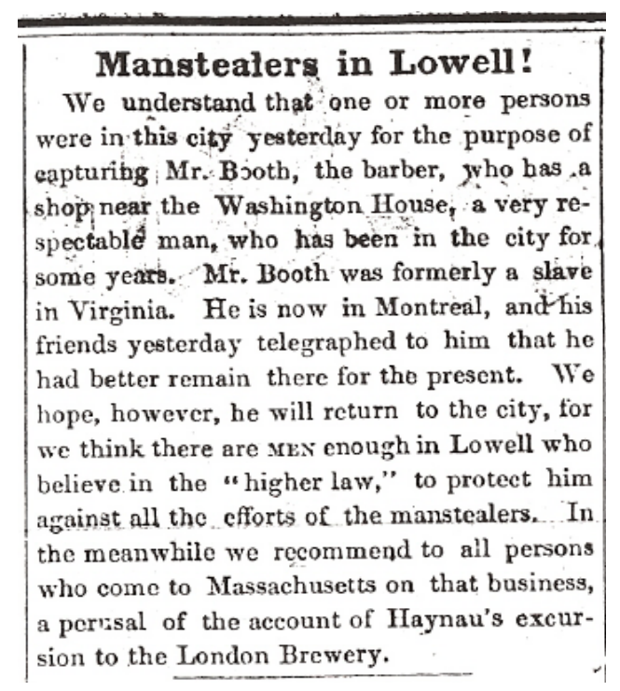

***Sources: Adapted from*** [Untold Lowell Stories: Black History](https://libguides.uml.edu/c.php?g=1125577) ***UMass Lowell University Library Center for Lowell History.***

1. Freedom Seekers were people who had been enslaved, escaped, and were seeking freedom in the North.
2. The Free Soil Party was a short-lived political party in the US. It was active from 1848 - 1854. Their main goal was to end slavery in the United States.
3. Term used for Black people in the 1800s.