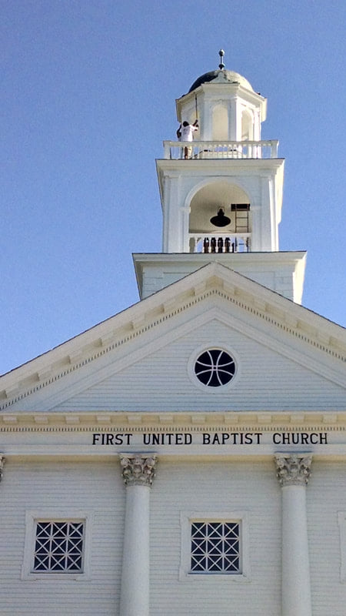
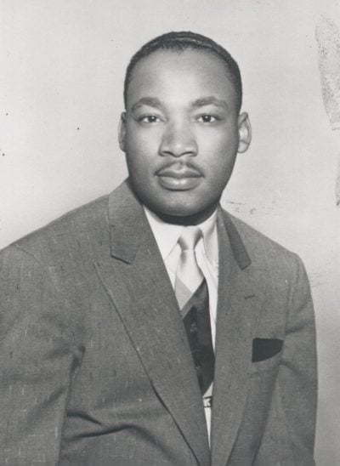
STORY CARD:
Martin Luther King, Jr. visits Lowell, Massachusetts

Image 1. First United Baptist Church, Lowell Massachusetts. Image 2. Martin Luther King, Jr., Student Photograph, Boston University.
Martin Luther King, Jr. (1929-1968), was born in Atlanta, Georgia, son of Martin Luther King, Sr. and Alberta Williams.
King was invited to visit Lowell on April 12, 1953, by Rev. Otto R. Loverude, (1900-1973), the minister of First United Baptist Church, Church Street, Lowell. King, who was then a student in the doctoral program at Boston University, came to the church to present a program.

More Information:
In a letter of invitation addressed to King, Loverude wrote:
"Tell us something of what it means to be a member of the minority race in the South..."
Martin Luther King, Jr. sent this response back to Loverude:
"This is to acknowledge your letter of February 18. Following your suggestion I will use as a subject at the 5:30 discussion group: 'What it means to be a Negro in the South.' My subject for the regular evening service will be: 'What does it mean to believe in God?'
I am very happy to be able to serve you and your church and I will look forward to this occasion with great anticipation. Please feel free to contact me about any additional information. I would appreciate it very much if you would give me some directions as to getting to the church. I will be driving out.
Sincerely yours,
Martin L. King Jr."
Source: Correspondence. Rev. Otto R. Loverude and Martin Luther King, Jr. Martin Luther King, Jr., Papers, 1954-1968, Howard Gotlieb Archival Research Center, Boston University, Boston, Massachusetts.
Sources: Adapted from Untold Lowell Stories: Black History UMass Lowell University Library Center for Lowell History.

