STORY CARD:

African Methodist Episcopal (AME) Zion Church
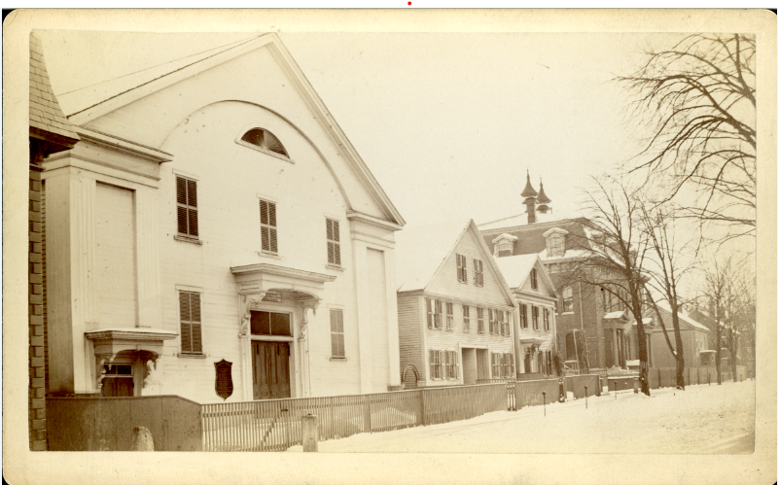
The building which now houses Girls Inc. on Worthen Street was once the home of the African Methodist Episcopal (AME) Zion Church. This is a historically African-American denomination based in the United States. It was officially formed in 1821 in New York City, but operated for a number of years before then. For many decades, this building held services for the AME Zion Church, the Methodist Episcopal Church, and the Church of All Nations. In 1945, this building was used as a meeting place for the Merrimack Valley branch of the NAACP.
(Thanks Lowell National Historical Park)
Historical Worthen Street Church, credit Lowell National Historical Park

