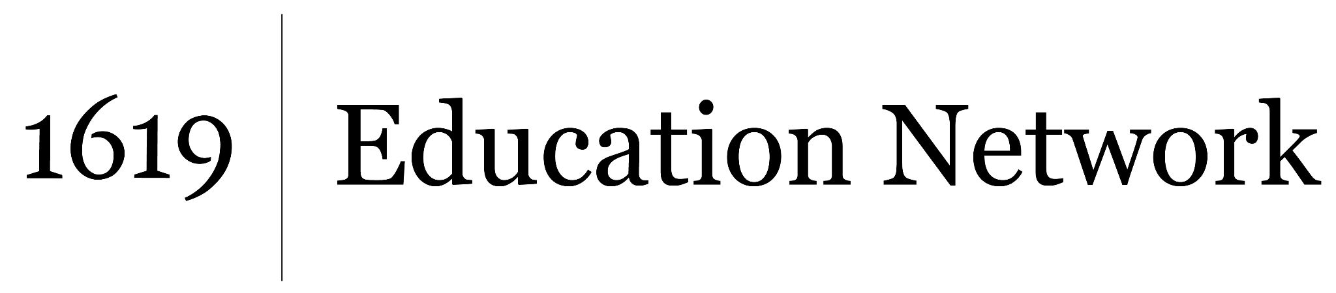
Before and After: Transatlantic Exchanges and Outcomes
Unit by Audubon Gentilly, part of the 2022 cohort of The 1619 Project Education Network
__________________________________________________________________
Name:

Write an essay describing the impact of the Columbian Exchange on people around the world after 1492. Make sure to include at least three supporting reasons and evidence from the articles we’ve read to prove the reasons you’ve stated.
In your essay make sure to:
- Write at least 5 paragraphs
- Write an introduction and conclusion
- Cite evidence
- Use transition words

