Venn Diagram
Directions: Complete the Venn diagram to compare and contrast the challenges in Show Way and Born on the Water.
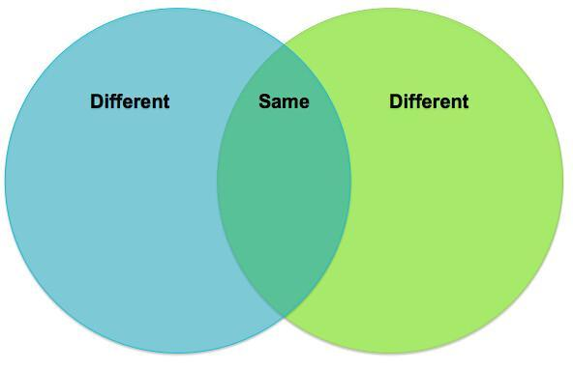
Name:____________________________ Date:____________________

