STORY CARD: Joseph Bradley Varnum,
ABOLISHING THE SLAVE TRADE
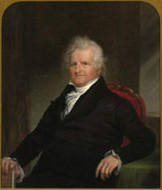

Hello! My name is Joseph Bradley Varnum. I have been in Congress and in the Senate, helping make laws for the new country.

I was born on a farm in Dracut, Massachusetts on January 29, 1750. When I was a child, I became good friends with a child named Silas Royal, who was enslaved by my family. As we grew up, I realized that slavery was wrong. My family freed Silas. When we grew up, Silas and I were soldiers together in the American Revolutionary War.

I knew that slavery was wrong and unfair, and I tried to think of a way to stop it. In 1805, I wrote a law to end the slave trade. President Thomas Jefferson signed it and made it a law on March 3, 1807. The law said that no one was allowed to go to Africa to kidnap and enslave people and bring them back to America. Sadly though, people who were already enslaved in America were not freed until almost sixty years later.

This resource was adapted from Joseph Bradley Varnum - Wikipedia

Although President Jefferson often said that slavery was wrong,he himself enslaved people on his farm, and he never freed them.

