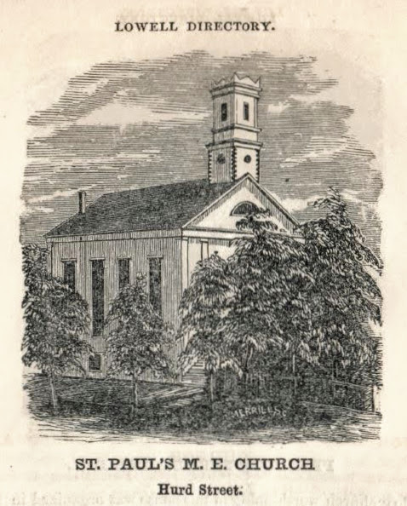
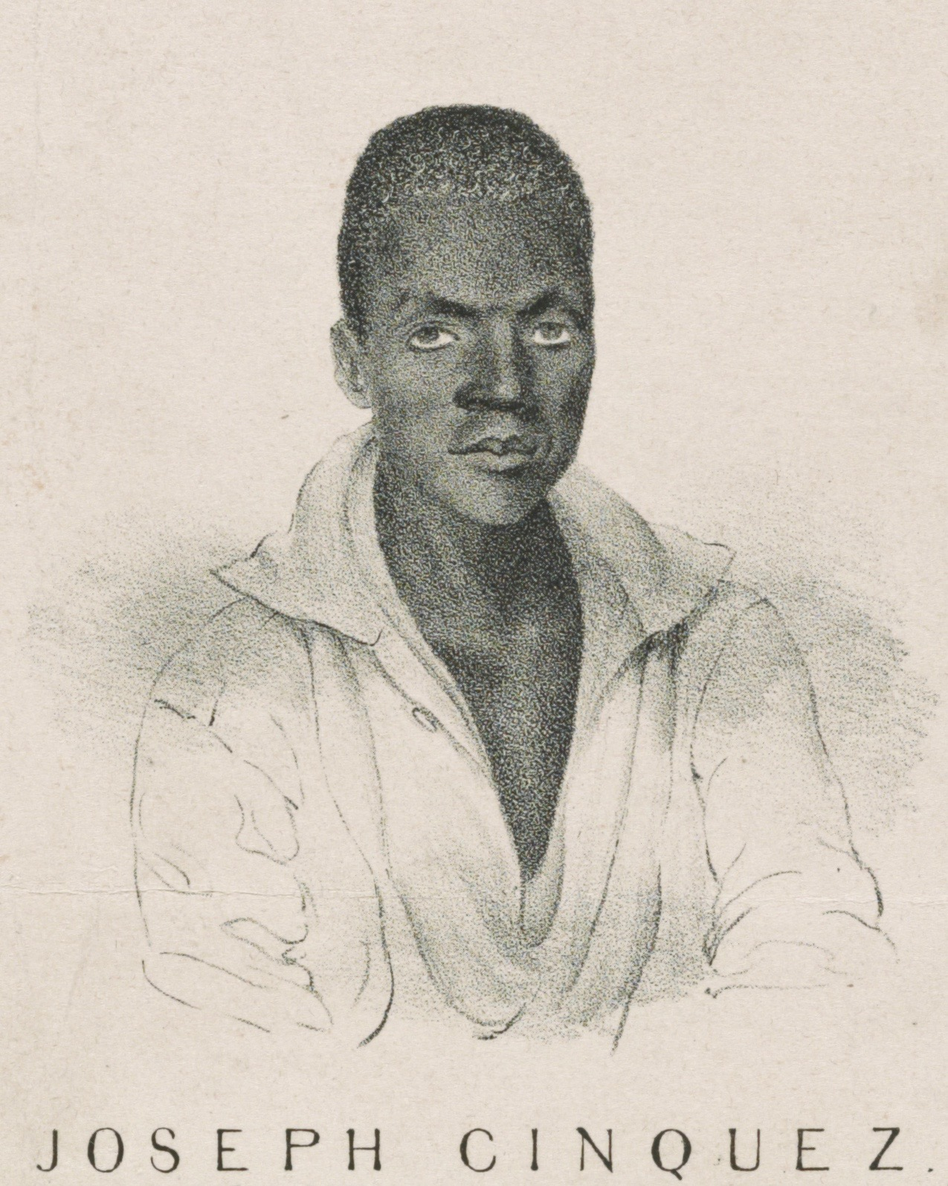
First Person Narrative: Amistad

My name is Joseph Cinque. I am here because my friends and I were kidnapped! We live in West Africa and we are members of the Mende tribe. One night some enslavers kidnapped us and put us on a ship going to Cuba. We didn’t know where we were going. We thought we’d never see our families again. It was very scary. But one night, when all of the enslavers on the ship were asleep, we escaped and took over the ship! We just wanted to go home. We told the sailors to take us back to West Africa. But they tricked us! They sailed to Long Island, New York, instead. My friends and I were put in jail.
Many people in America were angry that we had been kidnapped from our homes and then arrested when we tried to escape. It wasn’t fair at all. Our new friends were called Abolitionists. Abolitionists think slavery is wrong. They raised money for us so that we could defend ourselves in court.
Our case went all the way to the United States Supreme Court. Our lawyer was John Quincy Adams, and he was very famous. He used to be the President of the United States. Now he’s a lawyer. He told the court that it was against U.S. law for us to be kidnapped in Africa and brought here to be slaves. The Supreme Court ruled that we had been illegally kidnapped in Africa and were now free! We were so happy! We knew that we were going home.
After we were freed, we traveled all over New England raising money so we could go home. That’s why we went to Lowell, Massachusetts. I made a speech at St. Paul’s Church. They gave us money and a tour of the mills. We visited the Boot Mills and a carpet factory. The carpet factory agent gave me a beautiful rug to take back home to our families in West Africa.
Excerpt: from “Visit to the United States in 1841” by Joseph Sturge
“On Monday we proceeded to Haverhill… After a stay of two hours, we proceeded to Lowell. The heavy rain prevented a general attendance. Only thirty-one dollars was collected, beside some private donations. Mr. John Levi (ed: Levy), a colored citizen, rendered important services to us, and several of the clergymen and other inhabitants rendered efficient aid.
On Tuesday we went to Nashua, N.H., and remained two hours… In the evening at Lowell, the large Methodist Church, St. Paul's, was crowded, one thousand five hundred people being present, it was said, and many hundreds unable to get admission. (ed: 1840 Lowell’s Population was 22,000). The meeting was opened with an appropriate prayer by Rev. Luther Lee. In order to give an opportunity to the audience to see and hear Cinque, he was invited into the pulpit, where he made an energetic address. One hundred and six dollars were collected.
At the close of the services, nearly the whole congregation came forward and took the Mendians by the hand, with kind words and many presents. The ministers of all denominations attended the meeting, with many of the most respectable citizens.
During the day the Africans were invited to visit the 'Boott Corporation,’ and were conducted over the whole establishment (cotton mills,) by the agent, Mr. French. As might be supposed, they were astonished beyond measure. After inspecting the machinery, the fabrics, and the great wheel, one of them turned to me and said, 'Did man make this?' On receiving a reply, he said, 'He no live now--he live a great while ago.'
Afterwards they visited the carpet factory and expressed great delight at the beauty and excellence of the carpets and rugs. Cinque wished to purchase a miniature hearth rug, but the agent (ed: Royal Southwick) allowed him to select one of the large and beautiful rugs to take to Mendi, which he generously presented to him. The workmen here--chiefly Englishmen--made a collection of fifty-eight dollars and fifty cents on the spot and presented it to the Mendi Fund.”
Sources: Adapted from Untold Lowell Stories: Black History UMass Lowell University Library Center for Lowell History.

Sources: UMass Lowell University Library Center for Lowell History.

