Response to Literature:
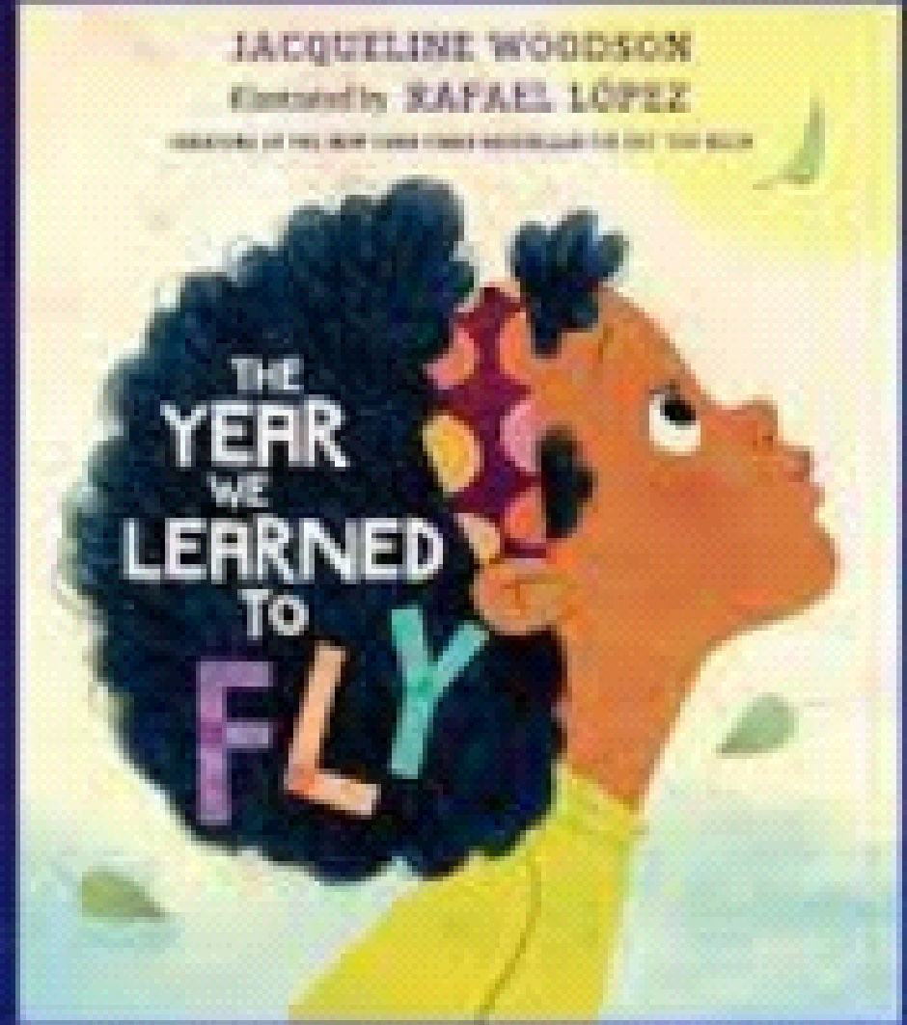
The Year We Learned to Fly by Jacqueline Woodson

Teacher Explanation:
Students will write a text-to-self response. They will tell something they learned from one of their ancestors.
Rubric:

Score | Skill: Response to Literature
1 | Student did not address the prompt.
2 | Student answered the prompt, but without details.
3 | Student answered the prompt and provided one reason to support their idea.
4 | Student answered the prompt and provided clear reasons to support their idea

Score | Skill: Conventions
1 | Student did not write recognizable letters/words.
2 | Student copied some letters/words, but they did not have meaning.
3 | Student wrote or copied letters/words with purpose and meaning. Some punctuation may be present (upper case letters, periods, spacing, etc.).
4 | Student wrote a combination of phonetic and conventionally spelled words. Punctuation may be present. Student can read their own writing and may even make revisions.

Score | Skill: Illustrations
1 | Illustration is not recognizable (ex. scribbling) and/or does not match words.
2 | Illustration is very simple without details (ex. use of one color to draw a single object) and/or has a weak connection to the words.
3 | Illustration is recognizable and includes details (ex. use of multiple colors and several objects) and is connected to the words.
4 | Illustration is easily recognized and includes details (ex. use of multiple colors, several related objects, may include some labels) and is clearly connected to the words.

TOTAL SCORE
out of 12 pts
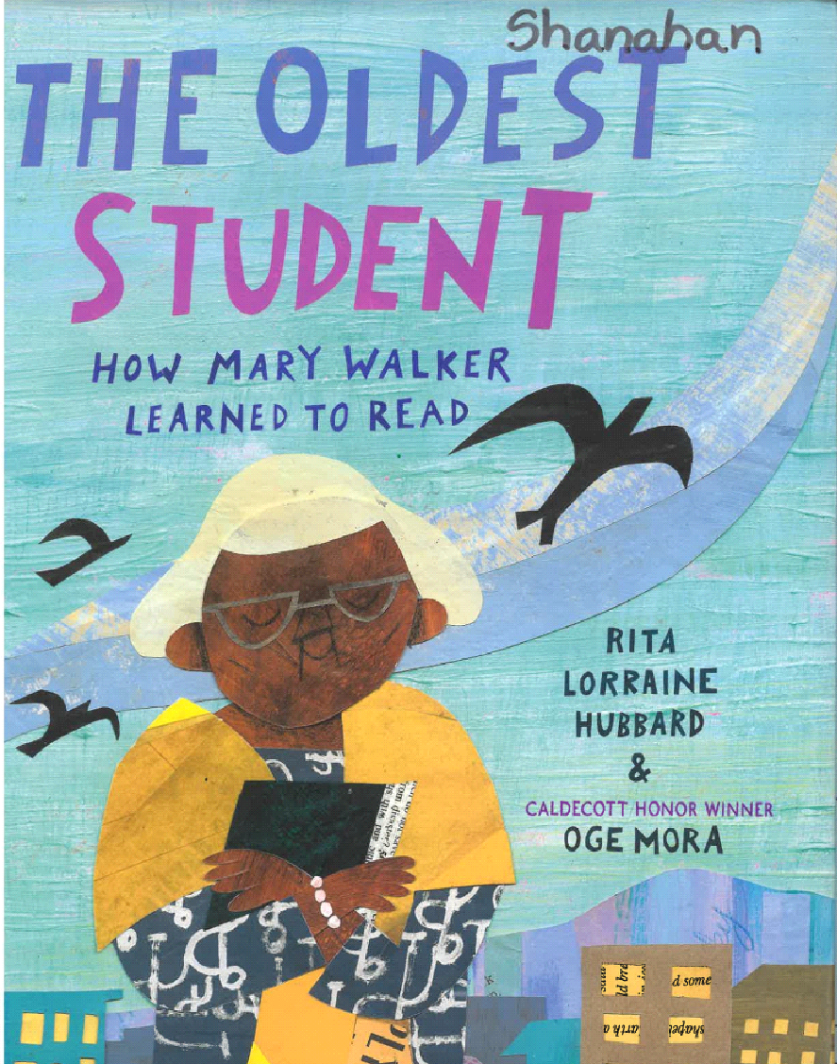
Response to Literature:
The Oldest Student: How Mary Walker Learned to Read by Rita Lorraine Hubbard

Teacher Explanation:
Students will write about a part of Mary’s life that made an impression on them.
Rubric:

Score | Skill: Response to Literature
1 | Student did not address the prompt.
2 | Student answered the prompt, but without details.
3 | Student answered the prompt and provided one reason to support their idea.
4 | Student answered the prompt and provided clear reasons to support their idea

Score | Skill: Conventions
1 | Student did not write recognizable letters/words.
2 | Student copied some letters/words, but they did not have meaning.
3 | Student wrote or copied letters/words with purpose and meaning. Some punctuation may be present (upper case letters, periods, spacing, etc.).
4 | Student wrote a combination of phonetic and conventionally spelled words. Punctuation may be present. Student can read their own writing and may even make revisions.

Score | Skill: Illustrations
1 | Illustration is not recognizable (ex. scribbling) and/or does not match words.
2 | Illustration is very simple without details (ex. use of one color to draw a single object) and/or has a weak connection to the words.
3 | Illustration is recognizable and includes details (ex. use of multiple colors and several objects) and is connected to the words.
4 | Illustration is easily recognized and includes details (ex. use of multiple colors, several related objects, may include some labels) and is clearly connected to the words.

TOTAL SCORE
out of 12 pts
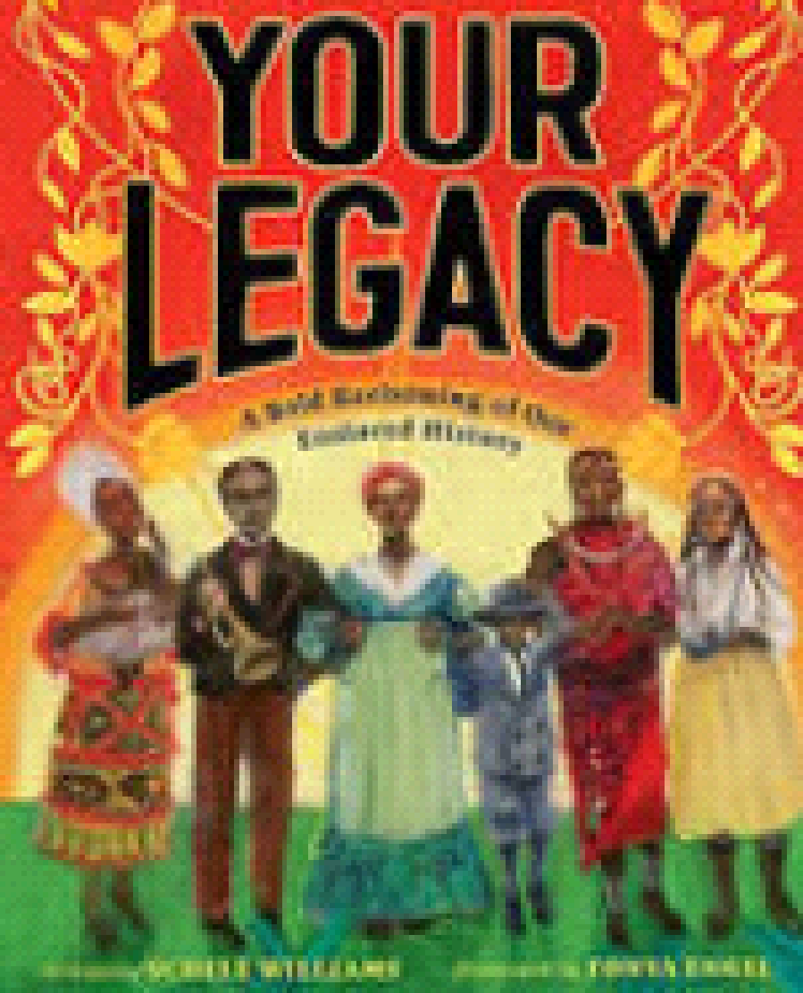
Response to Literature:
Your Legacy: A Bold Reclaiming of Our Enslaved History by Shele William
Teacher Explanation:
Students will choose one of the values in the book and write about why it is important.

Rubric:
Score | Skill: Response to Literature
1 | Student did not address the prompt.
2 | Student answered the prompt, but without details.
3 | Student answered the prompt and provided one reason to support their idea.
4 | Student answered the prompt and provided clear reasons to support their idea

Score | Skill: Conventions
1 | Student did not write recognizable letters/words.
2 | Student copied some letters/words, but they did not have meaning.
3 | Student wrote or copied letters/words with purpose and meaning. Some punctuation may be present (upper case letters, periods, spacing, etc.).
4 | Student wrote a combination of phonetic and conventionally spelled words. Punctuation may be present. Student can read their own writing and may even make revisions.

Score | Skill: Illustrations
1 | Illustration is not recognizable (ex. scribbling) and/or does not match words.
2 | Illustration is very simple without details (ex. use of one color to draw a single object) and/or has a weak connection to the words.
3 | Illustration is recognizable and includes details (ex. use of multiple colors and several objects) and is connected to the words.
4 | Illustration is easily recognized and includes details (ex. use of multiple colors, several related objects, may include some labels) and is clearly connected to the words.

TOTAL SCORE
out of 12 pts
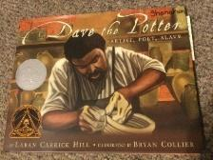
Response to Literature:
Dave the Potter: Artist, Poet, Slave by Laban Carrick Hill

Teacher Explanation:
Students will write about something interesting that they learned of Dave’s life.

Rubric:
Score | Skill: Response to Literature
1 | Student did not address the prompt.
2 | Student answered the prompt, but without details.
3 | Student answered the prompt and provided one reason to support their idea.
4 | Student answered the prompt and provided clear reasons to support their idea

Score | Skill: Conventions
1 | Student did not write recognizable letters/words.
2 | Student copied some letters/words, but they did not have meaning.
3 | Student wrote or copied letters/words with purpose and meaning. Some punctuation may be present (upper case letters, periods, spacing, etc.).
4 | Student wrote a combination of phonetic and conventionally spelled words. Punctuation may be present. Student can read their own writing and may even make revisions.

Score | Skill: Illustrations
1 | Illustration is not recognizable (ex. scribbling) and/or does not match words.
2 | Illustration is very simple without details (ex. use of one color to draw a single object) and/or has a weak connection to the words.
3 | Illustration is recognizable and includes details (ex. use of multiple colors and several objects) and is connected to the words.
4 | Illustration is easily recognized and includes details (ex. use of multiple colors, several related objects, may include some labels) and is clearly connected to the words.

TOTAL SCORE
out of 12 pts
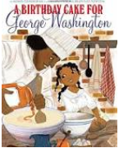
Response to Literature:
A Birthday Cake for George Washington by Ramon Ganeshram
Teacher Explanation:
Students will write about one thing they found interesting in the story.

Rubric:
Score | Skill: Response to Literature
1 | Student did not address the prompt.
2 | Student answered the prompt, but without details.
3 | Student answered the prompt and provided one reason to support their idea.
4 | Student answered the prompt and provided clear reasons to support their idea

Score | Skill: Conventions
1 | Student did not write recognizable letters/words.
2 | Student copied some letters/words, but they did not have meaning.
3 | Student wrote or copied letters/words with purpose and meaning. Some punctuation may be present (upper case letters, periods, spacing, etc.).
4 | Student wrote a combination of phonetic and conventionally spelled words. Punctuation may be present. Student can read their own writing and may even make revisions.

Score | Skill: Illustrations
1 | Illustration is not recognizable (ex. scribbling) and/or does not match words.
2 | Illustration is very simple without details (ex. use of one color to draw a single object) and/or has a weak connection to the words.
3 | Illustration is recognizable and includes details (ex. use of multiple colors and several objects) and is connected to the words.
4 | Illustration is easily recognized and includes details (ex. use of multiple colors, several related objects, may include some labels) and is clearly connected to the words.

TOTAL SCORE
out of 12 pts

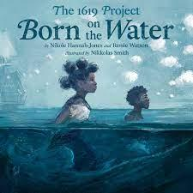
Response to Literature:
Born on the Water by Nikole Hannah-Jones and Renee Watson

Teacher Explanation:
Students will describe their first thoughts about the Ndongo people’s lives in Africa before they were born on the water.

Rubric:
Score | Skill: Response to Literature
1 | Student did not address the prompt.
2 | Student answered the prompt, but without details.
3 | Student answered the prompt and provided one reason to support their idea.
4 | Student answered the prompt and provided clear reasons to support their idea

Score | Skill: Conventions
1 | Student did not write recognizable letters/words.
2 | Student copied some letters/words, but they did not have meaning.
3 | Student wrote or copied letters/words with purpose and meaning. Some punctuation may be present (upper case letters, periods, spacing, etc.).
4 | Student wrote a combination of phonetic and conventionally spelled words. Punctuation may be present. Student can read their own writing and may even make revisions.

Score | Skill: Illustrations
1 | Illustration is not recognizable (ex. scribbling) and/or does not match words.
2 | Illustration is very simple without details (ex. use of one color to draw a single object) and/or has a weak connection to the words.
3 | Illustration is recognizable and includes details (ex. use of multiple colors and several objects) and is connected to the words.
4 | Illustration is easily recognized and includes details (ex. use of multiple colors, several related objects, may include some labels) and is clearly connected to the words.

TOTAL SCORE
out of 12 pts
Response to Literature:
Born on the Water by Nikole Hannah-Jones and Renee Watson
Teacher Explanation:
Students will write about something they learned about the people’s language, hands, or bodies.

Rubric:
Score | Skill: Response to Literature
1 | Student did not address the prompt.
2 | Student answered the prompt, but without details.
3 | Student answered the prompt and provided one reason to support their idea.
4 | Student answered the prompt and provided clear reasons to support their idea

Score | Skill: Conventions
1 | Student did not write recognizable letters/words.
2 | Student copied some letters/words, but they did not have meaning.
3 | Student wrote or copied letters/words with purpose and meaning. Some punctuation may be present (upper case letters, periods, spacing, etc.).
4 | Student wrote a combination of phonetic and conventionally spelled words. Punctuation may be present. Student can read their own writing and may even make revisions.

Score | Skill: Illustrations
1 | Illustration is not recognizable (ex. scribbling) and/or does not match words.
2 | Illustration is very simple without details (ex. use of one color to draw a single object) and/or has a weak connection to the words.
3 | Illustration is recognizable and includes details (ex. use of multiple colors and several objects) and is connected to the words.
4 | Illustration is easily recognized and includes details (ex. use of multiple colors, several related objects, may include some labels) and is clearly connected to the words.

TOTAL SCORE
out of 12 pts
Response to Literature:
Born on the Water by Nikole Hannah-Jones and Renee Watson
Teacher Explanation:
Students will write about the trip people made across the ocean.

Rubric:
Score | Skill: Response to Literature
1 | Student did not address the prompt.
2 | Student answered the prompt, but without details.
3 | Student answered the prompt and provided one reason to support their idea.
4 | Student answered the prompt and provided clear reasons to support their idea

Score | Skill: Conventions
1 | Student did not write recognizable letters/words.
2 | Student copied some letters/words, but they did not have meaning.
3 | Student wrote or copied letters/words with purpose and meaning. Some punctuation may be present (upper case letters, periods, spacing, etc.).
4 | Student wrote a combination of phonetic and conventionally spelled words. Punctuation may be present. Student can read their own writing and may even make revisions.

Score | Skill: Illustrations
1 | Illustration is not recognizable (ex. scribbling) and/or does not match words.
2 | Illustration is very simple without details (ex. use of one color to draw a single object) and/or has a weak connection to the words.
3 | Illustration is recognizable and includes details (ex. use of multiple colors and several objects) and is connected to the words.
4 | Illustration is easily recognized and includes details (ex. use of multiple colors, several related objects, may include some labels) and is clearly connected to the words.

TOTAL SCORE
out of 12 pts

Response to Literature:
Born on the Water by Nikole Hannah-Jones and Renee Watson
Teacher Explanation:
Students will write about the changes for the people born on the water.

Rubric:
Score | Skill: Response to Literature
1 | Student did not address the prompt.
2 | Student answered the prompt, but without details.
3 | Student answered the prompt and provided one reason to support their idea.
4 | Student answered the prompt and provided clear reasons to support their idea

Score | Skill: Conventions
1 | Student did not write recognizable letters/words.
2 | Student copied some letters/words, but they did not have meaning.
3 | Student wrote or copied letters/words with purpose and meaning. Some punctuation may be present (upper case letters, periods, spacing, etc.).
4 | Student wrote a combination of phonetic and conventionally spelled words. Punctuation may be present. Student can read their own writing and may even make revisions.

Score | Skill: Illustrations
1 | Illustration is not recognizable (ex. scribbling) and/or does not match words.
2 | Illustration is very simple without details (ex. use of one color to draw a single object) and/or has a weak connection to the words.
3 | Illustration is recognizable and includes details (ex. use of multiple colors and several objects) and is connected to the words.
4 | Illustration is easily recognized and includes details (ex. use of multiple colors, several related objects, may include some labels) and is clearly connected to the words.

TOTAL SCORE
out of 12 pts

Response to Literature:
Born on the Water by Nikole Hannah-Jones and Renee Watson
Teacher Explanation:
Students will write about the end of the story, including how the girl feels about her origin story.

Rubric:
Score | Skill: Response to Literature
1 | Student did not address the prompt.
2 | Student answered the prompt, but without details.
3 | Student answered the prompt and provided one reason to support their idea.
4 | Student answered the prompt and provided clear reasons to support their idea

Score | Skill: Conventions
1 | Student did not write recognizable letters/words.
2 | Student copied some letters/words, but they did not have meaning.
3 | Student wrote or copied letters/words with purpose and meaning. Some punctuation may be present (upper case letters, periods, spacing, etc.).
4 | Student wrote a combination of phonetic and conventionally spelled words. Punctuation may be present. Student can read their own writing and may even make revisions.

Score | Skill: Illustrations
1 | Illustration is not recognizable (ex. scribbling) and/or does not match words.
2 | Illustration is very simple without details (ex. use of one color to draw a single object) and/or has a weak connection to the words.
3 | Illustration is recognizable and includes details (ex. use of multiple colors and several objects) and is connected to the words.
4 | Illustration is easily recognized and includes details (ex. use of multiple colors, several related objects, may include some labels) and is clearly connected to the words.

TOTAL SCORE
out of 12 pts

