STORY CARD: Joseph Bradley Varnum,
ABOLISHING THE SLAVE TRADE
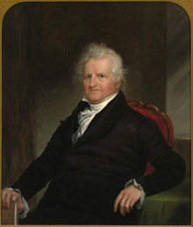

Joseph Bradley Varnum was an American lawmaker from Massachusetts. He worked in Washington, D.C. in the Congress and in the Senate, helping make laws for the new country.

Born on January 29, 1750, Joseph grew up in Dracut. His father was a farmer. When he was a child, Joseph became good friends with a child named Silas Royal, who was enslaved by the Varnum family. The Varnum family freed Silas. When they grew up, Silas and Joseph were soldiers together in the American Revolutionary War.

Mr. Varnum believed that slavery was wrong. He tried to think of a way to stop it. In 1805, he wrote a law to end the slave trade. President Thomas Jefferson signed it and made it a law on March 3, 1807. The law said that no one was allowed to go to Africa to kidnap and enslave people and bring them back to America. Sadly though, people who were already enslaved in America were not freed until almost sixty years later.

This resource was adapted from Joseph Bradley Varnum - Wikipedia

Although President Jefferson often said that slavery was wrong,he himself enslaved people on his farm, and he never freed them.

