Name ______________________________________________ Date _______________________
Character Traits Level 1
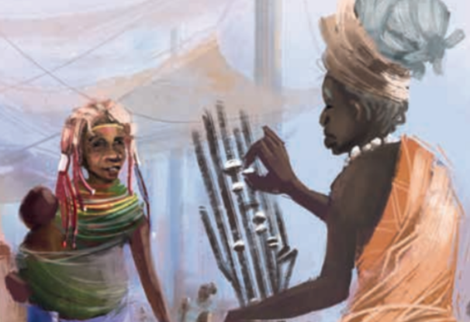
Character

Circle traits that describe your character
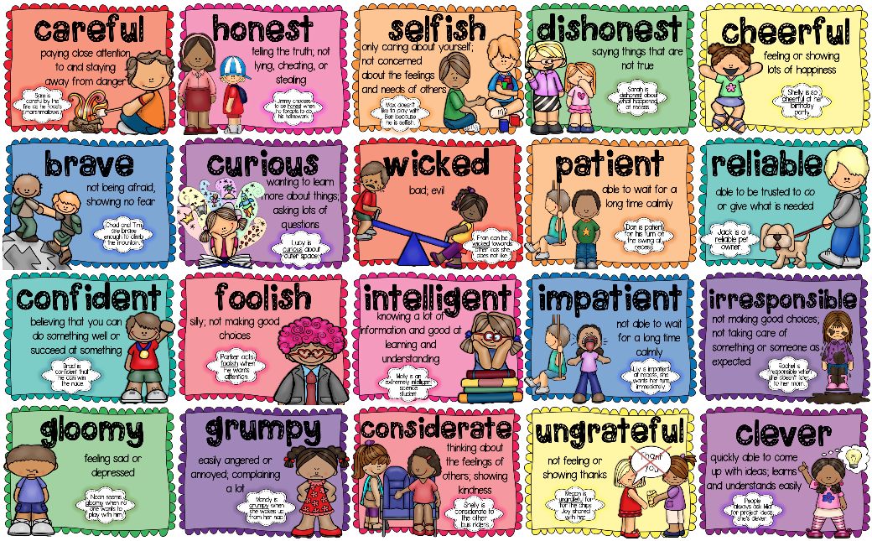

Name _______________________________________________ Date __________________________

Character Traits Level 2 and 3

Characters

Appearance (What do they look like?) | Personality (What kind of person are they?)  Caring Beautiful Happy  Rude Angry Wicked  Friendly Clever Kind  Grumpy Cruel Mean  Honest Gentle Brave  Helpful Brave Generous
What are they doing?

Name ______________________________________________ Date _______________________

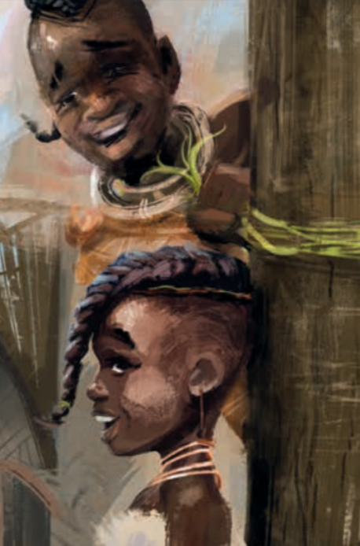
Character Traits Level 1
Character

Circle traits that describe your characters

Name _______________________________________________ Date __________________________

Character Traits Level 2 and 3
Characters

Appearance (What do they look like?) | Personality (What kind of person are they?)  Caring Beautiful Happy  Rude Angry Wicked  Friendly Clever Kind  Grumpy Cruel Mean  Honest Gentle Brave  Helpful Brave Generous
What are they doing?

