UNIT OVERVIEW

Unit Title | Analyzing our Past to Elevate our Future Through Perseverance
Unit Length | Ten lessons taught within a four-week period.
Grade Level(s)/Subject(s) | Social Studies for 2nd and 3rd grades.
Unit Overview | The unit focuses on students’ understanding of the experiences of the Ndonga people, the challenges they faced as a result of the transatlantic slave trade, and how they persevered. In this unit, students will also read a variety of literature in order to analyze the theme of encountering challenges and identifying the different ways characters persevere and overcome.  The main educational resource used in this unit is the book Born on the Water by Nicole Hannah-Jones. The unit is supplemented by three other biographies:Ron’s Big Mission by Rose Blue, Show Way by Jacqueline Woodson, and The Youngest Marcher by Cynthia Levinson. Through engagement with these texts, students will develop reading fluency and comprehension while gaining a better understanding of history through rich and thought provoking literature.  By the end of the unit, students select a character from one of the books explored in the unit and write a personal narrative inspired by that text. The personal narrative will describe the challenge or struggle faced by the character, and describe why the character is facing the challenge, including the systemic racism in place that led to the character’s problem. In the conclusion, students will show their understanding of how the character overcame the challenge and how they were able to persevere.
Objectives & Outcomes | By the end of this unit, the students will be able to…  - Ask and answer questions (who, what, where, when, and why and how) to demonstrate understanding of the key details in a story.  - Describe how characters in a story respond to major events and challenges.  - Determine the lesson, theme, and message learned from the story, and describe how this lesson will help them in their own lives when they are facing challenges.  - Explain the author’s purpose for writing a story and determine if the author is describing, explaining, or answering a question when reading the assigned excerpts.
Standards | Common Core Standards:  RL.2.1 -Ask and answer such questions as who, what, where, when, why, and how to demonstrate understanding of key details in a text.  RI. 2.2-Identify the main topic of a multi-paragraph text as well as the focus of the specific paragraphs within the text.  RL2.3 Describe how a main character responds to major events and challenges.  RI. 2.4-Determine the meaning of words and phrases in a text relevant to a grade 2 topic or subject idea.  RI.2.5-Know and use various text features (e.g., captions, bold print, subheadings, glossaries, indexes, electronic minus, icons) to locate key facts or information in a text efficiently.  RL.2.6-Identify the main purpose of a text, including what the author wants to answer, explain, or describe.  RL.2.9-Compare and contrast the most important points presented by two texts on the same topic.  RF.2.4-Read with sufficient accuracy and fluency to support comprehension.  RI.3.7-Use information gained from illustration (e.g., maps, photographs) and the words in a text to demonstrate understanding in the text (e.g., where, when, why, and how key events occur).  W2.3-Write narratives in which they recount a well-elaborated event or short sequence of events, include details to describe actions, thoughts, and feelings, use temporal words to signal event order, and provide a sense of closure.  SL2.3-Ask and answer questions about what a speaker says in order to clarify comprehension, gather additional information, or deepen understanding of s topic or issue.  W3.1-Write opinion pieces on topics or texts, supporting a point of view with reasons.  W.3.3-Write narratives to develop real or imagined experiences or events using effective technique, descriptive details, or clear event sequence.  W.3.8-Recall information from experiences or gather information from print and digital sources; take brief notes on source and sort evidence into provided categories.  RH.6-8.2-Determine the central ideas or information of a primary or secondary source; provide an accurate summary of the source distinct from prior knowledge or opinions.  R.2 Key Ideas and Details: Determine central ideas or themes of a text and analyze their development; summarize the key supporting details and ideas.
Facilitation Resources | Texts from The 1619 Project  This unit contains some texts available exclusively in Born on the Water by Nikole Hannah-Jones and Renee Watson. Learn more about this book and how to access them/it here.  Additional Texts and videos  PBS KIDS Talk About: Perseverance | PBS KIDS  PERSEVERE - Best Motivational Video from Ben Lionel Entertainment  Ron’s Big Mission by Rose Blue  Show Way by Jacqueline Woodson  The Youngest Marcher by Cynthia Levinson  Teaching Materials  Challenges Activity 1 [.pdf].docx]  Born on the Water Timeline Activity 2 [.pdf][.docx]  Asking Questions 3 Activity: Who, What, When, Where, and Why question frame graphic organizer [.pdf][.docx]  Student copies of world map  Exit ticket 4 for the daily reading [.pdf][.docx]  Exit Ticket 6: Perspective Taking [.pdf][.docx]  Identifying Author’s Purpose Activity 7: 3 column graphic organizer [.pdf].docx]  Identifying Theme Activity 10 [.pdf][.docx]  Identifying Challenges Activity 11 [.pdf][.docx]  Venn diagram graphic organizer 12 [.pdf][.docx]  Identifying challenges activity 13 [.pdf][.docx]  Opinion Writing Activity 14 [.pdf][.docx]  Formal Assessment 15 [.pdf][.docx]  Perseverance Activity 16 [.pdf][.docx]  Perseverance Activity 17 [.pdf][.docx]  Perseverance Activity Identification Exit Ticket 18 [.pdf].docx]  Perseverance Activity Identification Exit Ticket 19 [.pdf][.docx]  Perseverance Activity Identification Exit Ticket 20 and 21 [.pdf][.docx]  Perseverance Identification Activity 22 [.pdf][.docx]  Discussion Activity 23 [.pdf][.docx]  Author’s Purpose Analysis Activity 24 [.pdf][.docx]  Poem Interpretation Activity 25 [.pdf][.docx]  Poem Interpretation Activity 26 [.pdf][.docx]  Poem Interpretation Activity 27 [.pdf][.docx]  Rubric for evaluating writing assessments [.pdf][.docx]  Transition word graphic organizer  Performance task writing checklist  Sentence frames for performance task
Performance Task | Students will select a character from one of the books explored in the unit and write a personal narrative inspired by that text. The personal narrative will describe the challenge or struggle faced by the character, and describe why the character is facing the challenge, including the systemic racism in place that led to the character’s problem. In the conclusion, students will show their understanding of how the character overcame the challenge and how they were able to persevere.  For example, in Born on the Water by Nikole Hannah-Jones and Renee Watson the author addresses how the challenges of kidnapping, brutal enslavement, and the lasting impacts of enslavement would at times be navigated through many different types of perseverance. The theme of identifying how the character responded in order to persevere will be the focus of students’ writing.
Assessment/  Evaluation | The personal narrative will be the summative assessment performance task for this unit.  A rubric will be used to grade the formative assessment performance task (narrative writing.  Rubric for evaluating writing assessments [.pdf][.docx]

UNIT PACING/DAILY LESSONS

Pacing | Focus text(s) / resource(s) for today’s lesson | Lesson Objective(s) or Essential Question(s) | Lesson / Activities | Lesson Materials
Week 1
Students explore the definition of the word, “challenge,” and analyze the challenges faced by the characters in Born on the Water through guided reading and reflection.
Week 1 Day 1 | Born on the Water by Nikole Hannah-Jones and Renee Watson | Essential Question(s)  How do people persevere when faced with challenges?  Learning Objectives  RL.2.1 -Ask and answer such questions as who, what, where, when, why, and how to demonstrate understanding of key details in a text.  RI. 2.2-Identify the main topic of a multi-paragraph text as well as the focus of the specific paragraphs within the text.  RL:2.3 I can describe how a main character responds to major events and challenges.  RI. 2.4-Determine the meaning of words and phrases in a text relevant to a grade 2 topic or subject idea.  W2.3-Write narratives in which they recount a well-elaborated event or short sequence of events, include details to describe actions, thoughts, and feelings, use temporal words to signal event order, and provide a sense of closure.  W.3.8-Recall information from experiences or gather information from print and digital sources; take brief notes on source and sort evidence into provided categories. | Day 1  (I do)  The teacher will define the meaning of a challenge and tell students they will read about many challenges the Ndongo people faced as they were being enslaved.  Teacher will define the word “slavery” on an anchor chart.  Teacher will engage students in a picture book walk of Born on the Water.  (You Do)  The teacher will have the students brainstorm and draw a challenge they have faced or a challenge they know someone else has faced. | Born on the Water by Nikole Hannah-Jones and Renee Watson  T-chart graphic  Organizer  Chart paper  Drawing paper  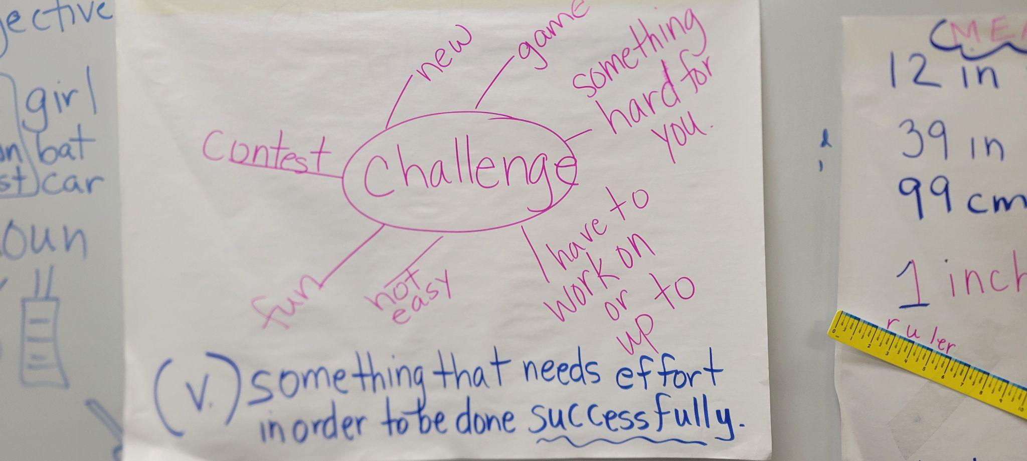  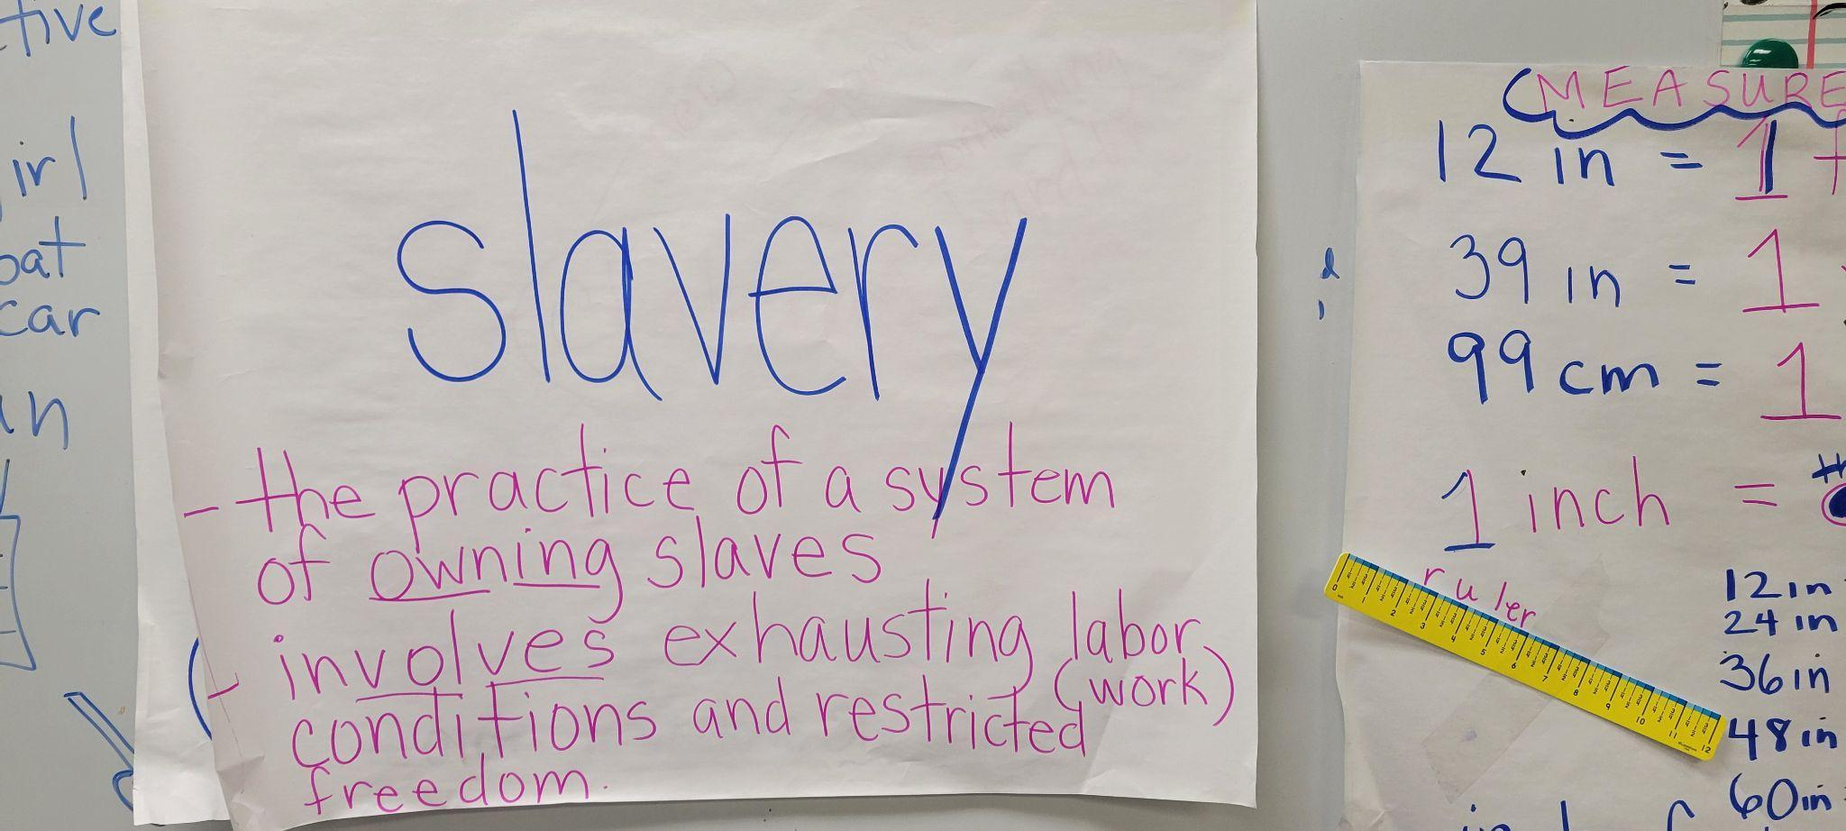
Week 1 Days 2-4 | Born on the Water by Nikole Hannah-Jones and Renee Watson | SL2.3-Ask and answer questions about what a speaker says in order to clarify comprehension, gather additional information, or deepen understanding of s topic or issue. | Day 2  (I do)  The teacher will prepare students before they read Born on the Water and share with them that they will read about challenges the Ndongo faced from meeting the Portuguese.  Teacher will begin to read the story, Born on the Water and identify two of the challenges the grandma shares with her granddaughter in the story.  Identifying Challenges Activity 1  (We do) Timeline Activity 2  Teacher will have students begin writing in sequence on chart paper the challenges the Ndongo people begin facing such as being taken from their life as they know it:  - Walking 200 miles with shackles on  - Being packed into The White Lion with other people who had been kidnapped from other villages  - Being separated from families and sold when they get to Virginia  - Being forced to plant tobacco and facing brutal treatment  - Longing for their family and their land.  (You do)  Asking Questions Activity 3  Teacher will have students write two wonders about the story they will begin reading using the Who, What, When, Where, and Why question format.  Day 3  (I do)  Teacher will continue to read and describe more of the challenges the grandmother shared about the Ndongo people experiences after being taken and add additional challenges to the class sequencing chart.  (We do)  Teacher will give students a world map. Students will draw a line from Africa and trace the line of travel from Africa to Virginia.  (You Do)Exit Ticket:Description of Voyage Activity 5  Teacher will give students an exit ticket in which students will write or draw a description of today’s reading that they would like to share their opinion about, or write a “wondering” in question format about the travel of the Ndongo people on the White Lion to Virginia.  Day 4  (I do)  Teacher will continue to read the story, Born on the Water, making specific stops to continue to share challenges the Indongo people experienced once they arrived in Virginia.  (You Do)Exit Slip  Perspective Writing Activity 6  Students will write from the perspective of an enslaved person who arrived in Virginia about the sounds, sights, tastes, and feelings they might have had when they first arrived on land. They should reference language from Born on the Water in their writing.  In an exit slip, students will use the text from Born on the Water to explain one of the senses which should include one detail from the book. | Born on the Water by Nikole Hannah-Jones and Renee Watson  Challenge anchor chart  Challenges Activity 1 [.pdf].docx]  Timeline Activity 2 [.pdf][.docx]  Asking Questions 3 Activity: Who, What, When, Where, and Why question frame graphic organizer [.pdf][.docx]  Student copies of world map  Exit ticket for the daily reading [.pdf][.docx]  Exit Ticket 6: Perspective Taking [.pdf][.docx]
Week 1 Day 5 |  | Same as above | (I do)  Teacher will complete the reading of the story, Born on the Water.  (We do)  Students will add to the graphic organizer identifying other challenges grandmother shares with her granddaughter that the Indongo people faced.  (You do)Perspective Writing Activity 6 Continued  Students will continue the perspective writing of an enslaved person arriving in Virginia and what are the sounds, sights, and how they felt when they first arrived on Virginian land.

Pacing | Focus text(s) / resource(s) for today’s lesson | Lesson Objective(s) or Essential Question(s) | Lesson / Activities | Lesson Materials
Week 2
Students explore the word, “perseverance” and analyze examples of perseverance in the face of challenges in four texts
Week 2 Day 1 | Born on the Water by Nikole Hannah-Jones and Renee Watson  PBS KIDS Talk About: Perseverance | PBS KIDS | Essential Question(s)  How do people persevere when faced with challenges?  Learning Objectives-  RI.2.5-Know and use various text features (e.g., captions, bold print, subheadings, glossaries, indexes, electronic minus, icons) to locate key facts or information in a text efficiently.  RL.2.6-Identify the main purpose of a text, including what the author wants to answer, explain, or describe.  RL.2.9-Compare and contrast the most important points presented by two texts on the same topic.  RF.2.4-Read with sufficient accuracy and fluency to support comprehension.  RL.2.9-Compare and contrast the most important points presented by two texts on the same topic.  W3.1-Write opinion pieces on topics or texts, supporting a point of view with reasons.  RH.6-8.2-  Determine the central ideas or information of a primary or secondary source; provide an accurate summary of the source distinct from prior knowledge or opinions.  R.2 Key Ideas and Details: Determine central ideas or themes of a text and analyze their development; summarize the key supporting details and ideas.  R.2 Key Ideas and Details: Determine central ideas or themes of a text and analyze their development; summarize the key supporting details and ideas. | (I do)  Teacher will explain the meaning of perseverance and the different ways that perseverance will be reflected in the story.  The teacher will also emphasize that not all challenges or problems can be overcome with perseverance.  The teacher will model and describe challenges, and how a person can overcome and persevere in order to provide students an example of perseverance.  (We do)  Identifying Author’s Purpose Activity 7  The teacher will share the poem, Stolen in Born On the Water and have students work in groups of 3 to identify a challenge in the 2nd column, and then identify how the Ndongo people who were kidnapped responded and persevered in the 3rd column. Students will identify the author’s purpose for this section in the text. The author’s purposes students can identify from are to describe, answer, and explain.  (You do)  Teachers will have students view the PBS video and write in sentences the message in the video. | Born on the Water by Nikole Hannah-Jones and Renee Watson  Identifying Author’s Purpose Activity 7: 3 column graphic organizer [.pdf].docx]
Week 2 Days 2-4 | YouTube Video 1  PERSEVERE - Best Motivational Video from Ben Lionel Entertainment  Ron’s Big Mission by Rose Blue  Show Way by Jacqueline Woodson  The Youngest Marcher by Cynthia Levinson | Same as above | (I do )  Teacher will share Youtube video 1 with the class.  (We do)  The teacher will have students read the story, Ron’s Big Mission, within their guided reading group. Students will discuss what they think the theme of the story is based on as they identify Ron’s actions.  (You do)Theme Identification Activity 10  The teacher will have students respond to today’s reading, Ron’s Big Mission by identifying the theme of the story. They will first select one of the themes from the 2 given. Then they will begin with the sentence frame, People should or People shouldn’t…  Day 3  (I do)  Teacher will read Show Way to students.  (We do)  Identifying Challenges Activity 11  The teacher will ask students to select Mathis May or Soonie and identify one of their challenges and how they responded and persevered in Show Way with a partner after reading the story in guided reading groups.  (You do)  Venn Diagram Activity 12  Teacher will ask students to compare one of the challenges in Show Way to challenges in Born on the Water on a Venn diagram.  Day 4  (I do)  Teacher will read,  The Youngest Marcher aloud to the students.  (We do)Youngest Marcher Identifying Challenges Activity 13  The teacher will have students identify the challenge Audrey faced in the story with provided sentence frames.  (You do)Opinion Writing Activity 14  The teacher will have students write their opinion about perseverance by the character Audrey. Sentence starters will be provided. | Identifying Theme Activity 10 [.pdf][.docx]  Identifying Challenges Activity 11 [.pdf][.docx]  Venn diagram graphic organizer 12 [.pdf][.docx]  Identifying challenges activity 13 [.pdf][.docx]  Opinion Writing Activity 14 [.pdf][.docx]
Week 2  Day 5 | Born on the Water by Nikole Hannah-Jones and Renee Watson | (Unit’s Formative Assessment)  I can write narratives in which recount a well elaborated event, including details, actions, thoughts, and feelings.  I can ask and answer questions about what a speaker says in order to clarify comprehension, gather information, or deepen understanding of a topic or issue. | (I do)  Teacher will model how to ask a question based on a question they have after reading the poem, The White Lion in Born on the Water in order to provide direction for the class forum task following this activity.  (We do and You do)  Formal Assessment  Activity 15  Teacher will have students write 2 questions to share in an open forum that will be answered among classmates based on their opinions, interpretations, and learning which will have to be supported by textual evidence. | Formal Assessment 15 [.pdf][.docx]

Week 3
Students reread Born on the Water and analyze evidence of perseverance in the face of challenges by citing text from each poem in the story.
Week 3 Day 1 | Born on the Water by Nikole Hannah-Jones and Renee Watson | Essential Question(s)  How do people persevere when faced with challenges?  Learning Objectives-  RL:2.3 I can describe how a main character responds to major events and challenges.  RI. 2.4-Determine the meaning of words and phrases in a text relevant to a grade 2 topic or subject idea.  W.3.8-Recall information from experiences or gather information from print and digital sources; take brief notes on source and sort evidence into provided categories.  RL.2.9-Compare and contrast the most important points presented by two texts on the same topic. | Day 1  (I do)  Teacher will review the meaning of perseverance and have students reread parts of the story, Born on the Water, to identify how the Ndongo people in the story responded to challenges and how they persevered.  (We d0)  The teacher will share ways people can respond to challenges and persevere and engage students in a discussion.  (You Do)Perseverance Identification Activity 16  The teacher will have the students read. The text from Born on the Water,  “But those who did not die, resolved to live no matter what.”  The teacher will have students highlight the words in the text that show perseverance. | Born on the Water by Nikole Hannah-Jones and Renee Watson  Perseverance Activity 16 [.pdf][.docx]  Highlighters  Markers  T-chart graphic organizer  Anchor chart poster paper
Week 3  Days 2-4 | Born on the Water by Nikole Hannah-Jones and Renee Watson |  | Day 2  (I do)  Teacher will display the poem from Born on the Water, “How to Make a Home” for students. Teacher will highlight the words that show perseverance in the text, “We are in a strange land, they said. But we are here and we will make this home.”  (We do)Perseverance Activity 17  Teacher will have students work in pairs and identify by highlighting the perseverance in the text, “We have our songs, our recipes, our know-how. We have our joy. We will love, laugh, sing, and hug our children as tight as you can hold a child.”  (You do)Perseverance Identification Activity 18  Teacher will have students independently complete the exit ticket and highlight the words that show perseverance in the following text, “We survive because we have each other.”  Students will also write their interpretation of those words.  Day 3  (I do) Teacher will read the poem, Legacy aloud.  (We do)Exit Ticket Perseverance Activity 19  Teacher will share the poem, Legacy with students and have groups of three read Legacy and identify how the people in the story showed perseverance in the face of the challenges of enslavement. Students will be given sentence frames.  (You Do) Perseverance Identification Activity 20  Teacher will read the poem, Song. Students will then be given a t-chart graphic organizer to identify one example of a challenge and explain how the people persevered.  Day 4  (I do)  Teacher will reread poems, Questions and What Grandma Tells Me, and They Had a Language. Their Hands Had a Knowing  (We do/You do)Perseverance Identification Activity 21  Teacher will share the words “Let me tell you where we are from'' and “Before they were enslaved they were free.” In different color markers, students will write words interpreting what these two sentences would mean to the granddaughter and why. | Perseverance Activity 17 [.pdf][.docx]  Perseverance Activity Identification Exit Ticket 18 [.pdf].docx]  Perseverance Activity Identification Exit Ticket 19 [.pdf][.docx]  Perseverance Activity Identification Exit Ticket 20 and 21 [.pdf][.docx]  Highlighters  2 large pieces of chart paper  Multiple packs of markers  Discussion frames
Week 3 Day 5 | Born on the Water by Nikole Hannah-Jones and Renee Watson | Essential Question-  How do people persevere when faced with challenges? | (I do)  Teacher will reread the poem, Pride aloud to the students.  (You do)Perseverance Identification Activity 22  The teacher will have students highlight the words from the poem, Pride that are connected to the title, Pride. | Perseverance Identification Activity 22 [.pdf][.docx]

Week 4
Summary of Lesson Themes
Week 4  Day 1 | Born on the Water by Nikole Hannah-Jones and Renee Watson | Learning Objectives-  RF.2.4-Read with sufficient accuracy and fluency to support comprehension.  RL.2.6-Identify the main purpose of a text, including what the author wants to answer, explain, or describe.  SL2.3-Ask and answer questions about what a speaker says in order to clarify comprehension, gather additional information, or deepen understanding of s topic or issue.  W2.3-Write narratives in which they recount a well-elaborated event or short sequence of events, include details to describe actions, thoughts, and feelings, use temporal words to signal event order, and provide a sense of closure.  W3.1-Write opinion pieces on topics or texts, supporting a point of view with reasons. | Day 1  (I do)  Teacher will read the William Tucker poem from Born on the Water ,  to students.  (We d0)Discussion Activity 23  The teacher will have groups of 4 identify the challenge faced, and perseverance the Tuckers demonstrated under the conditions of slavery, in a discussion using the discussion frames provided.  (You Do)  Author’s Purpose Activity 24  The teacher will have students complete an exit ticket about why the author wrote the words “The first truly American child” in the excerpt explored, and what the author wants the reader to know by using this text. Students will identify the author’s purpose by circling the type in the author’s purpose identification bank. | Born on the Water by Nikole Hannah-Jones and Renee Watson  Discussion Activity 23 [.pdf][.docx]  Author’s Purpose Analysis Activity 24 [.pdf][.docx]
Week 4  Days 2-4 | Born on the Water by Nikole Hannah-Jones and Renee Watson  The Youngest Marcher by Cynthia Levinson | Same as above | Day 2  (I do)  Teacher will define the word resistance. Teacher will give a few examples of how the people of Ndongo resisted.  (We do)  Teacher will have pairs of students identify other forms of resistance in Born on the Water.  (You do)Poem Interpretation Activity 25  The teacher will have students write what the author might mean by the sentence “Hope had a name. Hope is a child born.”  Day 3  (I do)  Teacher will have students read the poem, Pride.  (We do)Poem Interpretation Activity 26  Teacher will have students in groups of 4 discuss the sentence, “Why we believe we are our ancestors' wildest dreams.” The leader of the group of students will share what their group came up with. Group will be given discussion frames.  (You do)Poem Interpretation Activity 27  Teacher will have students write how Audrey would make her ancestors proud with the actions she took in the book The Youngest Marcher.  Day 4  (I do)  Teacher will read the poem titled Pride from Born on the Water to the students to prepare students for discussion and poem interpretation.  (We do)  Teacher will have students discuss the sentence, “We are their hope.” Teacher will provide discussion frames.  (You do)Poem Interpretation Activity 28  Teacher will ask students to write their reflection of the sentence, “  “Never forget you came from a people of great strength.”  Teacher will also give the option to students to write their interpretation of the sentence,  “And I am not ashamed. I know what my story is,where I am from, where I begin… | Poem Interpretation Activity 25 [.pdf][.docx]  Poem Interpretation Activity 26 [.pdf][.docx]  Poem Interpretation Activity 27 [.pdf][.docx]
Week  4  Day 5 | Born on the Water by Nikole Hannah-Jones and Renee Watson | Same as above | (I do)  Teacher will share the writing rubric for the assessment. The assessment involves a personal narrative writing from the perspective of a character from a text explored in the unit that needs to include a challenge the character faced, and how they preserved through those difficulties.  The teacher will share sentence frames and a graphic organizer with sequential steps that will aid in the writing process for students.  Performance Task  (You do)  Teacher will pass out narrative writing assignments. Students will select a character of their choice from one of the stories read throughout the unit.  Students will be given a checklist for guidance and support the tasks expectations.  Sentence frames and transition word graphic organizers can be accessed during the assessment time to help students write the narrative details in sequential order.  Directions: You will select a character from one of the stories read in this four-week unit.  You will write and introduce your character. In the middle of your writing, you will describe the character’s problem or the challenge they are faced with as a result of the systemic racism described in their story. The conclusion should include the character’s response to the challenge, the way the character perseveres,and the pride, feelings, or effects that resulted from their act of perseverance. | Rubric for evaluating writing assessments [.pdf][.docx]  Transition word graphic organizer  Performance task writing checklist  Sentence frames for performance task

