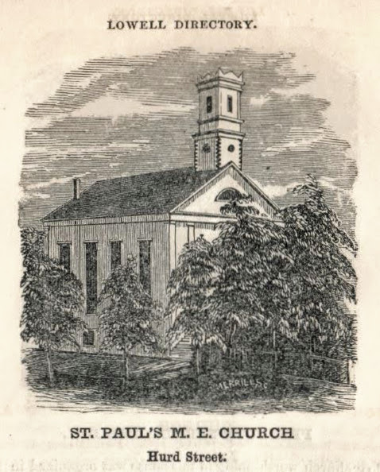
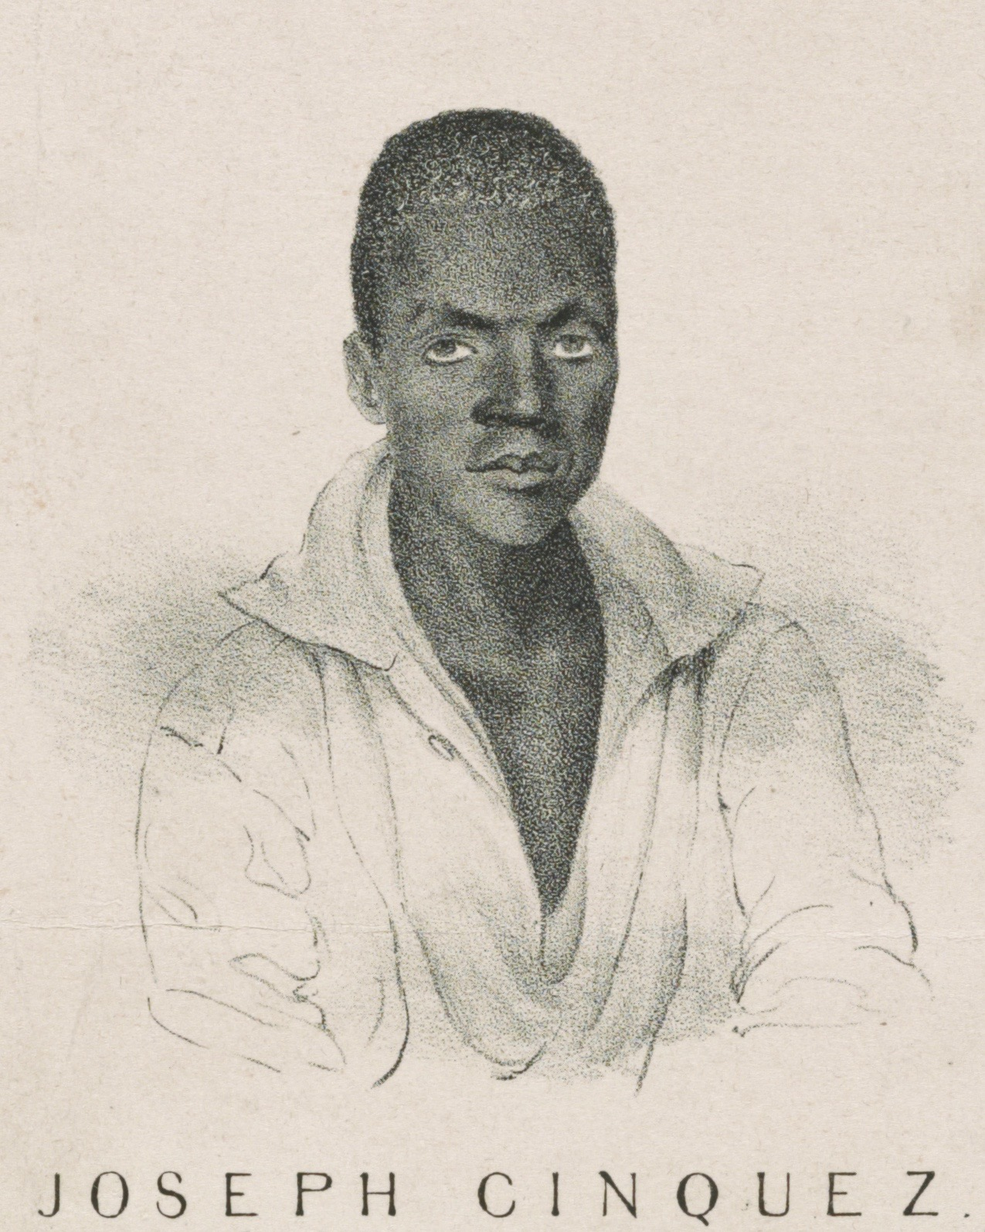
STORY CARD: Amistad

In 1839, a Spanish schooner carrying fifty-three people was sailing in the waters near Cuba. The ship was named “Amistad”. Amistad is the Spanish word for “Friendship.” The Amistad was a slave ship. The people onboard were from the Mende tribe in West Africa, and they had been kidnapped in Africa to be sold as slaves in North America. One night, they rose up against their captors and took over. They tried to force the crew to take them back to Africa, but the crew went north instead and landed in Long Island, New York. The enslaved men were captured, arrested, and put on trial for mutiny and piracy.
Many abolitionists were angry that the Africans had been kidnapped from their homes and then arrested when they tried to escape. Abolitionists raised money for the “Amistad Africans” to defend themselves in court. The case went all the way to the United States Supreme Court. Their lawyer was former President of the United States John Quincy Adams. The Supreme Court ruled that the Africans had been illegally kidnapped in Africa and were now free. The Amistad Africans then traveled throughout New England raising money to return to Africa. They visited Lowell, and were given money and a tour of the mills. Joseph Cinque made a speech at St. Paul’s Church. They visited the Boot Mills and a carpet factory in Lowell. The carpet factory agent gave Mr. Cinque a beautiful rug to take back home to their families in West Africa.
Excerpt: from “Visit to the United States in 1841” by Joseph Sturge
“On Monday we proceeded to Haverhill… After a stay of two hours, we proceeded to Lowell. The heavy rain prevented a general attendance. Only thirty-one dollars was collected, beside some private donations. Mr. John Levi (ed: Levy), a colored citizen, rendered important services to us, and several of the clergymen and other inhabitants rendered efficient aid.
On Tuesday we went to Nashua, N.H., and remained two hours… In the evening at Lowell, the large Methodist Church, St. Paul's, was crowded, one thousand five hundred people being present, it was said, and many hundreds unable to get admission. (ed: 1840 Lowell’s Population was 22,000). The meeting was opened with an appropriate prayer by Rev. Luther Lee. In order to give an opportunity to the audience to see and hear Cinque, he was invited into the pulpit, where he made an energetic address. One hundred and six dollars were collected.
At the close of the services, nearly the whole congregation came forward and took the Mendians by the hand, with kind words and many presents. The ministers of all denominations attended the meeting, with many of the most respectable citizens.
During the day the Africans were invited to visit the 'Boott Corporation,’ and were conducted over the whole establishment (cotton mills,) by the agent, Mr. French. As might be supposed, they were astonished beyond measure. After inspecting the machinery, the fabrics, and the great wheel, one of them turned to me and said, 'Did man make this?' On receiving a reply, he said, 'He no live now--he live a great while ago.'
Afterwards they visited the carpet factory and expressed great delight at the beauty and excellence of the carpets and rugs. Cinque wished to purchase a miniature hearth rug, but the agent (ed: Royal Southwick) allowed him to select one of the large and beautiful rugs to take to Mendi, which he generously presented to him. The workmen here--chiefly Englishmen--made a collection of fifty-eight dollars and fifty cents on the spot and presented it to the Mendi Fund.”
Sources: Adapted from Untold Lowell Stories: Black History UMass Lowell University Library Center for Lowell History.

Sources: UMass Lowell University Library Center for Lowell History.

