Belonging and Memory in Athens, Georgia: Project Overview
Joy Village School Fall 2022

“Many folks have no sense of place” - bell hooks

Do I belong here? This is a question that every human asks. Over the next two weeks, we will explore what it means to belong, and how Black folks have experienced belonging in Athens, a city that so often excluded us. Along the way, we will become photographers, interviewers, journalists, and historians as we try to answer our essential question:

What conditions create a sense of belonging in Black Athenians?

Backstory: “The 1619 Project”
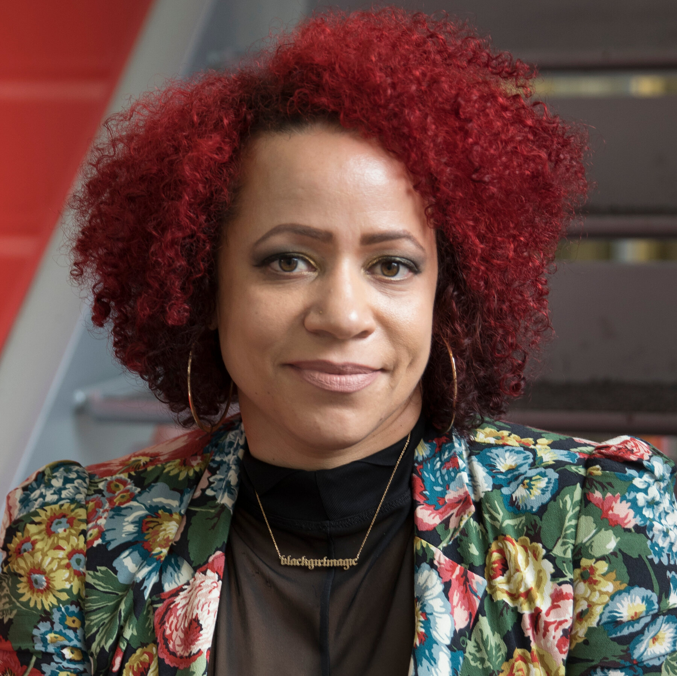
Last year, the Joy Village School was chosen to be part of The 1619 Project Education Network. The 1619 Project is a groundbreaking journalistic collection of essays and photos that tell the story of the experience of Black folks in America since the arrival of our enslaved ancestors to this land in the year 1619. The project was developed by Nikole Hannah-Jones, who was awarded a Pulitzer Prize in 2020 for her work. Though it has received critical acclaim, The 1619 Project has also been viewed as a radical and dangerous text by some.

Questions for thought:
- Why is “The 1619 Project” such an impactful resource?
- Why is “The 1619 Project” often seen as a threat?

Educators all around the country are now using “The 1619 Project” to teach their students the truth about the oppression Black Americans have experienced and continue to experience as a result of slavery. That’s what we are going to do too! We will read an article from “The 1619 Project” to help us think about the Black experience in Athens, Georgia and whether or not Black people feel like they belong here.

Project Overview

Phase 1: Information Gathering

In the first part of the project, we will gather information from primary and secondary sources that will help us answer our essential question in the following ways:

- Read Article (secondary source): We will begin by reading an article from “The 1619 Project”to begin to understand how wealth-stripping and displacement of Black folks are foundational to the American story.
- Photo Essays (primary source): We will take a driving tour of Athens’ historic Black neighborhoods to take photos of scenes of belonging and scenes of displacement.
- Interviews (primary source): We will interview native Black Athenians to find out about their sense of belonging in Athens over the years.

Phase 2: Analysis, Synthesis, and Essay Writing

- Analysis: We will analyze all the data we collected from the article, the photos, and the interviews to see what they have to tell us about our essential question.
- Synthesis: We will take a stance and formulate an answer to the essential question.
- Essay Drafting: We will draft a first draft of a five paragraph essay to express our answer to the essential question.
- Essay Review: We will practice reviewing each others first drafts and providing helpful feedback.
- Essay Editing & Publishing: We will edit our essays to help them answer our essential question and then publish our work to share with the world.

