Historical Terms and themes | Meaning | Symbol
1619 |  | 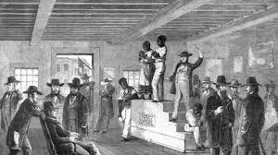
Mayflower |  | 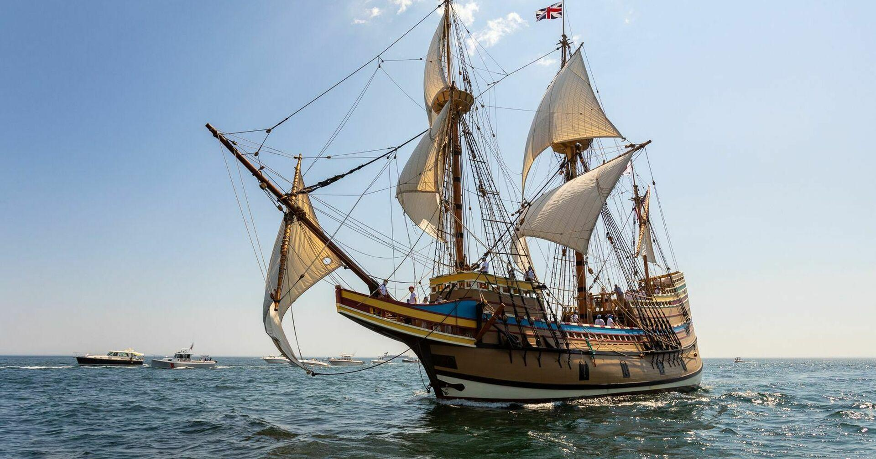
Kingdom of Ndongo |  | 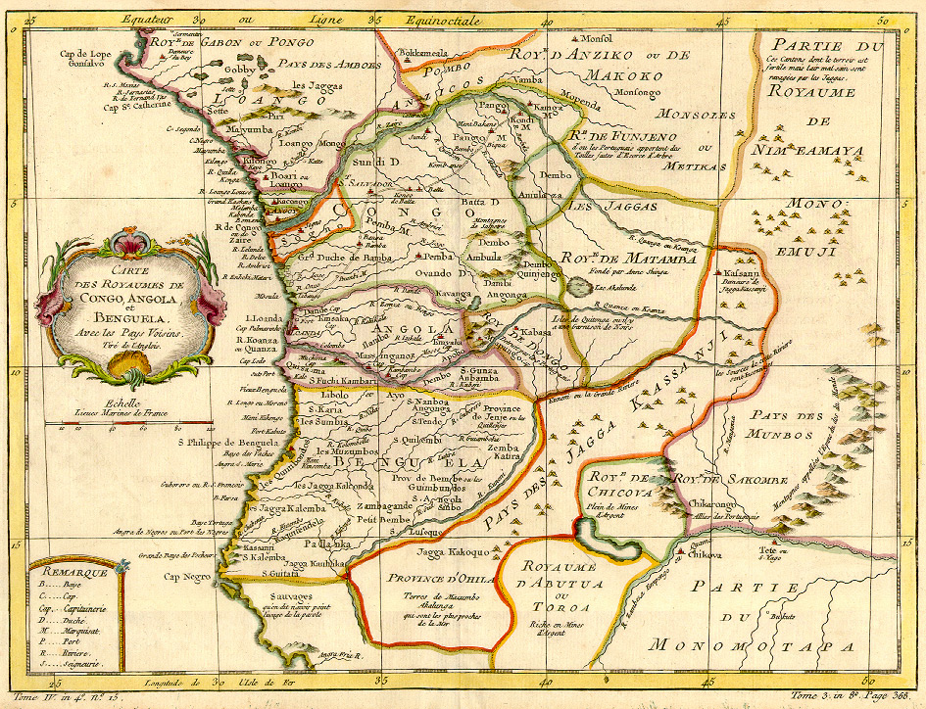
Black People have been victimized but are not victims |  | 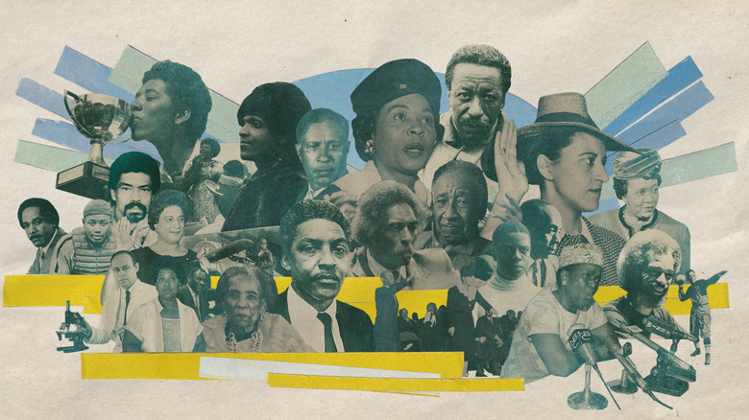  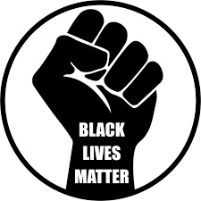
Theme throughout history: Resistance

Agency and Resistance:  Everyday Acts of Agency  Black People making their lives better underneath an oppressive system  Kerry James Marshall Here  Black everyday life, joy, resistance, and agency. |  | 