Group Members:

Altered Books Planning Sheet
Each class will be given a American History Book
Example:
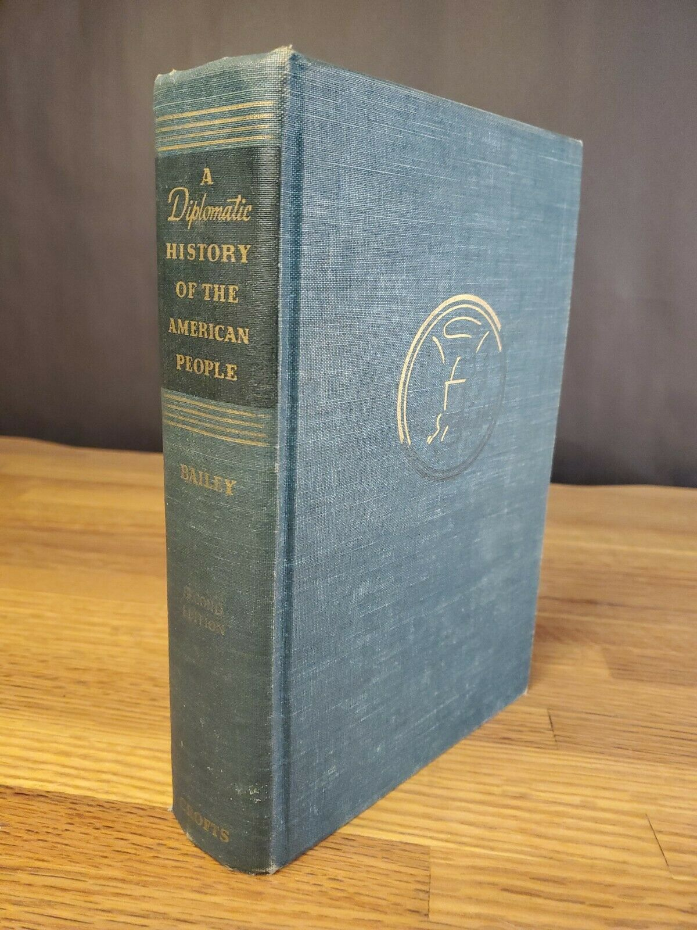

Resources:
- Altered Book Techniques Here
- Altered Book Flip Through Here
- Altered Books Tips and Tricks Here
- Altered Books Basics Here
- How to Glue Flat Pages Here
- How to Use Soft Chalk Pastels with Water for Pages That Really Pop Here
- Altered Books Flip through Techniques Here
- Collage Basics in an Altered Book Layout Here

In class have available: Altered Books Workshop by Bev Brazelton in class Here

Altered Book Examples:
- Altered Books Samples: Here
- Pintrist Altered Books: Here and Here

Review the work of Brian Dettmer. Altered Book Artist Here

Discuss in whole group:
- How is identifying, learning and teaching about Black Cultural Ambassadors furthering our commitment to responding to cultural erasure by promoting truth and reconciliation?

- Why is telling the stories of the Black experience through Black Cultural Ambassadors and using figurative language to tell theses stories an important part of combating erasure?

Reflect on the following questions:

- What resource did you find most helpful? (Include a resource you found on your own if you would like.)

- What aspects of the 1619 Project will you include in your altered book? (use Born on the Water and the following as a reference: A K-8 section of The New York Times Magazine about the lasting impact of slavery in the United States Here)

- What vocabulary words will you include in your book?

Draw, tape or cut and paste Below technique ideas you have for your Altered Book:

- What techniques will you use in your book?

Sketch, cut and paste, or describe images you will use in your altered book:

- What materials do you need?

Who will be the Black Cultural Ambassadors that you will include in your work?

Name of Cultural Ambassador | Medium  (Visual Art, Music, Theater, Dance or Writing) | How do you know about them? (you can select someone you know through personal experience, discovered, or recently researched) | Using figurative language create a phrase to represent the cultural ambassador | How will you represent them in your Altered Book to share their impact on American Cultural Identity? (Add a description)

Black Cultural Ambassadors:
- Famous Black Artist Here
- 10 Groundbreaking African American Artist that Shaped History Here
- 10 Black Artist You Should Know Here

15 Black Dancers who Changed American Dance Here

5 Iconic Black Artists Who Changed Dance History Here
- History of Black Theater in America Here
- 10 Major African-American Playwrights Here

12 Most Influential Black Musicians of All Time Here
- 9 Black Musicians Who Changed the World Here

The Largely Forgotten Black Musicians Whose Innovations Shaped Nearly Everything Here

Black and Blue: How Nina Simone Transformed the Civil Rights Movement into Music Here
- 10 Black Authors Who Changed the World Here
- Black Authors that Impacted the Culture of the USA Here

Photocopy Image transfer Here

