Student Created Rubric:

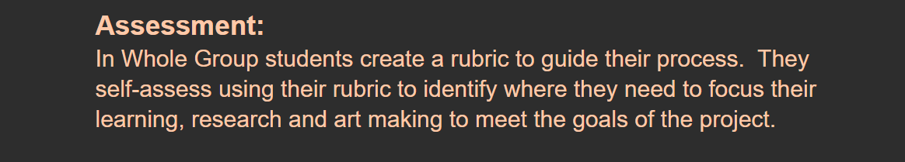

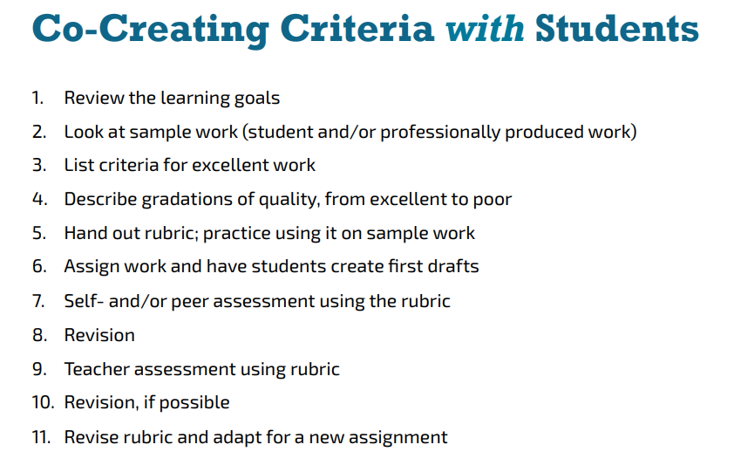

Students use the whole group work to fill out their rubric. We work together to identify the gradations of the criteria.

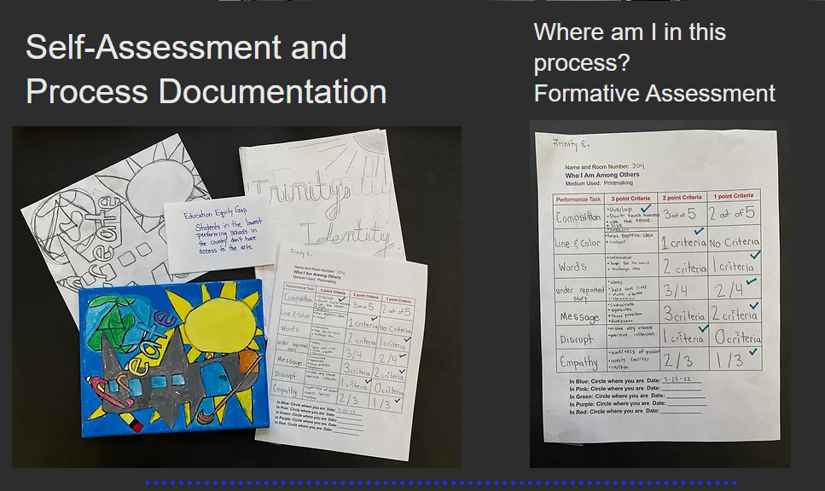

Students date and color code their self-assessment and identify next steps using the rubric. The same rubric is used multiple times throughout the process to guide learning and next steps.

