Critical Analysis Document: The Great Migration
LAUNCH: Day 1
Directions: Read the text on the left, then answer the guiding questions on the right.
THE GREAT MIGRATION  The Great Migration was the relocation of more than 6 million African Americans from the rural South to the cities of the North, Midwest and West from about 1916 to 1970. Driven from their homes by unsatisfactory economic opportunities and harsh segregationist laws, many Black Americans headed north, where they took advantage of the need for industrial workers that arose during the First World War. During the Great Migration, African Americans began to build a new place for themselves in public life, actively confronting racial prejudice as well as economic, political and social challenges to create a Black urban culture that would exert enormous influence in the decades to come. | 1. When did the Great Migration occur?  2. Why did so many African Americans leave their homes in the rural South to cities in the North, Midwest, and the Western parts of the United States?

End of Launch: Discuss as a whole class

Watch this video clip (1:38 minutes) about the Great Migration to answer the time-stamped guiding questions below.

1.In what years did the first wave of the Great Migration occur? (0:22)
2. In what years did the second wave of the Great Migration occur? (0:25)
3. What cultural effects did the first wave of the Great Migration bring? (0:43)
4. What compelled many African Americans to leave their homes? (0:51)
5. What important movement happened in the United States because of the Great Migration? (1:14)

As early as 1917, W.E.B. Du Bois observed that at least one quarter of a million African Americans had migrated to the North since 1910. Analyze the quote below to answer the guiding question.
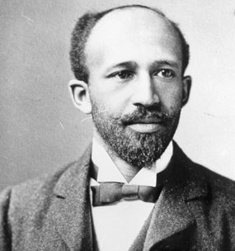  W. E. B. Du Bois, circa 1907  “Here we see a social evolution working itself out before our eyes. The mass of the freedmen are changing rapidly the economic basis of their social development.”  W.E.B. Du Bois, 1917 | What do you think W.E.B. Du Bois is saying about the effects that African Americans are making because of this migration north or west?

Below is an excerpt from Pulitzer Prize-winning author Isabel Wilkerson’s book The Warmth of Other Suns: The Epic Story of America’s Great Migration. The book chronicles the decades-long migration of Black citizens who fled the South for northern and western cities in search of a better life.
Chickasaw County, Mississippi, Late October 1937

Ida Mae Brandon Gladney

The night clouds were closing in on the salt licks east of the oxbow lakes along the folds in the earth beyond the Yalobusha River. The cotton was at last cleared from the field. Ida Mae tried now to get the children ready and to gather the clothes and quilts and somehow keep her mind off the churning within her. She had sold off the turkeys and doled out in secret the old stools, the wash pots, the tin tub, the bed pallets. Her husband was settling with Mr. Edd over the worth of a year’s labor, and she did not know what would come of it. None of them had been on a train before—not unless you counted the clattering local from Bacon Switch to Okolona, where, “by the time you sit down, you there,” as Ida Mae put it. None of them had been out of Mississippi. Or Chickasaw County, for that matter.

There was no explaining to little James and Velma the stuffed bags and chaos and all that was at stake or why they had to put on their shoes and not cry and bring undue attention from anyone who might happen to see them leaving. Things had to look normal, like any other time they might ride into town, which was rare enough to begin with.

Velma was six. She sat with her ankles crossed and three braids in her hair and did what she was told. James was too little to understand. He was three. He was upset at the commotion. Hold still now, James. Lemme put your shoes on, Ida Mae told him. James wriggled and kicked. He did not like shoes. He ran free in the field. What were these things? He did not like them on his feet. So Ida Mae let him go barefoot.

Miss Theenie stood watching. One by one, her children had left her and gone up north. Sam and Cleve to Ohio. Josie to Syracuse. Irene to Milwaukee. Now the man Miss Theenie had tried to keep Ida Mae from marrying in the first place was taking her away, too. Miss Theenie had no choice but to accept it and let Ida Mae and the grandchildren go for good. Miss Theenie drew them close to her, as she always did whenever anyone was leaving. She had them bow their heads. She whispered a prayer that her daughter and her daughter’s family be protected on the long journey ahead in the Jim Crow car (segregated train car for colored people).

“May the Lord be the first in the car,” she prayed, “and the last out.”

When the time had come, Ida Mae and little James and Velma and all that they could carry were loaded into a brother-in-law’s truck, and the three of them went to meet Ida Mae’s husband at the train depot in Okolona for the night ride out of the bottomland.

1. Why do you think Ida Mae and her family are leaving Mississippi and migrating North?
2. What emotion does Ida Mae feel about the journey ahead? Use one piece of text-based evidence to support your answer.
3. Why do you think Ida Mae let James go without shoes?
4. Why do you think Ida Mae didn’t want anyone to know they were leaving?
5. Imagine leaving all your family and moving to an unfamiliar place you have never been. Describe how that would make you feel. (Remember, there’s no facetime, social media, or modern technology to keep you connected to your family. Communication meant writing letters and an occasional phone call if you could afford it.)

Watch this video clip (1:15) from the PBS series American Experience about the Great Migration. | 1. Why did so many African American migrate from the South to Chicago?
Watch this video clip (0:39-3:33) from Carnegie Hall to see the Great Migration’s impact on African American musical expression and creation of new genres. | 1. What types of musical genres did African Americans bring north during the Great Migration?

Day 1: Exit Ticket
What are two reasons African Americans left the rural South during the Great Migration?

LAUNCH: Day 2
Picture A  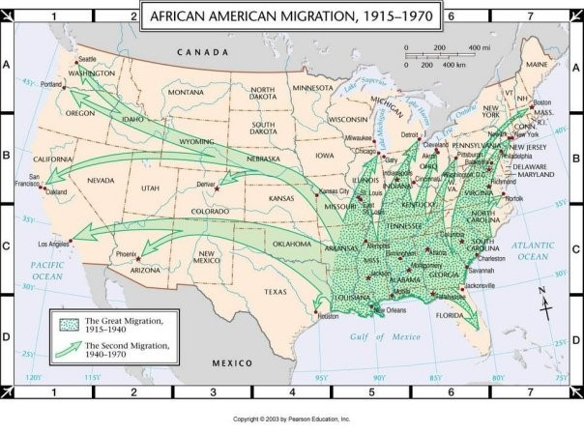 | 1. Describe what you see in Picture A.  2. In what direction(s) is the migration happening? What evidence from the Map supports your answer?  (North, East, South, or West)

End of Launch: Discuss as a whole class
The Great Migration’s Effect on the African American Cultural Experience
The Black experience during the Great Migration became an important theme in the artistic movement known first as the New Negro Movement and later as the Harlem Renaissance, which would have an enormous impact on the culture of the era. The Harlem Renaissance was the development of the Harlem neighborhood in New York City as a Black cultural mecca in the early 20th Century and the subsequent social and artistic explosion that resulted. Lasting roughly from the 1910s through the mid-1930s, the period is considered a golden age in African American culture, manifesting in literature, music, stage performance and art.
The Great Migration also began a new era of increasing political activism among African Americans, who after being disenfranchised in the South found a new place for themselves in public life in the cities of the North and West. The civil rights movement directly benefited from this activism.

Louis Armstrong | Bessie Smith |  | Duke Ellington
Jazz Singer/Musician  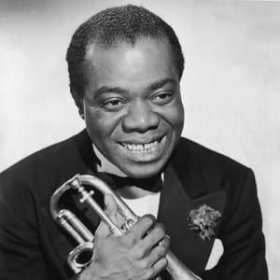  Hulton Archive/Getty Images  Louis Armstrong was a jazz trumpeter, bandleader, and singer that influenced countless musicians with both his daring trumpet style and unique vocals. | Jazz Singer  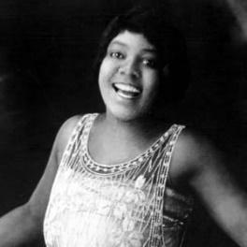  Edward Elcha/Michael Ochs  As a Jazz and blues singer, Smith was a powerful vocalist with a soulful voice that won her countless fans and earned her the title "Empress of the Blues." |  | Jazz Singer/Musician  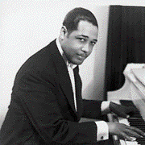  Bettmann/Getty Images  An originator of big-band jazz, Ellington was a composer, pianist, and bandleader who composed thousands of scores over his 50-year career.
“La vie en rose” 1950  (2.42 minutes) | “Downhearted Blues” 1923 (3.25 minutes) |  | “It don't mean a thing” (1943) (2.45 minutes)
Describe what you heard? | Describe what you heard? |  | Describe what you heard?
Langston Hughes |  | Norman Lewis
Poet & Writer  “The Negro Speaks of Rivers”  I’ve known rivers:  I’ve known rivers ancient as the world and older than the flow of human blood in human veins.  My soul has grown deep like the rivers.  I bathed in the Euphrates when dawns were young.  I built my hut near the Congo and it lulled me to sleep.  I looked upon the Nile and raised the pyramids above it.  I heard the singing of the Mississippi when Abe Lincoln went down to New Orleans, and I’ve seen its muddy bosom turn all golden in the sunset.  I’ve known rivers:  Ancient, dusky rivers.  My soul has grown deep like the rivers. |  | Artist  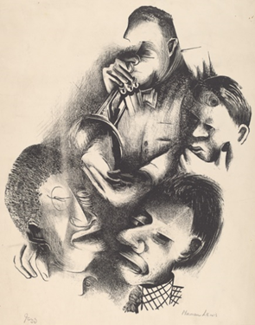  Norman Lewis, Jazz, 1938
1. What is the message that Hughes is trying to convey? |  | 1. Describe what you see in this picture.

Day 2: Exit Ticket
What did you learn?

Select three of the individuals you learned about today and describe their impact during the “Golden Age” in African American culture known as the Harlem Renaissance.
1.

2.

3.

