Critical Analysis Document: Culture and Identity

LAUNCH: Day 1
Out of darkness and pain, emerges a new and beautiful culture.

Watch a video clip (6:45-7:35) of Nikole Hannah-Jones talking about The 1619 Project from the New York Times Magazine to answer the following questions.

1. What does Nikole Hannah-Jones say was created because of Black culture?

2. What does she say is one of Black culture's biggest contributions?

3. Can you think of anything else Black culture has contributed she did not mention?

End of LAUNCH: Discuss as a whole class.

1619 Project article excerpt: “The Idea of America” by Nikole Hannah-Jones
They say our people were born on the water.  When it occurred, no one can say for certain. Perhaps it was in the second week, or the third, but surely by the fourth, when they had not seen their land or any land for so many days that they lost count. It was after fear had turned to despair, and despair to resignation, and resignation to an abiding understanding. The teal eternity of the Atlantic Ocean had severed them so completely from what had once been their home that it was as if nothing had ever existed before, as if everything and everyone they cherished had simply vanished from the earth. They were no longer Mbundu or Akan or Fulani. These men and women from many different nations, all shackled together in the suffocating hull of the ship, they were one people now.  Just a few months earlier, they had families, and farms, and lives and dreams. They were free. They had names, of course, but their enslavers did not bother to record them. They had been made black by those people who believed that they were white, and where they were heading, black equaled ‘‘slave,’’ and slavery in America required turning human beings into property by stripping them of every element that made them individuals. This process was called seasoning, in which people stolen from western and central Africa were forced, often through torture, to stop speaking their native tongues and practicing their native religions.  But as the sociologist Glenn Bracey wrote, ‘‘Out of the ashes of white denigration, we gave birth to ourselves.’’ For as much as white people tried to pretend, black people were not chattel. And so, the process of seasoning, instead of erasing identity, served an opposite purpose: In the void, we forged a new culture all our own. | 1. What do they mean when they say, “Our people were born on the water?”  2. What did these enslaved Africans have in common?  3. How did “Seasoning” affect the enslaved Africans?  4. These stolen men and women once from many different nations were stripped of their former identity and in turn created what?
Today, our very manner of speaking recalls the Creole languages that enslaved people innovated in order to communicate both with Africans speaking various dialects and the English- speaking people who enslaved them. Our style of dress, the extra flair, stems back to the desires of enslaved people — shorn of all individuality — to exert their own identity. Enslaved people would wear their hat in a jaunty manner or knot their head scarves intricately. Today’s avantgarde nature of black hairstyles and fashion displays a vibrant reflection of enslaved people’s determination to feel fully human through self- expression. The improvisational quality of black art and music comes from a culture that because of constant disruption could not cling to convention. Black naming practices, so often impugned by mainstream society, are themselves an act of resistance. Our last names belong to the white people who once owned us. That is why the insistence of many black Americans, particularly those most marginalized, to give our children names that we create, that are neither European nor from Africa, a place we have never been, is an act of self- determination. When the world listens to quintessential American music, it is our voice they hear. The sorrow songs we sang in the fields to soothe our physical pain and find hope in a freedom we did not expect to know until we died became American gospel. Amid the devastating violence and poverty of the Mississippi Delta, we birthed jazz and blues. And it was in the deeply impoverished and segregated neighborhoods where white Americans forced the descendants of the enslaved to live that teenagers too poor to buy instruments used old records to create a new music known as hip-hop.  Our speech and fashion and the drum of our music echoes Africa but is not African. Out of our unique isolation, both from our native cultures and from white America, we forged this nation’s most significant original culture. In turn, ‘‘mainstream’’ society has coveted our style, our slang and our song, seeking to appropriate the one truly Ameri- can culture as its own. As Langston Hughes wrote in 1926, ‘‘They’ll see how beautiful I am/And be ashamed—/I, too, am America.’’ | The “Seasoning” process leads to self-expression of a new culture.  5. How did enslaved people impact Black hairstyles?  6. How did enslaved people impact Black art and music?  7. How did the enslaved people impact the way African American names?  8. What are some cultural impacts that enslaved people had on African American identity and culture?

Day 1 Exit Ticket:
- What do you think is the most important influence enslaved Africans had on African American culture and identity?

LAUNCH: Day 2

What are two ways in which enslaved people impacted the development of African American identity and culture in the United States?

A Culture Being Created
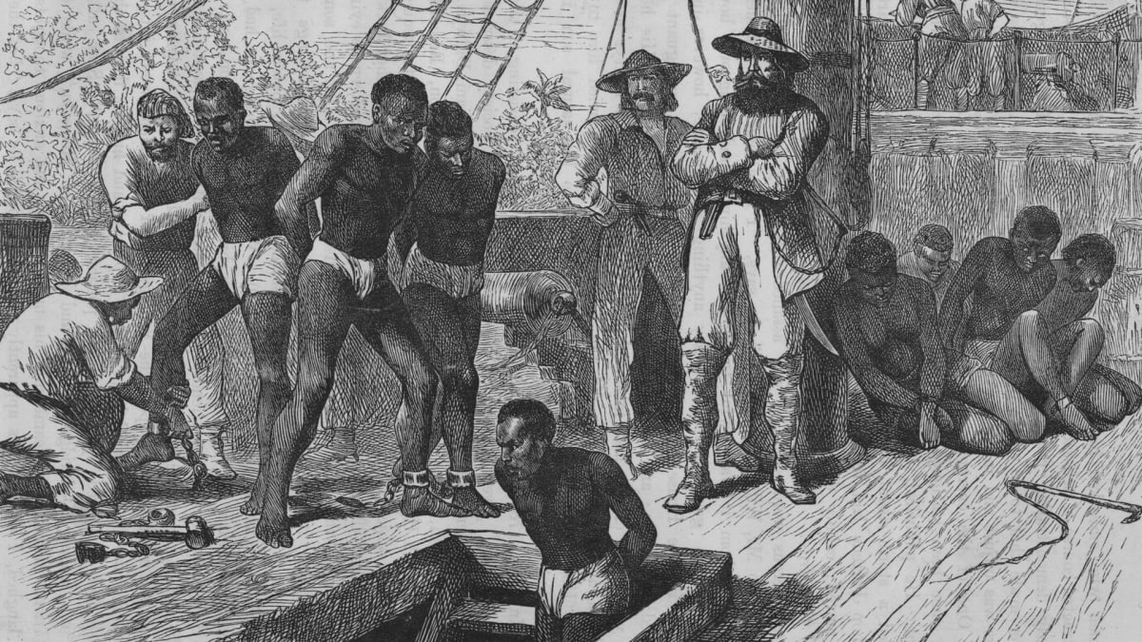
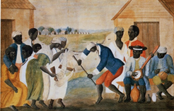
Atlantic Middle Passage Slave Trade Plantation Dance, South Carolina, ca. 1785-1795

On board slave ships during the Middle Passage, enslaved Africans were frequently forced to dance. Once a day, some of them were brought up from the hold and encouraged to drum, sing, and dance. Slave captains believed that dancing enlivened the captives' spirits and reduced their sense of pain, suffering, and longing. Unbeknownst to the slave-ship captains, the daily dancing and exercise regime likely provided one of the bases for the continuity of African-based expressive culture in the New World. For the rhythms and dances preserved during the Middle Passage became the roots of New World African music and dances. Singing, drumming, and dancing resurfaced in new, transformed rhythms and music in slave communities and societies.

Vernacular dances such as jigs, shuffles, breakdowns, shale-downs, and backsteps, as well as the strut, the ring shout, and other religious expressions, were danced to the accompaniment of these drum-less rhythms and to the fiddle, the banjo, bows, gourds, bells, and other hand or feet instruments—all New World African inventions by enslaved Africans.

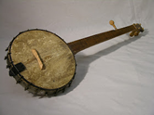  African American Banjo | 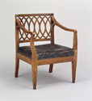  Armchair

Enslaved African craftsmen and visual artists laid the foundations of the African American visual arts tradition during slavery as well. Enslaved craftsmen made furniture and other utilitarian objects, some of which carried unique New World African visual arts expressions. Carvers and stone sculptors have left utilitarian objects and artworks of surprising aesthetic quality. Quiltmakers fashioned objects of beauty from scraps of cloth, and stone milliners and tailors were among the nation's pioneer fashion designers. Enslaved Africans left their cultural stamp on other aspects of American culture. Southern American speech patterns, for instance, are heavily influenced by the language patterns invented by enslaved Africans. Southern cuisine and "soul food" are nearly synonymous. Both are African American cuisines from the slavery era. Sermons, oratory, and other forms of oral literature in the African American vernacular idiom, including contemporary rap, trace their roots to genres developed by enslaved Africans during slavery.

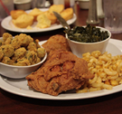  Soul Food | 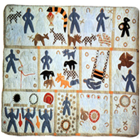  ‘‘Quilt’ by Harriet Powers 1886

Explain three examples of how enslaved people contributed to African American identity and culture.
1.

2.

3.

Black is Beautiful: The Emergence of Black Culture and Identity in the 60s and 70s

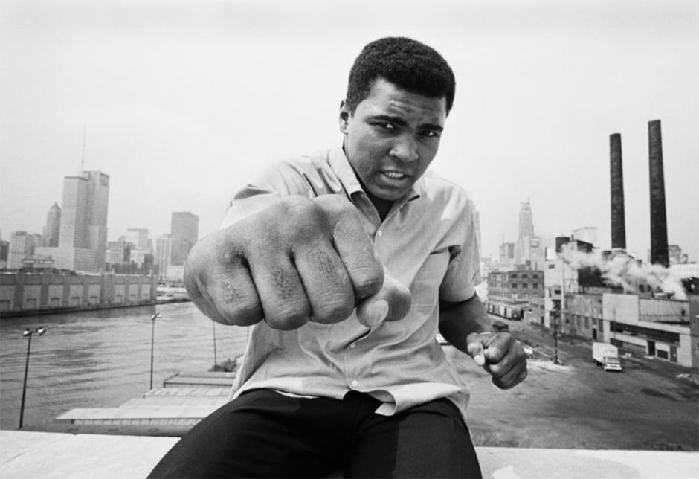  Thomas Hoepker/Magnum Photos  “I’m So Pretty”  Muhammad Ali’s style of boxing boasted its own brand of beauty. His graceful footwork and charismatic confidence attracted audiences to his moves and his message. | 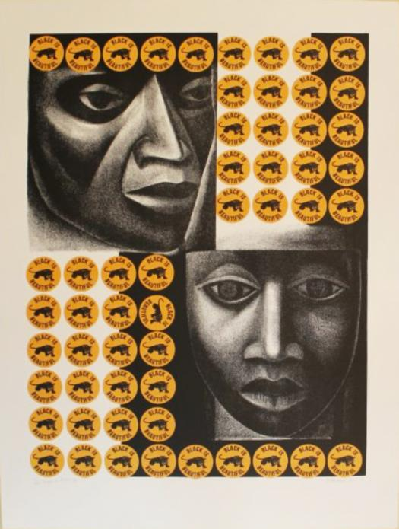  Catlett Mora Family Trust/Licensed by VAGA, New York, NY  Negro Es Bello II, by Elizabeth Catlett, 1969  Negro Es Bello translates from Spanish as “Black is beautiful.” Placing those words alongside Black panther imagery, the artist connects Black pride with Black Power.
1. How did Muhammad Ali help contribute to African American identity and culture? | 2. How did artists like Elizabeth Catlett help contribute to African American identity and culture?

“Say it loud”  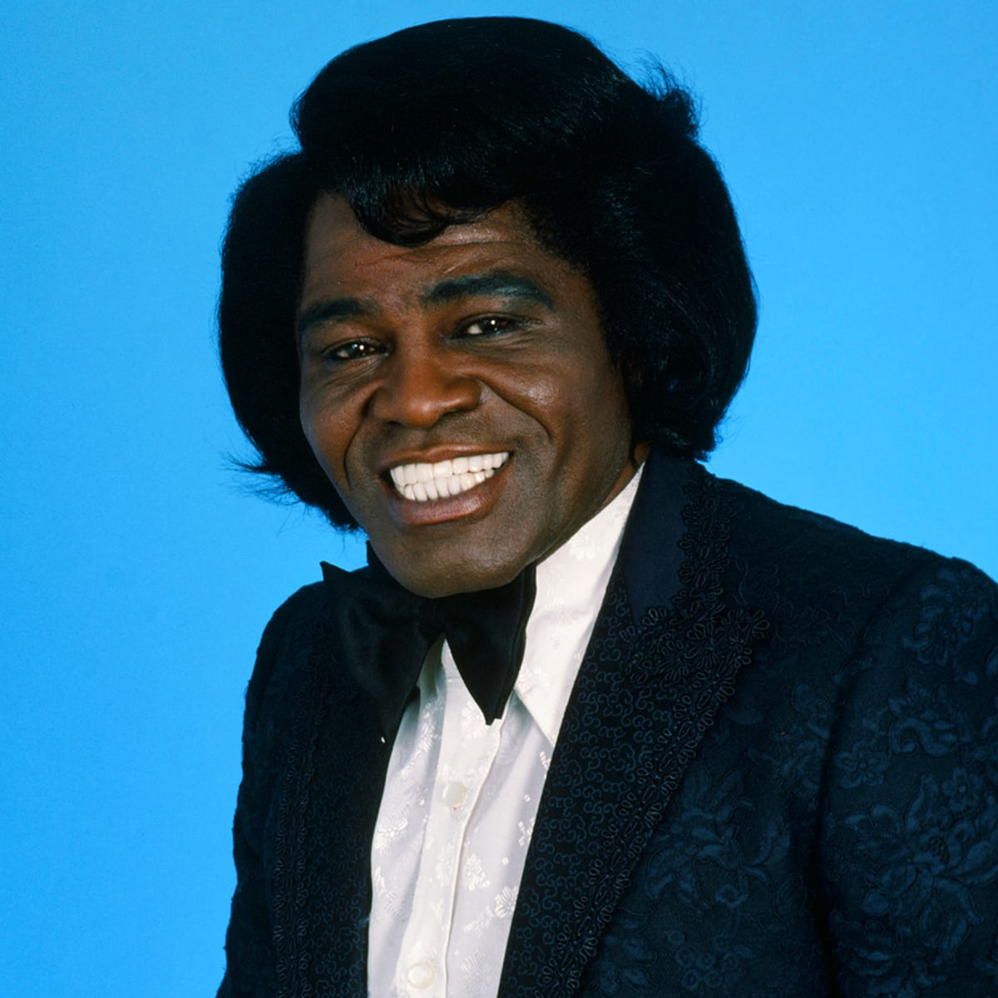  James Brown  "Some people say we got a lot of malice  Some say it's a lotta nerve  But I say we won't quit movin'  Until we get what we deserve ...  Say it loud - I'm Black and I'm proud!" | James Brown, the "Godfather of Soul," was a prolific singer, songwriter, and bandleader, as well as one of the most iconic figures in funk and soul music.  Analyze the song quote on the left and watch the video clip (1.33 mins)  1. What is the message in the song “Say it Loud?”  2. How did James Brown contribute to African American identity and culture?

Television is on the brink of a revolutionary change ... The stations are changing - not because they like Black people but because Black people, too, own the airwaves and are forcing them to change.  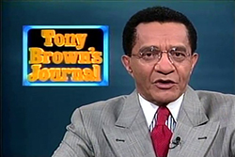  TONY BROWN  1970 | 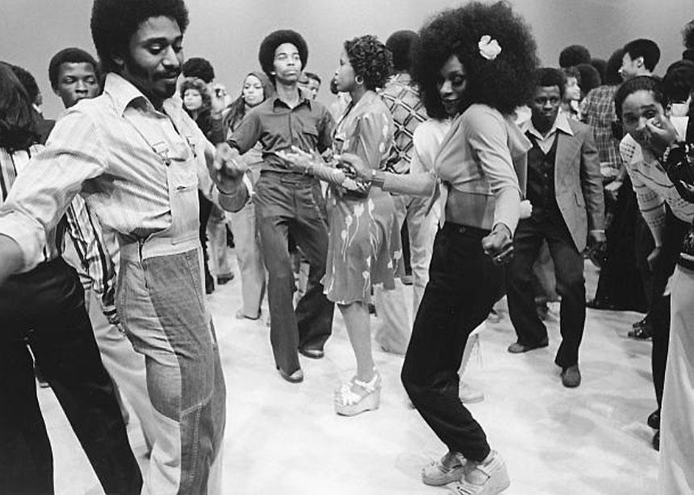  Michael Ochs Archives via Getty Images  Soul Train  This televised musical program featured in-studio dancers showcasing the latest moves. The show brought African American cultural expression into millions of non-black households. Photo circa 1970.

- What impact did mainstream television have on the emergence of Black culture and identity?

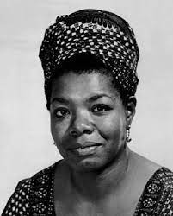  Maya Angelou  Maya Angelou  Maya Angelou was an African American woman who grew up in Arkansas. In the segregated south, Angelou experienced firsthand racial prejudices and childhood traumas so horrible, that she stopped speaking for five and a half years. But she rose-up and became a powerful author, actress, screenwriter, dancer, poet, and civil rights activist. | As you listen to Maya Angelou reciting her poem "Still I Rise" (Start- 1.25) fill in the chart below.  1. As you listen to the Poem, write down five words that stand out.  2. What do you think is the main idea of Maya Angelou's poem “Still I Rise?”

How did Maya Angelou contribute to African American identity and culture?

Using the information you learned during this lesson, notes, and your prior knowledge, select three African Americans from throughout history and up to the present day who you believe have had the greatest impact on African American culture and identity. Explain why.
(Note: It can be someone you learned about in this lesson)

1.Name :
Why:

2. Name :
Why:

3. Name :
Why:

Out of three African Americans you listed, who do you believe had the greatest impact on African American culture and identity? Explain why.

Day 2 Exit Ticket:

As a group, select only one African American who you believe has had the greatest impact on African American culture and identity. Explain why.

Do you agree with your group's choice? If not, who would you have chosen and why?

