“Statement of Cotton,” 1859-1856, Robert H. Stewart Account Books
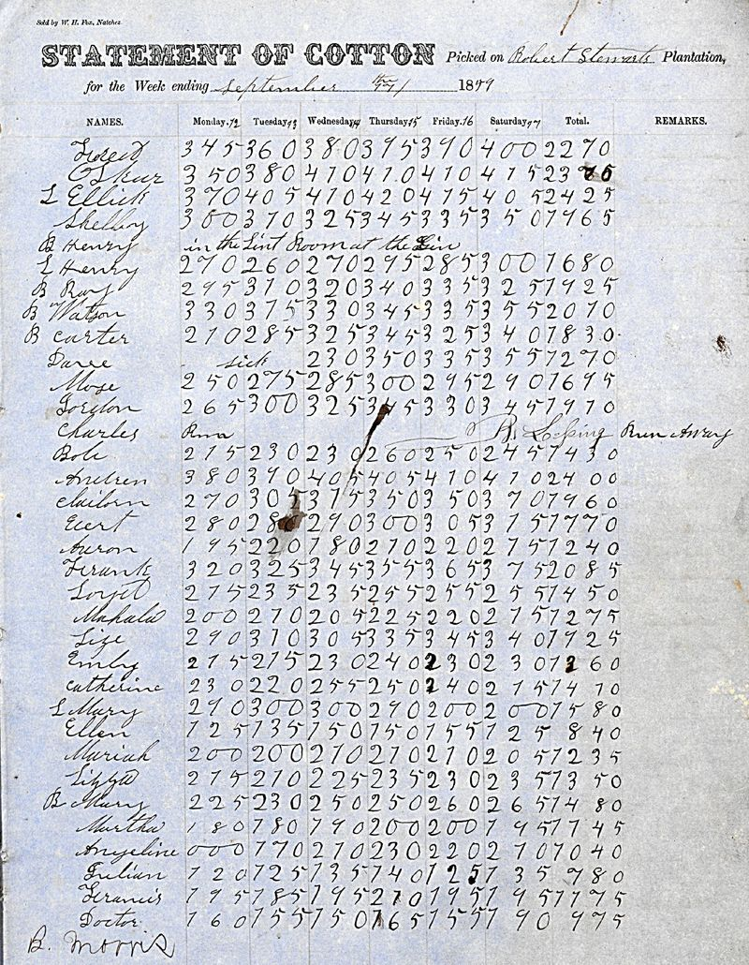
Retrieved from “Lessons from the ‘Data Exhaust’ of Plantation Slavery” by Caitlin Rosenthal

