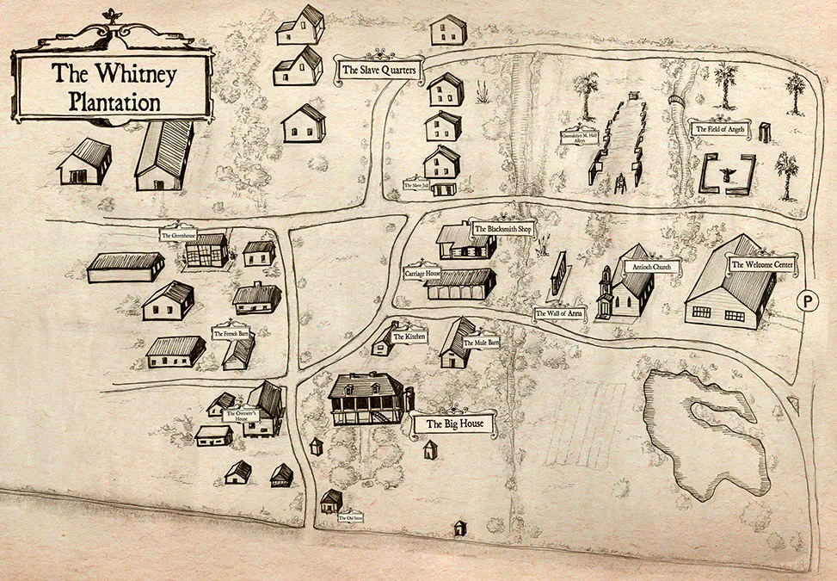
Map of the Whitney Plantation from www.whitneyplantation.org

