What is Redlining?

Step 2: Identify Title and the Legend

* Look at the title and the legends.
* What are they labeled?
* What does this tell you?

Step 1: Backdrop the Document

* Is it a primary or secondary source?
* How do you know?
* When did it occur? What was going on then?
* Why might this be important?

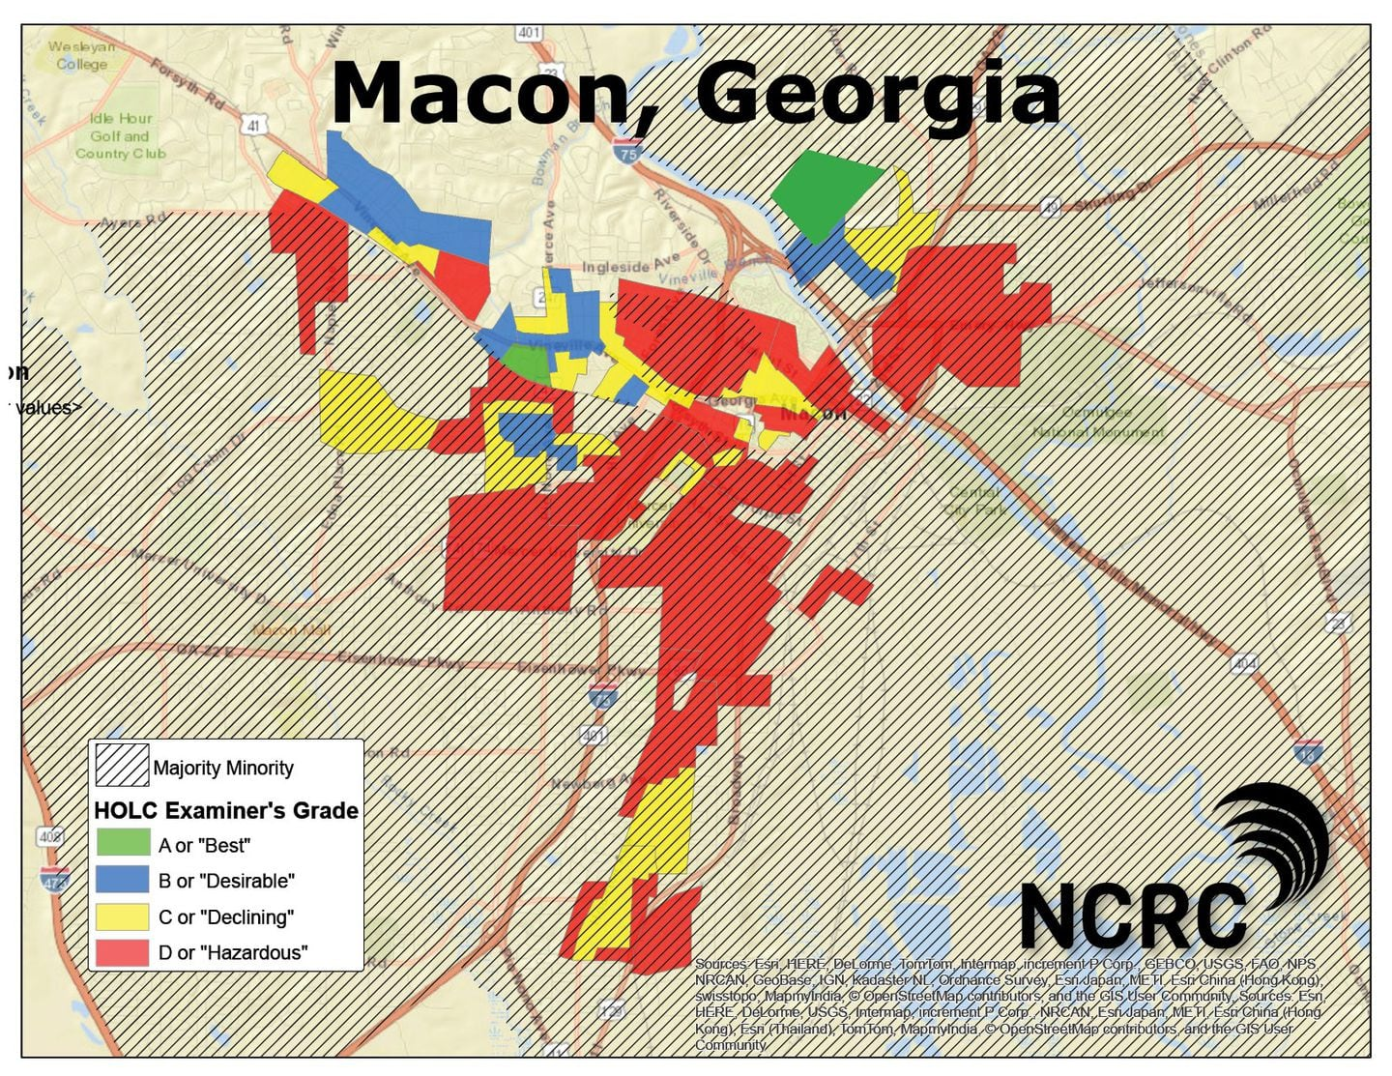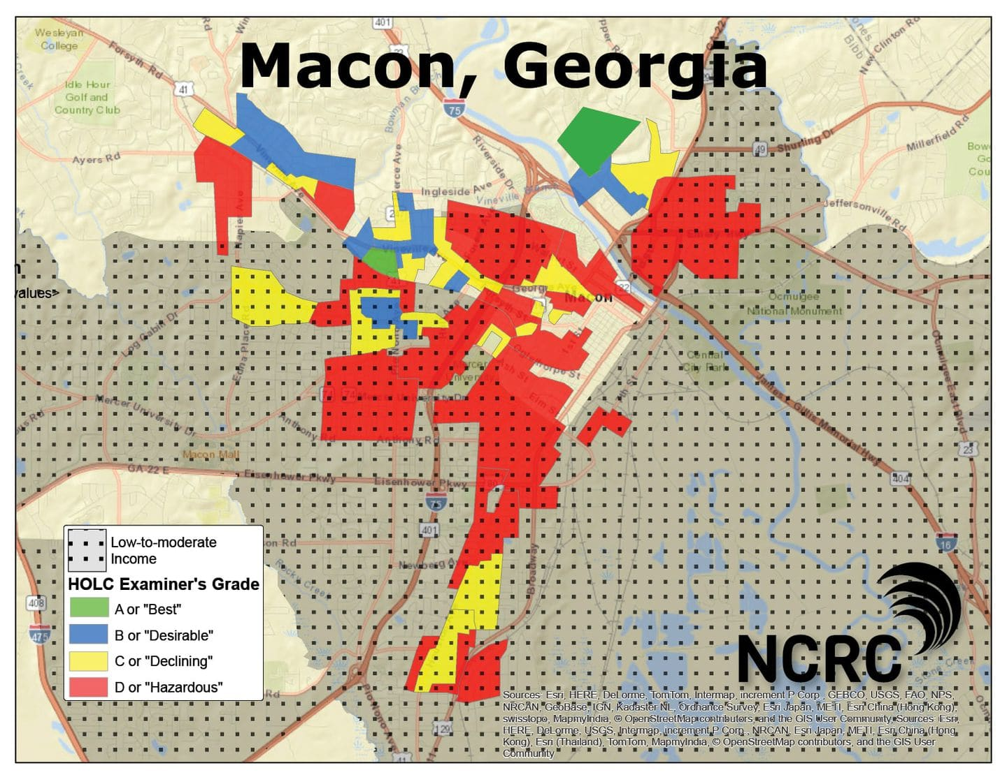

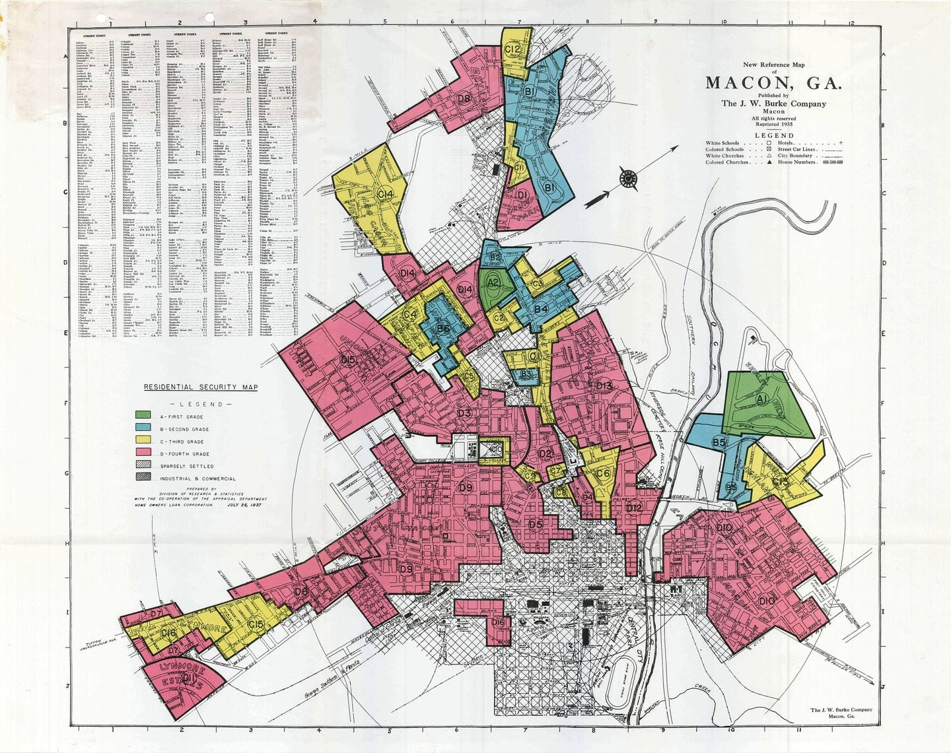

**OBSERVE**

* *Identify and note details.*
* *What do you notice first?*
* *What can you easily explain?*
* *What do you notice that you can’t explain?*
* *What do you notice that you didn’t notice earlier?*

**REFLECT**

* *Where do you think this came from?*
* *Why do you think somebody made this?*
* *What do you think was happening when this was made?*
* *Why do you think this item is so important?*
* *If somebody made this today, what would be different?*
* *What can you learn from examining this?*

**QUESTION**

* *Ask questions that lead to more observations and reflection.*
* *What do you wonder about*
  + *Who?*
  + *What?*
  + *When?*
  + *Where?*
  + *Why?*
  + *How?*