Do Now: Examine the following mask and complete the See/Think/Wonder chart. Be thorough in your observations.

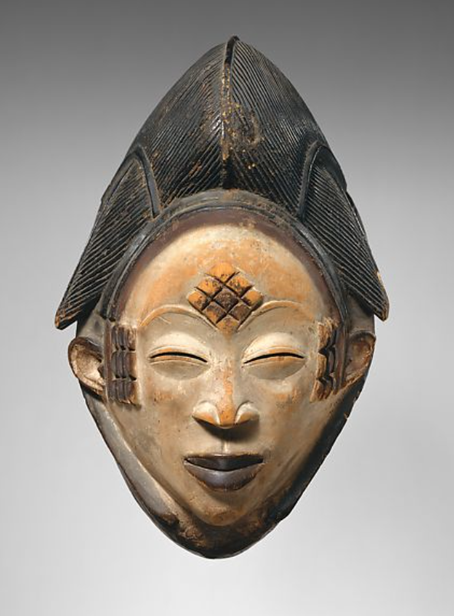

See | Think | Wonder

African Masks Reading

Directions: Read the following article, “The West African Mask” from www.culturesofwestafrica.com

“When fully activated, masks become ‘spirits made tangible’.”
—West African masquerader turned curator, artist, and art historian, Chika Okeke-Agula​
As sculptural, aesthetic, and museum-worthy that the mask may be, it cannot, and was never meant to, stand on its own, at least in traditional West Africa. It is but an agent, a medium for the ancestral powers that animate all things, and can only be understood in the context in which it was conceived, through the creative process that brings it into being, and by the dynamic interplay of the rhythm, color, texture, and movement that brings it, ultimately, to life.
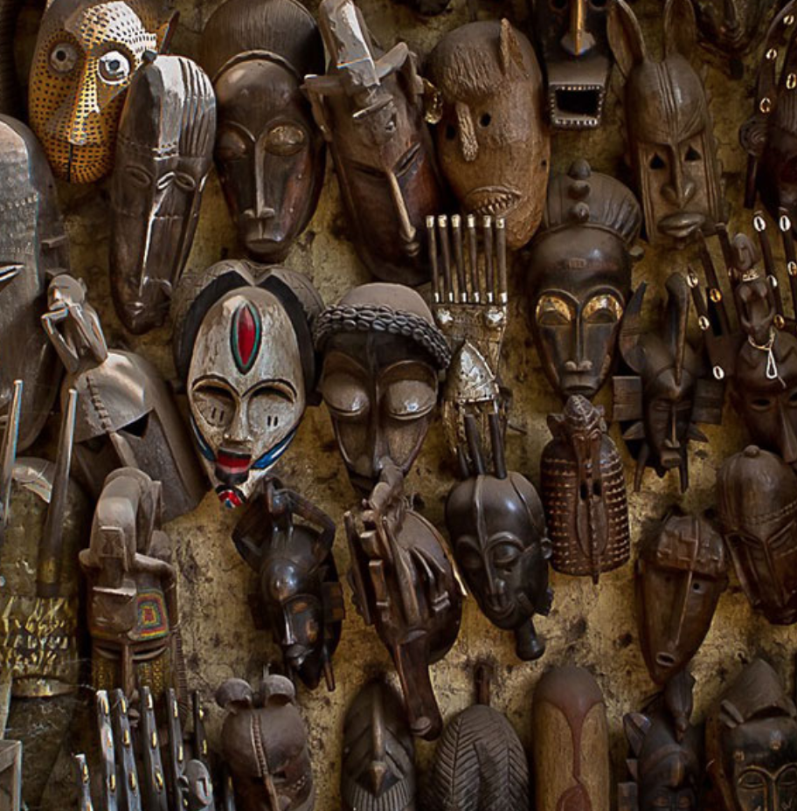
“Masks of Mali” Image by Anthony Pappone

Whether of wood, copper, ivory, or leather, whether semi-abstract, anthropomorphic, or architectonic in form, whether simple or superstructural, the West African mask is less of a covering than an interstice, an opening through which to glimpse the spirit world.
The ‘spirit’ of the mask, ritually transferred from the natural materials out of which it is carved by its blacksmith/sculptor, then protectively shrouded while not in use, emerges in full force through the traditional masked dance, performed to channel the divine, summon ancestral wisdom, escort the departed, accompany initiates, reaffirm societal values, venerate the living, and to mark the natural cycles of existence, from birth to death, season to season.​

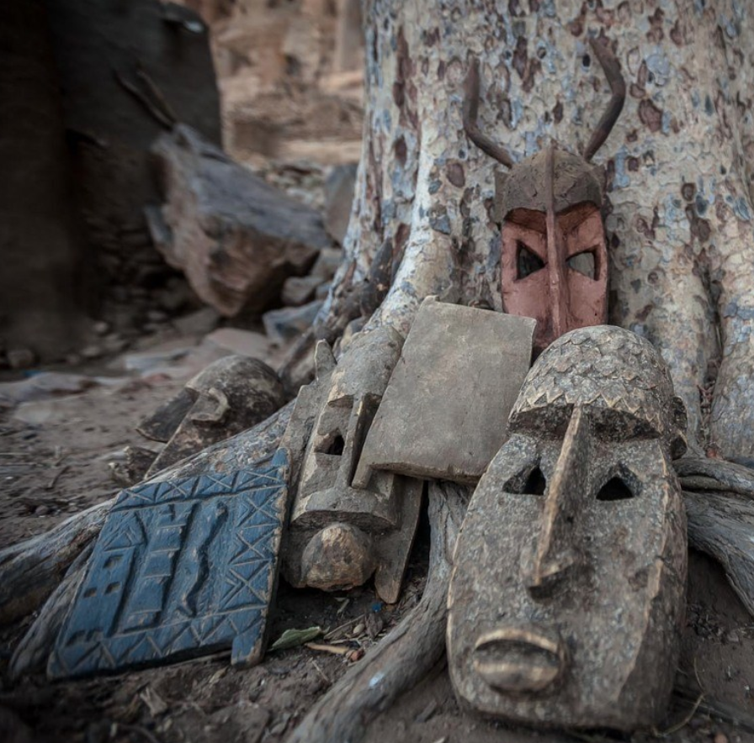
“Dogon Masks” image by Anthony Pappone

“There is a particular kind of art in Africa, which is unique to the continent and can be found nowhere else in the world. It is an art, which is especially exemplified by the mask, and the masquerade in which the mask is used.” — D. Duerdon . . .
To the rhythm of drums, the mask emerges. Its bearer surrenders to its power. As the tempo accelerates, the ground pulsates, colors swirl, the dust kicks up, and whatever divide exists between the corporeal and the incorporeal, the spiritual and the mundane, the temporal and the intemporal dissolves.
“The African understanding of space and time underscores the important position of the masquerade tradition in this universe. In this understanding, [there is an] invidious gradation between the physical and the spiritual […]. This is the world of the living and that of the ancestors. The masquerade’s appearance is then an intervention process between the two worlds. It provides a link for the needed continuum between them. This is done in order to vitalise, regenerate and valuate the essence of living and the issues of survival.” — J. Obaseki​
Notes (What are you learning? What stands out to you?)

____________________________________________________________________________

____________________________________________________________________________

____________________________________________________________________________

____________________________________________________________________________

____________________________________________________________________________

____________________________________________________________________________

Mask Making Activity

You will not make a mask that represents who you are, your lived experiences, culture, hopes, dreams, aspirations, etc. Use all of the materials provided and be as creative as possible – HAVE FUN ☺

Every mask must have the following:

- A shared, community symbol agreed upon by the class.
- At least two colors that are symbolic to you.
- At least one symbol that is meaningful to you.

To get started on planning your mask, please answer the following questions.

1. What is important to you in life?

____________________________________________________________________________

____________________________________________________________________________

____________________________________________________________________________

____________________________________________________________________________

2. What are your favorite colors, or colors that are significant to you? Why?

____________________________________________________________________________

____________________________________________________________________________

____________________________________________________________________________

3. What are symbols that are important to you?

____________________________________________________________________________

____________________________________________________________________________

____________________________________________________________________________

____________________________________________________________________________

https://www.metmuseum.org/art/collection/search/318667

