The Courageous Conversation Compass
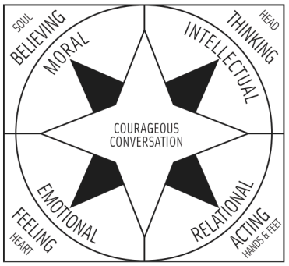
Purpose of the Courageous Conversation Compass:
• a personal navigational tool to guide participants through these conversations • helps us to know where we are personally as well as to recognize the direction from which other participants come
• helps us to locate the sources of our emotions and actions or lack thereof
The Four Points are:
o Emotional (heart): responding to information through feelings (when racial issues strike us at a physical level and causes an internal sensation such as anger, sadness, joy, or embarrassment).
o Intellectual (mind): response to a racial issue or information may be characterized by personal disconnect with subject or to search for more information or data. Our intellectual response is often verbal and based in our best thinking.
o Moral (soul): responding from a deep-seated belief that relates to the racial information or event. Justifications of one’s moral views may be seated in the “gut” and may not be verbally articulated.
o Relational (hands/feet): connecting and responding to racial information through actions and behaviors.
Adapted from Glenn Singleton’s Courageous Conversations About Race: A Field Guide for Achieving Equity in Schools, 2nd Edition (2015).

