UNIT OVERVIEW

Unit Length | Three-five school days, depending on the grade/level of the students, and curriculum timing.
Grade Level(s) / Subject(s) | 9-12 Social Studies/Humanities
Unit Overview | As part of the core mission of The 1619 Project is revealing the hidden histories of the systematically excluded, this mini-unit returns to the source of humanity by exploring the geography of West Africa and creating masks in the spirit and essence of West Africa that represent the students’ lived experiences. This unit will introduce students to African geography and the culture of West Africa and Sub-Saharan Africa through mask-making and visual art.  Essential Questions:  - How can we challenge our geographic perceptions of the African continent?  - How are masks used historically/presently in West Africa and Sub-Saharan Africa?  - How can you create a mask that reflects your life experiences and culture?  - Why is consistent map-practice essential to understanding geography, history, and current events?
Objectives & Outcomes | - Students will learn the geography and current capitals and countries of the African continent.  - Students will explore the hidden history of the masks in West Africa and Sub-Saharan Africa and their cultural significance.  - Students will create their own masks that reflect their lived experiences/hopes/culture/pride.
Standards | New York State Scope and Sequence for Social Studies 9-12:  - Individual Development and Cultural Identity  - Development Movement and Interaction of Cultures  - Time, Continuity and Change  - Geography, Humans and the Environment  Common Core Standards:  RL.11-12-.2 Determine a theme or central idea of a text and analyze in detail its development over the course of the text, including how it emerges and is shaped and refined by specific details; provide an objective summary of the text.  RL.11-12.3 Analyze how complex characters (e.g., those with multiple or conflicting motivations) develop over the course of a text, interact with other characters, and advance the plot or develop the theme.  RL.11-12.9 Analyze how an author draws on and transforms source material in a specific work (e.g., how Shakespeare treats a theme or topic from Ovid or the Bible or how a later author draws on a play by Shakespeare).  RI.11.12.7 Analyze various accounts of a subject told in different mediums (e.g., a person’s life story in both print and multimedia), determining which details are emphasized in each account.  SL.11.12.4 Present information, findings, and supporting evidence clearly, concisely, and logically such that listeners can follow the line of reasoning and the organization, development, substance, and style are appropriate to purpose, audience, and task.  W.11.12.1 Write arguments to support claims in an analysis of substantive topics or texts, using valid reasoning and relevant and sufficient evidence.  W.11.12.4 Write arguments to support claims in an analysis of substantive topics or texts, using valid reasoning and relevant and sufficient evidence.
Unit Resources | Resources Used with Students:  - Born on the Water by Nikole Hannah-Jones and Renée Watson, illustrated by Nikkolas Smith  - Africa Is NOT a Country, a video by Iwani Mawocha  - “The West African Mask” article from www.culturesofwestafrica.com  - “The Dama, Masked Dance of the Dogon” video from www.culturesofwestafrica.com  Additional Resources / Background for Educators:  - World History by Elisabeth Gaynor Ellis and Anthony Esler; Pearson, 2011, pages 340-356. The historical anchor texts are three chapters:  - “Early Civilization of Africa”  - “The Kingdoms of West Africa”  - “Kingdoms and Trading States of East Africa.”  - Africana: The Encyclopedia of the African and African American Experience, edited by Kwame Anthony Appiah and Henry Louis Gates Jr.  - “The Art of Africa” from the Metropolitan Museum of Art  Educator Note:  The author created a mini-grant on www.Donorschoose.org to fundraise for the necessary supplies for mask-making. Here is a link to the original DonorsChoose page.
Performance Task(s) | Students will make their own masks that represent their culture, values, joys, likes, etc.
Assessment / Evaluation | In the first two lessons, students will answer the essential question of the day in writing as their formative assessment. In the final lesson, students will create their mask as their summative assessment.

DAILY LESSONS AND RESOURCES

Day 1: Geography and the Middle Passage

Lesson Objective(s) or Essential Question(s)
Essential Question: Why is it important to understand the geography of a place, land, area?

Lesson Objectives:

- Students will explore geography in their own lives.
- Students will think/pair/share to foster communication and participation.
- Students will review history of the Middle Passage.
Lesson Materials & Resources
Text:
- Born on the Water by Nikole Hannah-Jones and Renée Watson, illustrated by Nikkolas Smith

Worksheet:
- Day One Worksheet [.pdf]
- Day One Worksheet [.docx]
Lesson Activities
Do Now:

Students use their textbooks or devices to look up the word geography and write down all its definitions.

Activities:

1. Ask students to describe the geography of their commute to school.

2. Students share their observations with a partner, and compare/contrast the geography of their commutes using a T-chart.

3. Remind students of the five main themes of geography: location, place, human-environment interaction, movement, and region. Ask them to describe these terms in their own words.

4. Tell students they will be exploring Born on the Water today, which begins in West Africa. Introduce terms they will encounter in this book:
- Middle Passage
- Slave Trade
- Slave vs. enslaved person

Ask students to write down the definitions of each term, and their own associations with each. (This brainstorm is private.)

5. Read Born on the Water aloud. (This can be done by the instructor, a student volunteer, or a read-around-the-room.) While students listen, they should write down:
- What stands out to you?
- What examples of geography can be found in the reading?
- How is the history different or similar to the history you already knew?
- What is your opinion of this book?
- What is the relationship between geography and history in this reading?
- What examples of pride can be found in the reading? How is pride visualized?

Formative Assessment:

Students answer the essential question below using examples from their lived experiences and Born on the Water. Students must use evidence to support their answers.

Why is it important to understand the geography of a place, land, area?
Student Responses
- Example 1: completed worksheet and formative assessment by a student at UBUNTU: High School for Law Advocacy and Community Justice, fall 2021
- Example 2: completed worksheet and formative assessment by a student at UBUNTU: High School for Law Advocacy and Community Justice, fall 2021

Day 2: African Geography

Lesson Objective(s) or Essential Question(s)
Essential Question: How can we challenge our geographic perceptions of the African continent?

Lesson Objective:

- Students will familiarize themselves with the ecosystems, modern nation-states, and natural resources of the African continent.
- Students will challenge their biases and preconceived notions about the African continent.
- Students will develop a fuller and more accurate understanding of African geography as a whole and West African and Sub-Saharan African geography specifically.
Lesson Materials & Resources
Videos/Images:
- Africa Is NOT a Country, a video by Iwani Mawocha
- Printable Maps
- “True Size of Africa” map

Worksheet:
- Day Two Worksheet [.pdf]
- Day Two Worksheet [.docx]
Lesson Activities
Do Now:

1. Students make a list of the following:

- All of the African countries and capitals you know
- All the deserts, mountains, and rivers in African you know

2. Students respond in writing: Are you comfortable with the level of knowledge that you have about the African continent? Explain.

Activities:

1. Students watch Africa Is NOT a Country, a video from Iwani Mawocha.

2. Students respond to the following questions:

- Why is Ms. Mawocha upset with representations of the African continent?
- What do Europeans and Americans get wrong about the African continent?
- How does Ms. Mawocha want people to view the African continent and its peoples?
- What are stereotypes that you or your community have experienced? How do they make you feel?

3. Students turn and talk with a partner and compare their responses to the questions above. This will be followed by a whole class discussion and review of answers. Students who are comfortable sharing their own experiences of stereotyping, or of being stereotyped, should share with the class, making connections to their own lived experiences.

4. The whole class will now explore Google Earth together to see where Zimbabwe, South Africa, Rwanda, Angola, and Ghana are located.

5. Working in pairs/groups, students should explore the following countries: Senegal, Mali, Liberia, Nigeria, Cameroon, and the Democratic Republic of the Congo. (If only one computer/projector is available, this can be done as a whole class.) For each country, students should record:

- Capital city
- Population
- Official language
- Destinations

6. Students are now given a master map of Africa and an outline map of Africa. Students are asked to fill in as many countries/capitals as they can on the outline map (students can complete the map correctly for homework).

Educator Note: The author uses Eduplace maps (the website has been retired), but feel free to use the following resource: Printable Maps. The author’s students do an outline map quiz each Friday until most of the class knows at least 50% of African countries.

7. Students view the “True Size of Africa” map, which compares the size of the African continent with other places, and answer the following questions:

- What is the surface area of the African continent?
- What is the surface area of the United States?
- Does this map change your perception of the African continent? Explain.

Formative Assessment:

Answer the following essential question using evidence from all activities in the lessons. How can we challenge our geographic perceptions of the African continent?
Student Responses
- Completed worksheet and formative assessment by a student at UBUNTU: High School for Law Advocacy and Community Justice, fall 2021

Days 3-5: African Masks

Lesson Objective(s) or Essential Question(s)
Essential Questions:

- How are masks an expression of culture and ubiquitous throughout the human diaspora?
- How can we create a mask that is representative of our lived experiences?
Lesson Materials & Resources
Texts/Videos:
- “The West African Mask” [article]
- “The Dama, Masked Dance of the Dogon” [video]

Worksheet:
- Day Three Worksheet [.pdf]
- Day Three Worksheet [.docx]
Lesson Activities
Do Now: Students examine the mask below from the Metropolitan Museum of Art and complete a See/Think/Wonder chart.
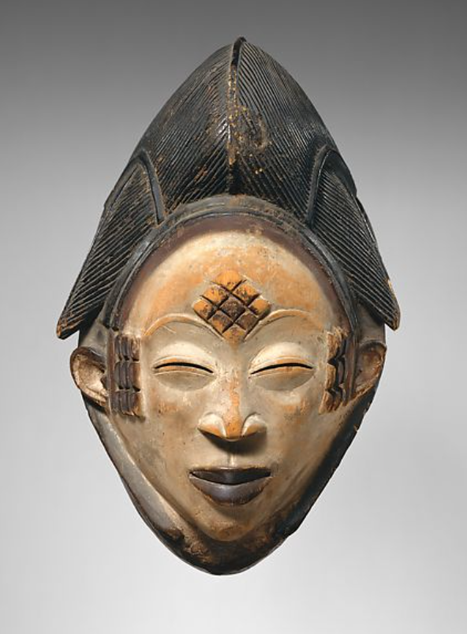
Activities:

1. Students read a short article on West African masks from culturesofwestafrica.com and examine the associated images. While reading and observing, students take notes on what they learn and what stands out to them.

2. Students watch a video on the funeral ceremony of the Dogon Elders (9:50). While reading and observing, students take notes on what they learn and what stands out to them.

Summative Assessment / Mask-making Project:

1. Explain to students that they will be making a mask that represents who you are, your lived experiences, culture, hopes, dreams, aspirations, etc.

2. Students answer the following questions in writing:

- What is important to you in life?
- What are your favorite colors or colors that are significant to you?
- What are symbols that are important to you?

3. As a class, students come up with a symbol that is collectively important to the community, and that they would all be comfortable with/proud to include as part of their mask.

4. Students spend the remainder of this unit time creating their masks, using provided materials. Students should be encouraged to be as creative as possible, and to have fun! All masks should include:

- The agreed upon collective symbol to demonstrate that we are a community and accountable to one another.
- At least two colors that are symbolic to you.
- At least one symbol that is meaningful to you.

5. Once students have completed their masks, have students do a gallery walk and/or present their masks, explaining why they chose the symbols and colors they did.
Student Responses
- Example 1: completed worksheet by a student at UBUNTU: High School for Law Advocacy and Community Justice, fall 2021
- Example 2: completed worksheet by a student at UBUNTU: High School for Law Advocacy and Community Justice, fall 2021
