Children on a Louisiana sugar-cane plantation around 1885
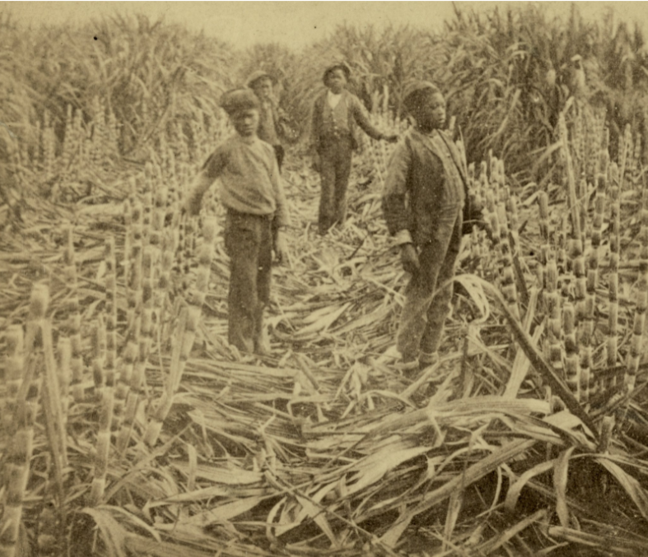
Source: Schomburg Center for Research in Black Culture, New York Public Library

