Name: ________________________________________

See-Discuss-Write Activity

Directions: Examine the images below, sourced from the article “Sugar” by Khalil Gibran Muhammad in The 1619 Project. Use the table below to guide you in making observations, discussing with a partner, and writing.

Four children are pictured on a sugar-cane plantation | Thousands of wooden sugar barrels lined up as men work around them
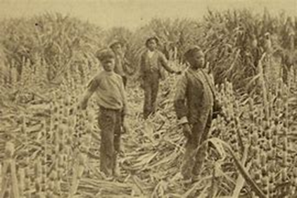  Caption: Children on a Louisiana sugar-cane plantation around 1885. Schomburg Center for Research in Black Culture, New York Public Library | 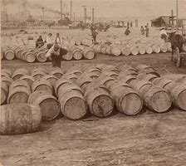  Caption: Men working among thousands of barrels of sugar in New Orleans in 1902. Underwood & Underwood, via the Library of Congress

Jot down one interesting thing that you see. Turn to your partner and discuss. | After viewing the images, what conclusions can you make about the production of sugar?

