Object: Child Shackles
Source: The Smithsonian National Museum of African American History and Culture
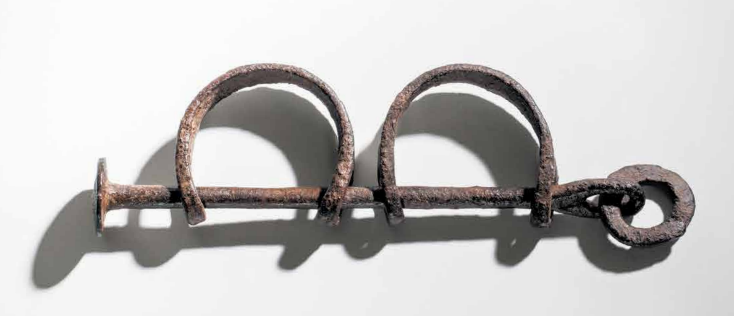

1888 Wood Cutting: Slave Caravan in Congo
Source: Wall Street Journal
