The Wealth Gap
By: Trymaine Lee

Elmore Bolling, whose brothers called him Buddy, was a kind of one-man economy in Lowndesboro, Ala. He leased a plantation, where he had a general store with a gas station out front and a catering business; he grew cotton, corn and sugar cane. He also owned a small fleet of trucks that ran livestock and made deliveries between Lowndesboro and Montgomery. At his peak, Bolling employed as many as 40 people, all of them black like him.
One December day in 1947, a group of white men showed up along a stretch of Highway 80 just yards from Bolling’s home and store, where he lived with his wife, Bertha Mae, and their seven young children. The men confronted him on a section of road he had helped lay and shot him seven times — six times with a pistol and once with a shotgun blast to the back. His family rushed from the store to find him lying dead in a ditch.
The shooters didn’t even cover their faces; they didn’t need to. Everyone knew who had done it and why. “He was too successful to be a Negro,” someone who knew Bolling told a newspaper at the time. When Bolling was killed, his family estimates he had as much as $40,000 in the bank and more than $5,000 in assets, about $500,000 in today’s dollars. But within months of his murder nearly all of it would be gone. White creditors and people posing as creditors took the money the family got from the sale of their trucks and cattle. They even staked claims on what was left of the family’s savings. The jobs that he provided were gone, too. Almost overnight the Bollings went from prosperity to poverty. Bertha Mae found work at a dry cleaner. The older children dropped out of school to help support the family. Within two years, the Bollings fled Lowndes County, fearing for their lives.
The period that followed the Civil War was one of economic terror and wealth-stripping that has left black people at lasting economic disadvantage. White Americans have seven times the wealth of black Americans on average. Though black people make up nearly 13 percent of the United States population, they hold less than 3 percent of the nation’s total wealth. The median family wealth for white people is $171,000, compared with just $17,600 for black people. It is worse on the margins. According to the Economic Policy Institute, 19 percent of black households have zero or negative net worth. Just 9 percent of white families are that poor.
Today’s racial wealth gap is perhaps the most glaring legacy of American slavery and the violent economic dispossession that followed. The fate suffered by Elmore Bolling and his family was not unique to them, or to Jim Crow Alabama. It was part of a much broader social and political campaign. When legal slavery ended in 1865, there was great hope for formerly enslaved people. Between 1865 and 1870, the Reconstruction Amendments established birthright citizenship — making all black people citizens and granting them equal protection under the law — and gave black men the right to vote. There was also the promise of compensation. In January 1865, Gen. William Sherman issued an order reallocating hundreds of thousands of acres of white-owned land along the coasts of Florida, Georgia and South Carolina for settlement by black families in 40-acre plots. Congress established the Freedmen’s Bureau to oversee the transition from slavery to freedom, and the Freedman’s Savings Bank was formed to help four million formerly enslaved people gain financial freedom.
When Lincoln was assassinated, Vice President Andrew Johnson effectively rescinded Sherman’s order by pardoning white plantation owners and returning to them the land on which 40,000 or so black families had settled. “This is a country for white men, and by God, as long as I am President, it shall be a government for white men,” Johnson declared in 1866. The Freedmen’s Bureau, always meant to be temporary, was dismantled in 1872. More than 60,000 black people deposited more than $1 million into the Freedman’s Savings Bank, but its all-white trustees began issuing speculative loans to white investors and corporations, and when it failed in 1874, many black depositors lost much of their savings.
ALT Text: Photograph of Elmore Bolling and his wife, Bertha Mae Nowden Bolling
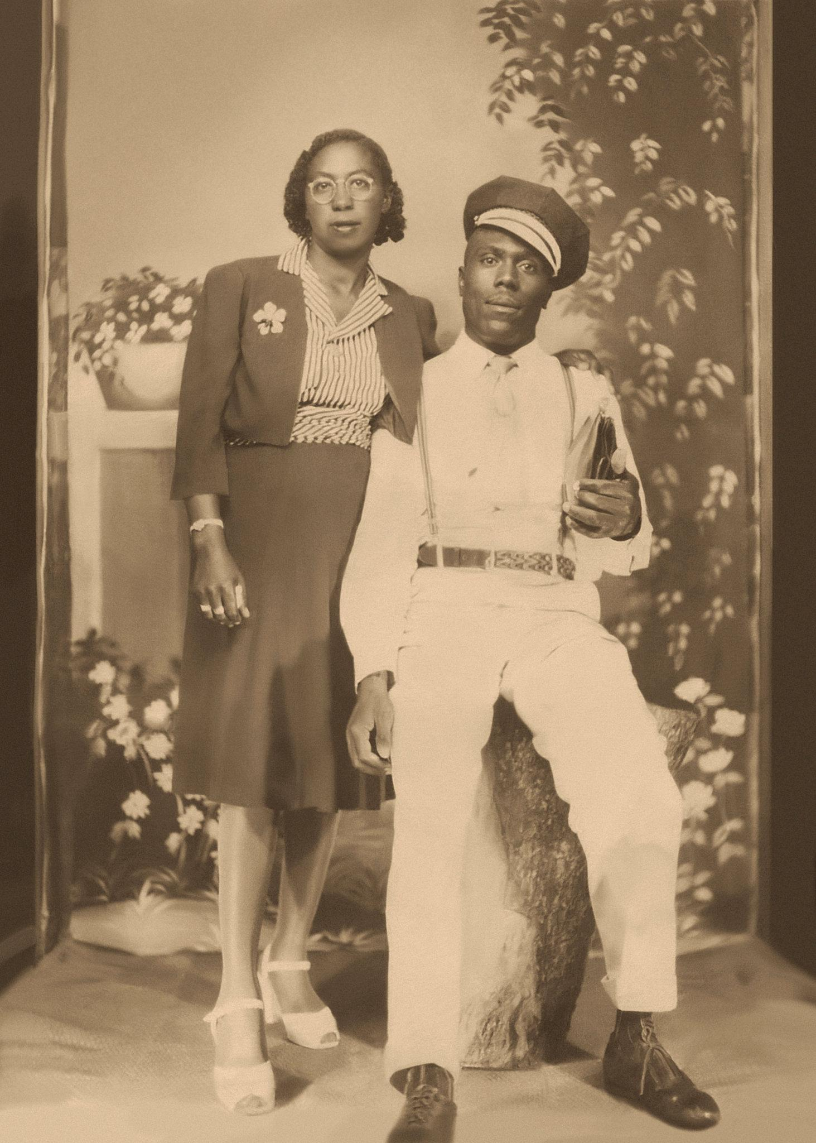
Caption: Elmore Bolling and his wife, Bertha Mae Nowden Bolling, in Alabama circa 1945. From Josephine Bolling McCall
“The origins of the racial wealth gap start with the failure to provide the formerly enslaved with the land grants of 40 acres,” says William A. Darity Jr., a professor of public policy and African-American studies at Duke University. Any financial progress that black people made was regarded as an affront to white supremacy. After a decade of black gains under Reconstruction, a much longer period of racial violence would wipe nearly all of it away.
To assuage Southern white people, the federal government pulled out the Union troops who were stationed in the South to keep order. During this period of so-called Redemption, lawmakers throughout the South enacted Black Codes and Jim Crow laws that stripped black people of many of their freedoms and property. Other white people, often aided by law enforcement, waged a campaign of violence against black people that would rob them of an incalculable amount of wealth.

Armed white people stormed prosperous majority-black Wilmington, N.C., in 1898 to murder dozens of black people, force 2,000 others off their property and overthrow the city government. In the Red Summer of 1919, at least 240 black people were murdered across the country. And in 1921, in one of the bloodiest racial attacks in United States history, Greenwood, a prosperous black neighborhood in Tulsa, Okla., was burned and looted. It is estimated that as many as 300 black people were murdered and 10,000 were rendered homeless. Thirty-five square blocks were destroyed. No one was ever convicted in any of these acts of racist violence.

“You have limited opportunity to accumulate wealth, and then you have a process where that wealth is destroyed or taken away,” Darity says. “And all of that is prior to the effects of restrictive covenants — redlining, the discriminatory application of the G.I. Bill and other federal programs.”

The post-Reconstruction plundering of black wealth was not just a product of spontaneous violence, but etched in law and public policy. Through the first half of the 20th century, the federal government actively excluded black people from government wealth-building programs. In the 1930s, President Franklin Roosevelt’s New Deal helped build a solid middle class through sweeping social programs, including Social Security and the minimum wage. But a majority of black people at the time were agricultural laborers or domestic workers, occupations that were ineligible for these benefits. The establishment of the Home Owners Loan Corporation in 1933 helped save the collapsing housing market, but it largely excluded black neighborhoods from government-insured loans. Those neighborhoods were deemed “hazardous” and colored in with red on maps, a practice that came to be known as “redlining.”

The G.I. Bill is often hailed as one of Roosevelt’s most enduring legacies. It helped usher millions of working-class veterans through college and into new homes and the middle class. But it discriminatorily benefited white people. While the bill didn’t explicitly exclude black veterans, the way it was administered often did. The bill gave veterans access to mortgages with no down payments, but the Veterans Administration adopted the same racially restrictive policies as the Federal Housing Administration, which guaranteed bank loans only to developers who wouldn’t sell to black people. “The major way in which people have an opportunity to accumulate wealth is contingent on the wealth positions of their parents and their grandparents,” Darity says. “To the extent that blacks have the capacity to accumulate wealth, we have not had the ability to transfer the same kinds of resources across generations.”

Seventy years later, the effects of Bolling’s murder are still felt by his children and their children. “There was no inheritance, nothing for my father to pass down, because it was all taken away,” says Josephine Bolling McCall, the only one of Bolling’s children to get a college degree. Of the seven siblings, those with more education fared best; the men struggled most, primarily working as low-paid laborers. Of Elmore and Bertha Mae’s 25 grandchildren, only six graduated from college; of those, two are McCall’s children. The rest are unemployed or underemployed. They have never known anything like the prosperity of their grandparents.
Trymaine Lee is a Pulitzer Prize- and Emmy Award-winning journalist and a correspondent for MSNBC. He covers social-justice issues and the role of race in politics and law enforcement.

