Sugar
By: Khalil Gibran Muhammad

Domino Sugar’s Chalmette Refinery in Arabi, La., sits on the edge of the mighty Mississippi River, about five miles east by way of the river’s bend from the French Quarter, and less than a mile down from the Lower Ninth Ward, where Hurricane Katrina and the failed levees destroyed so many black lives. It is North America’s largest sugar refinery, making nearly two billion pounds of sugar and sugar products annually. Those ubiquitous four-pound yellow paper bags emblazoned with the company logo are produced here at a rate of 120 bags a minute, 24 hours a day, seven days a week during operating season.
The United States makes about nine million tons of sugar annually, ranking it sixth in global production. The United States sugar industry receives as much as $4 billion in annual subsidies in the form of price supports, guaranteed crop loans, tariffs and regulated imports of foreign sugar, which by some estimates is about half the price per pound of domestic sugar. Louisiana’s sugar-cane industry is by itself worth $3 billion, generating an estimated 16,400 jobs.
A vast majority of that domestic sugar stays in this country, with an additional two to three million tons imported each year. Americans consume as much as 77.1 pounds of sugar and related sweeteners per person per year, according to United States Department of Agriculture data. That’s nearly twice the limit the department recommends, based on a 2,000-calorie diet.
Sugar has been linked in the United States to diabetes, obesity and cancer. If it is killing all of us, it is killing black people faster. Over the last 30 years, the rate of Americans who are obese or overweight grew 27 percent among all adults, to 71 percent from 56 percent, according to the Centers for Disease Control, with African-Americans overrepresented in the national figures. During the same period, diabetes rates overall nearly tripled. Among black non-Hispanic women, they are nearly double those of white non-Hispanic women, and one and a half times higher for black men than white men.
None of this — the extraordinary mass commodification of sugar, its economic might and outsize impact on the American diet and health — was in any way foreordained, or even predictable, when Christopher Columbus made his second voyage across the Atlantic Ocean in 1493, bringing sugar-cane stalks with him from the Spanish Canary Islands. In Europe at that time, refined sugar was a luxury product, the backbreaking toil and dangerous labor required in its manufacture an insuperable barrier to production in anything approaching bulk. It seems reasonable to imagine that it might have remained so if it weren’t for the establishment of an enormous market in enslaved laborers who had no way to opt out of the treacherous work.

ALT Text: Four children are pictured on a sugar-cane plantation
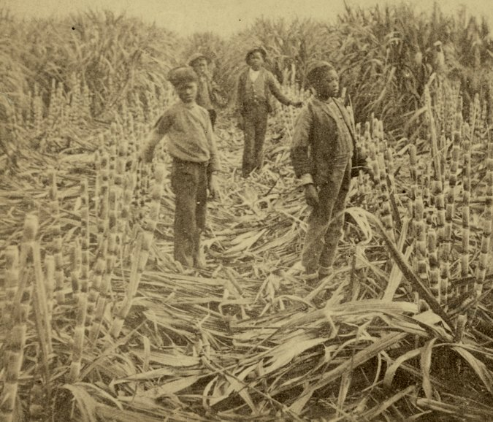
Caption: Children on a Louisiana sugar-cane plantation around 1885. Schomburg Center for Research in Black Culture, New York Public Library

For thousands of years, cane was a heavy and unwieldy crop that had to be cut by hand and immediately ground to release the juice inside, lest it spoil within a day or two. Even before harvest time, rows had to be dug, stalks planted and plentiful wood chopped as fuel for boiling the liquid and reducing it to crystals and molasses. From the earliest traces of cane domestication on the Pacific island of New Guinea 10,000 years ago to its island-hopping advance to ancient India in 350 B.C., sugar was locally consumed and very labor-intensive. It remained little more than an exotic spice, medicinal glaze or sweetener for elite palates.
It was the introduction of sugar slavery in the New World that changed everything. “The true Age of Sugar had begun — and it was doing more to reshape the world than any ruler, empire or war had ever done,” Marc Aronson and Marina Budhos write in their 2010 book, “Sugar Changed the World.” Over the four centuries that followed Columbus’s arrival, on the mainlands of Central and South America in Mexico, Guyana and Brazil as well as on the sugar islands of the West Indies — Cuba, Barbados and Jamaica, among others — countless indigenous lives were destroyed and nearly 11 million Africans were enslaved, just counting those who survived the Middle Passage.
“White gold” drove trade in goods and people, fueled the wealth of European nations and, for the British in particular, shored up the financing of their North American colonies. “There was direct trade among the colonies and between the colonies and Europe, but much of the Atlantic trade was triangular: enslaved people from Africa; sugar from the West Indies and Brazil; money and manufactures from Europe,” writes the Harvard historian Walter Johnson in his 1999 book, “Soul by Soul: Life Inside the Antebellum Slave Market.” “People were traded along the bottom of the triangle; profits would stick at the top.”
Before French Jesuit priests planted the first cane stalk near Baronne Street in New Orleans in 1751, sugar was already a huge moneymaker in British New York. By the 1720s, one of every two ships in the city’s port was either arriving from or heading to the Caribbean, importing sugar and enslaved people and exporting flour, meat and shipbuilding supplies. The trade was so lucrative that Wall Street’s most impressive buildings were Trinity Church at one end, facing the Hudson River, and the five-story sugar warehouses on the other, close to the East River and near the busy slave market. New York’s enslaved population reached 20 percent, prompting the New York General Assembly in 1730 to issue a consolidated slave code, making it “unlawful for above three slaves” to meet on their own, and authorizing “each town” to employ “a common whipper for their slaves.”
In 1795, Étienne de Boré, a New Orleans sugar planter, granulated the first sugar crystals in the Louisiana Territory. With the advent of sugar processing locally, sugar plantations exploded up and down both banks of the Mississippi River. All of this was possible because of the abundantly rich alluvial soil, combined with the technical mastery of seasoned French and Spanish planters from around the cane-growing basin of the Gulf and the Caribbean — and because of the toil of thousands of enslaved people. More French planters and their enslaved expert sugar workers poured into Louisiana as Toussaint L’Ouverture and Jean-Jacques Dessalines led a successful revolution to secure Haiti’s independence from France.
Within five decades, Louisiana planters were producing a quarter of the world’s cane-sugar supply. During her antebellum reign, Queen Sugar bested King Cotton locally, making Louisiana the second-richest state in per capita wealth. According to the historian Richard Follett, the state ranked third in banking capital behind New York and Massachusetts in 1840. The value of enslaved people alone represented tens of millions of dollars in capital that financed investments, loans and businesses. Much of that investment funneled back into the sugar mills, the “most industrialized sector of Southern agriculture,” Follett writes in his 2005 book, “Sugar Masters: Planters and Slaves in Louisiana’s Cane World 1820-1860.” No other agricultural region came close to the amount of capital investment in farming by the eve of the Civil War. In 1853, Representative Miles Taylor of Louisiana bragged that his state’s success was “without parallel in the United States, or indeed in the world in any branch of industry.”
The enslaved population soared, quadrupling over a 20-year period to 125,000 souls in the mid-19th century. New Orleans became the Walmart of people-selling. The number of enslaved labor crews doubled on sugar plantations. And in every sugar parish, black people outnumbered whites. These were some of the most skilled laborers, doing some of the most dangerous agricultural and industrial work in the United States.
In the mill, alongside adults, children toiled like factory workers with assembly-line precision and discipline under the constant threat of boiling hot kettles, open furnaces and grinding rollers. “All along the endless carrier are ranged slave children, whose business it is to place the cane upon it, when it is conveyed through the shed into the main building,” wrote Solomon Northup in “Twelve Years a Slave,” his 1853 memoir of being kidnapped and forced into slavery on Louisiana plantations.

ALT Text: Thousands of wooden sugar barrels lined up as men work around them
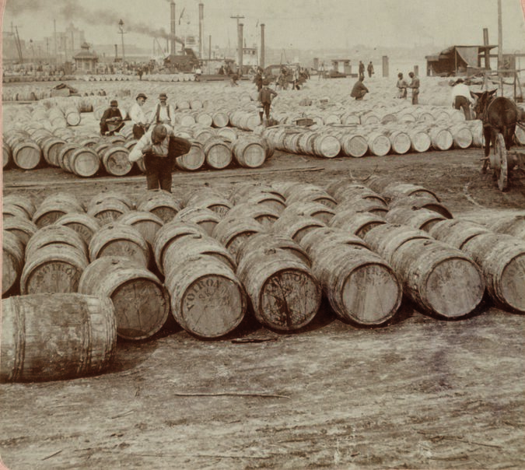
Caption: Men working among thousands of barrels of sugar in New Orleans in 1902. Underwood & Underwood, via the Library of Congress

To achieve the highest efficiency, as in the round-the-clock Domino refinery today, sugar houses operated night and day. “On cane plantations in sugar time, there is no distinction as to the days of the week,” Northup wrote. Fatigue might mean losing an arm to the grinding rollers or being flayed for failing to keep up. Resistance was often met with sadistic cruelty.
A formerly enslaved black woman named Mrs. Webb described a torture chamber used by her owner, Valsin Marmillion. “One of his cruelties was to place a disobedient slave, standing in a box, in which there were nails placed in such a manner that the poor creature was unable to move,” she told a W.P.A. interviewer in 1940. “He was powerless even to chase the flies, or sometimes ants crawling on some parts of his body.”
Louisiana led the nation in destroying the lives of black people in the name of economic efficiency. The historian Michael Tadman found that Louisiana sugar parishes had a pattern of “deaths exceeding births.” Backbreaking labor and “inadequate net nutrition meant that slaves working on sugar plantations were, compared with other working-age slaves in the United States, far less able to resist the common and life-threatening diseases of dirt and poverty,” wrote Tadman in a 2000 study published in the American Historical Review. Life expectancy was less like that on a cotton plantation and closer to that of a Jamaican cane field, where the most overworked and abused could drop dead after seven years.
To achieve the highest efficiency, as in the round-the-clock Domino refinery today, sugar houses operated night and day. “On cane plantations in sugar time, there is no distinction as to the days of the week,” Northup wrote. Fatigue might mean losing an arm to the grinding rollers or being flayed for failing to keep up. Resistance was often met with sadistic cruelty.
A formerly enslaved black woman named Mrs. Webb described a torture chamber used by her owner, Valsin Marmillion. “One of his cruelties was to place a disobedient slave, standing in a box, in which there were nails placed in such a manner that the poor creature was unable to move,” she told a W.P.A. interviewer in 1940. “He was powerless even to chase the flies, or sometimes ants crawling on some parts of his body.”
Louisiana led the nation in destroying the lives of black people in the name of economic efficiency. The historian Michael Tadman found that Louisiana sugar parishes had a pattern of “deaths exceeding births.” Backbreaking labor and “inadequate net nutrition meant that slaves working on sugar plantations were, compared with other working-age slaves in the United States, far less able to resist the common and life-threatening diseases of dirt and poverty,” wrote Tadman in a 2000 study published in the American Historical Review. Life expectancy was less like that on a cotton plantation and closer to that of a Jamaican cane field, where the most overworked and abused could drop dead after seven years.

THE ENSLAVED PECAN PIONEER
By Tiya Miles

Pecans are the nut of choice when it comes to satisfying America’s sweet tooth, with the Thanksgiving and Christmas holiday season being the pecan’s most popular time, when the nut graces the rich pie named for it. Southerners claim the pecan along with the cornbread and collard greens that distinguish the regional table, and the South looms large in our imaginations as this nut’s mother country.

The presence of pecan pralines in every Southern gift shop from South Carolina to Texas, and our view of the nut as regional fare, masks a crucial chapter in the story of the pecan: It was an enslaved man who made the wide cultivation of this nut possible.

Pecan trees are native to the middle southwestern region of the Mississippi River Valley and the Gulf Coast of Texas and Mexico. While the trees can live for a hundred years or more, they do not produce nuts in the first years of life, and the kinds of nuts they produce are wildly variable in size, shape, flavor and ease of shell removal. Indigenous people worked around this variability, harvesting the nuts for hundreds and probably thousands of years, camping near the groves in season, trading the nuts in a network that stretched across the continent, and lending the food the name we have come to know it by: paccan.

Once white Southerners became fans of the nut, they set about trying to standardize its fruit by engineering the perfect pecan tree. Planters tried to cultivate pecan trees for a commercial market beginning at least as early as the 1820s, when a well-known planter from South Carolina named Abner Landrum published detailed descriptions of his attempt in the American Farmer periodical. In the mid-1840s, a planter in Louisiana sent cuttings of a much-prized pecan tree over to his neighbor J.T. Roman, the owner of Oak Alley Plantation. Roman did what many enslavers were accustomed to in that period: He turned the impossible work over to an enslaved person with vast capabilities, a man whose name we know only as Antoine. Antoine undertook the delicate task of grafting the pecan cuttings onto the limbs of different tree species on the plantation grounds. Many specimens thrived, and Antoine fashioned still more trees, selecting for nuts with favorable qualities. It was Antoine who successfully created what would become the country’s first commercially viable pecan varietal.

Decades later, a new owner of Oak Alley, Hubert Bonzano, exhibited nuts from Antoine’s trees at the Centennial Exposition of 1876, the World’s Fair held in Philadelphia and a major showcase for American innovation. As the horticulturalist Lenny Wells has recorded, the exhibited nuts received a commendation from the Yale botanist William H. Brewer, who praised them for their “remarkably large size, tenderness of shell and very special excellence.” Coined “the Centennial,” Antoine’s pecan varietal was then seized upon for commercial production (other varieties have since become the standard).

Was Antoine aware of his creation’s triumph? No one knows. As the historian James McWilliams writes in “The Pecan: A History of America’s Native Nut” (2013): “History leaves no record as to the former slave gardener’s location — or whether he was even alive — when the nuts from the tree he grafted were praised by the nation’s leading agricultural experts.” The tree never bore the name of the man who had handcrafted it and developed a full-scale orchard on the Oak Alley Plantation before he slipped into the shadow of history.

Most of these stories of brutality, torture and premature death have never been told in classroom textbooks or historical museums. They have been refined and whitewashed in the mills and factories of Southern folklore: the romantic South, the Lost Cause, the popular “moonlight and magnolias” plantation tours so important to Louisiana’s agritourism today.
When I arrived at the Whitney Plantation Museum on a hot day in June, I mentioned to Ashley Rogers, 36, the museum’s executive director, that I had passed the Nelson Coleman Correctional Center about 15 miles back along the way. “You passed a dump and a prison on your way to a plantation,” she said. “These are not coincidences.”
The Whitney, which opened five years ago as the only sugar-slavery museum in the nation, rests squarely in a geography of human detritus. The museum tells of the everyday struggles and resistance of black people who didn’t lose their dignity even when they lost everything else. It sits on the west bank of the Mississippi at the northern edge of the St. John the Baptist Parish, home to dozens of once-thriving sugar plantations; Marmillion’s plantation and torture box were just a few miles down from Whitney.
The museum also sits across the river from the site of the German Coast uprising in 1811, one of the largest revolts of enslaved people in United States history. As many as 500 sugar rebels joined a liberation army heading toward New Orleans, only to be cut down by federal troops and local militia; no record of their actual plans survives. About a hundred were killed in battle or executed later, many with their heads severed and placed on pikes throughout the region. Based on historians’ estimates, the execution tally was nearly twice as high as the number in Nat Turner’s more famous 1831 rebellion. The revolt has been virtually redacted from the historical record. But not at Whitney. And yet tourists, Rogers said, sometimes admit to her, a white woman, that they are warned by hotel concierges and tour operators that Whitney is the one misrepresenting the past. “You are meant to empathize with the owners as their guests,” Rogers told me in her office. In Louisiana’s plantation tourism, she said, “the currency has been the distortion of the past.”
The landscape bears witness and corroborates Whitney’s version of history. Although the Coleman jail opened in 2001 and is named for an African-American sheriff’s deputy who died in the line of duty, Rogers connects it to a longer history of coerced labor, land theft and racial control after slavery. Sugar cane grows on farms all around the jail, but at the nearby Louisiana State Penitentiary, or Angola, prisoners grow it. Angola is the largest maximum-security prison by land mass in the nation. It opened in its current location in 1901 and took the name of one of the plantations that had occupied the land. Even today, incarcerated men harvest Angola’s cane, which is turned into syrup and sold on-site.
From slavery to freedom, many black Louisianans found that the crushing work of sugar cane remained mostly the same. Even with Reconstruction delivering civil rights for the first time, white planters continued to dominate landownership. Freedmen and freedwomen had little choice but to live in somebody’s old slave quarters. As new wage earners, they negotiated the best terms they could, signed labor contracts for up to a year and moved frequently from one plantation to another in search of a life whose daily rhythms beat differently than before. And yet, even compared with sharecropping on cotton plantations, Rogers said, “sugar plantations did a better job preserving racial hierarchy.” As a rule, the historian John C. Rodrigue writes, “plantation labor overshadowed black people’s lives in the sugar region until well into the 20th century.”
ALT Text: Text: “Down Among De Sugar Cane.” Character Song and Chorus Image: Drawing of group of enslaved sugar-plantation workers gathered around dancing and playing instruments.
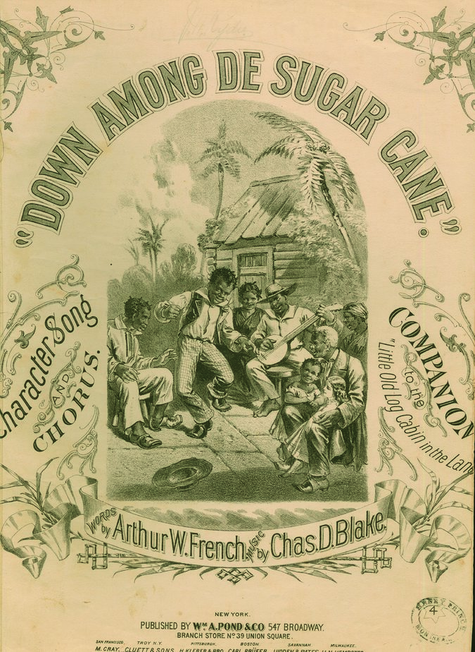

Caption: Sheet music to an 1875 song romanticizing the painful, exhausted death of an enslaved sugar-plantation worker. From Sheridan Libraries/Levy/Gado/Getty Images
Sometimes black cane workers resisted collectively by striking during planting and harvesting time — threatening to ruin the crop. Wages and working conditions occasionally improved. But other times workers met swift and violent reprisals. After a major labor insurgency in 1887, led by the Knights of Labor, a national union, at least 30 black people — some estimated hundreds — were killed in their homes and on the streets of Thibodaux, La. “I think this will settle the question of who is to rule, the nigger or the white man, for the next 50 years,” a local white planter’s widow, Mary Pugh, wrote, rejoicing, to her son.
Many African-Americans aspired to own or rent their own sugar-cane farms in the late 19th century, but faced deliberate efforts to limit black farm and land owning. The historian Rebecca Scott found that although “black farmers were occasionally able to buy plots of cane land from bankrupt estates, or otherwise establish themselves as suppliers, the trend was for planters to seek to establish relations with white tenants or sharecroppers who could provide cane for the mill.”
By World War II, many black people began to move not simply from one plantation to another, but from a cane field to a car factory in the North. By then, harvesting machines had begun to take over some, but not all, of the work. With fewer and fewer black workers in the industry, and after efforts in the late 1800s to recruit Chinese, Italian, Irish and German immigrant workers had already failed, labor recruiters in Louisiana and Florida sought workers in other states.
In 1942, the Department of Justice began a major investigation into the recruiting practices of one of the largest sugar producers in the nation, the United States Sugar Corporation, a South Florida company. Black men unfamiliar with the brutal nature of the work were promised seasonal sugar jobs at high wages, only to be forced into debt peonage, immediately accruing the cost of their transportation, lodging and equipment — all for $1.80 a day. One man testified that the conditions were so bad, “It wasn’t no freedom; it was worse than the pen.” Federal investigators agreed. When workers tried to escape, the F.B.I. found, they were captured on the highway or “shot at while trying to hitch rides on the sugar trains.” The company was indicted by a federal grand jury in Tampa for “carrying out a conspiracy to commit slavery,” wrote Alec Wilkinson, in his 1989 book, “Big Sugar: Seasons in the Cane Fields of Florida.” (The indictment was ultimately quashed on procedural grounds.) A congressional investigation in the 1980s found that sugar companies had systematically tried to exploit seasonal West Indian workers to maintain absolute control over them with the constant threat of immediately sending them back to where they came from.
At the Whitney plantation, which operated continuously from 1752 to 1975, its museum staff of 12 is nearly all African-American women. A third of them have immediate relatives who either worked there or were born there in the 1960s and ’70s. These black women show tourists the same slave cabins and the same cane fields their own relatives knew all too well.
Farm laborers, mill workers and refinery employees make up the 16,400 jobs of Louisiana’s sugar-cane industry. But it is the owners of the 11 mills and 391 commercial farms who have the most influence and greatest share of the wealth. And the number of black sugar-cane farmers in Louisiana is most likely in the single digits, based on estimates from people who work in the industry. They are the exceedingly rare exceptions to a system designed to codify black loss.
And yet two of these black farmers, Charles Guidry and Eddie Lewis III, have been featured in a number of prominent news items and marketing materials out of proportion to their representation and economic footprint in the industry. Lewis and Guidry have appeared in separate online videos. The American Sugar Cane League has highlighted the same pair separately in its online newsletter, Sugar News.
Lewis has no illusions about why the marketing focuses on him, he told me; sugar cane is a lucrative business, and to keep it that way, the industry has to work with the government. “You need a few minorities in there, because these mills survive off having minorities involved with the mill to get these huge government loans,” he said. A former financial adviser at Morgan Stanley, Lewis, 36, chose to leave a successful career in finance to take his rightful place as a fifth-generation farmer. “My family was farming in the late 1800s” near the same land, he says, that his enslaved ancestors once worked. Much of the 3,000 acres he now farms comes from relationships with white landowners his father, Eddie Lewis Jr., and his grandfather before him, built and maintained.
Lewis is the minority adviser for the federal Farm Service Agency (F.S.A.) in St. Martin and Lafayette Parish, and also participates in lobbying federal legislators. He says he does it because the stakes are so high. If things don’t change, Lewis told me, “I’m probably one of two or three that’s going to be farming in the next 10 to 15 years. They’re trying to basically extinct us.” As control of the industry consolidates in fewer and fewer hands, Lewis believes black sugar-cane farmers will no longer exist, part of a long-term trend nationally, where the total proportion of all African-American farmers has plummeted since the early 1900s, to less than 2 percent from more than 14 percent, with 90 percent of black farmers’ land lost amid decades of racist actions by government agencies, banks and real estate developers.
ALT Text: Seven story brick building known as the The Rhinelander Sugar House, a sugar refinery
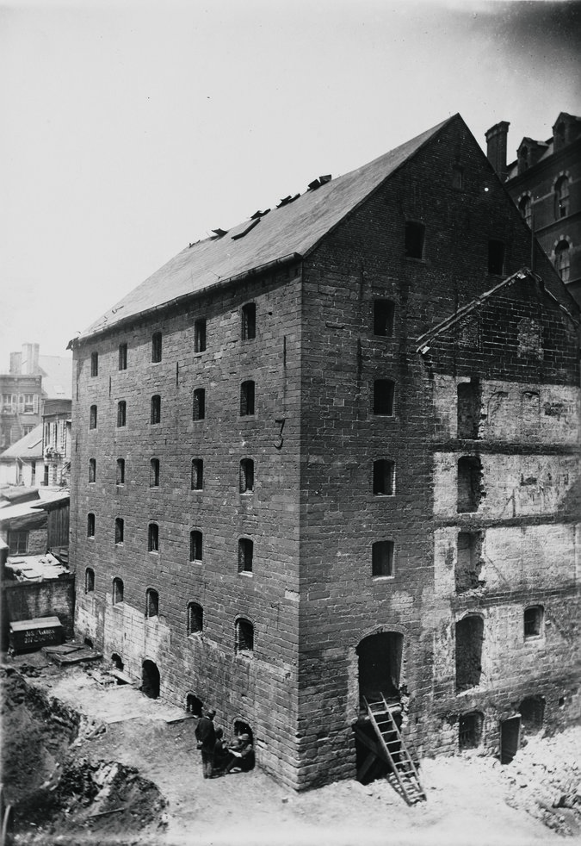
Caption: The Rhinelander Sugar House, a sugar refinery and warehouse on the site of what is now the headquarters of the New York Police Department, in the late 1800s. When it was built in 1763, the building was one of the largest in the colony. Photograph by Hugo V. Sass, via the Museum of The City of New York

“There’s still a few good white men around here,” Lewis told me. “It’s not to say it’s all bad. But this is definitely a community where you still have to say, ‘Yes sir,’ ‘Yes, ma’am,’ and accept ‘boy’ and different things like that.”
One of the biggest players in that community is M.A. Patout and Son, the largest sugar-cane mill company in Louisiana. Founded in 1825, Patout has been known to boast that it is “the oldest complete family-owned and operated manufacturer of raw sugar in the United States.” It owns three of the 11 remaining sugar-cane mills in Louisiana, processing roughly a third of the cane in the state.
The company is being sued by a former fourth-generation black farmer. As first reported in The Guardian, Wenceslaus Provost Jr. claims the company breached a harvesting contract in an effort to deliberately sabotage his business. Provost, who goes by the first name June, and his wife, Angie, who is also a farmer, lost their home to foreclosure in 2018, after defaulting on F.S.A.-guaranteed crop loans. June Provost has also filed a federal lawsuit against First Guaranty Bank and a bank senior vice president for claims related to lending discrimination, as well as for mail and wire fraud in reporting false information to federal loan officials. The suit names a whistle-blower, a federal loan officer, who, in April 2015, “informed Mr. Provost that he had been systematically discriminated against by First Guaranty Bank,” the lawsuit reads.
(In court filings, M.A. Patout and Son denied that it breached the contract. Representatives for the company did not respond to requests for comment. In court filings, First Guaranty Bank and the senior vice president also denied Provost’s claims. Their representatives did not respond to requests for comment.)
Lewis is himself a litigant in a separate petition against white landowners. He claims they “unilaterally, arbitrarily and without just cause terminated” a seven-year-old agreement to operate his sugar-cane farm on their land, causing him to lose the value of the crop still growing there. Lewis is seeking damages of more than $200,000, based on an independent appraisal he obtained, court records show. The landowners did not respond to requests for comment.
But the new lessee, Ryan Doré, a white farmer, did confirm with me that he is now leasing the land and has offered to pay Lewis what a county agent assessed as the crop’s worth, about $50,000. Doré does not dispute the amount of Lewis’s sugar cane on the 86.16 acres. What he disputes is Lewis’s ability to make the same crop as profitable as he would. Doré, who credits M.A. Patout and Son for getting him started in sugar-cane farming, also told me he is farming some of the land June Provost had farmed.
Lewis and the Provosts say they believe Doré is using his position as an elected F.S.A. committee member to gain an unfair advantage over black farmers with white landowners. “He’s privileged with a lot of information,” Lewis said.
Doré denied he is abusing his F.S.A. position and countered that “the Lewis boy” is trying to “make this a black-white deal.” Doré insisted that “both those guys simply lost their acreage for one reason and one reason only: They are horrible farmers.”
It’s impossible to listen to the stories that Lewis and the Provosts tell and not hear echoes of the policies and practices that have been used since Reconstruction to maintain the racial caste system that sugar slavery helped create. The crop, land and farm theft that they claim harks back to the New Deal era, when Southern F.S.A. committees denied black farmers government funding.
“June and I hope to create a dent in these oppressive tactics for future generations,” Angie Provost told me on the same day this spring that a congressional subcommittee held hearings on reparations. “To this day we are harassed, retaliated against and denied the true DNA of our past.”
Khalil Gibran Muhammad is a Suzanne Young Murray professor at the Radcliffe Institute for Advanced Study at Harvard University and author of “The Condemnation of Blackness.” Tiya Miles is a professor in the history department at Harvard and the author, most recently, of “The Dawn of Detroit: A Chronicle of Slavery and Freedom in the City of the Straits.”

