Name: ________________________________________

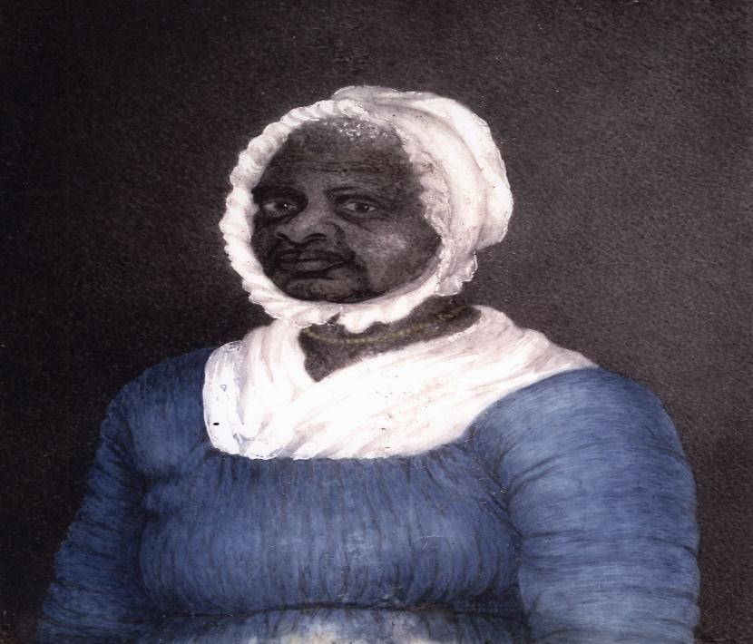

This miniature portrait of Elizabeth Freeman (“Mum Bett”) was painted by Susan Anne Livingston Ridley Sedgwick in 1811.

Quote:

“Any time while I was a slave, if one minute's freedom had been offered to me, and I had been told I must die at the end of that minute, I would have taken it — just to stand one minute on God's earth a free woman — I would”. – Mum Bett, aka Elizabeth Freeman (c. 1744-1829)

Quick write: Interpret the quote from Mum Bett. In your opinion, what does this quote suggest about her?

