Mass Incarceration
by Bryan Stevenson

Several years ago, my law office was fighting for the release of a black man who had been condemned, at the age of 16, to die in prison. Matthew was one of 62 Louisiana children sentenced to life imprisonment without parole for nonhomicide offenses. But a case I’d argued at the Supreme Court was part of a 2010 ruling that banned such sentences for juveniles, making our clients eligible for release.
Some had been in prison for nearly 50 years. Almost all had been sent to Angola, a penitentiary considered one of America’s most violent and abusive. Angola is immense, larger than Manhattan, covering land once occupied by slave plantations. Our clients there worked in fields under the supervision of horse-riding, shotgun-toting guards who forced them to pick crops, including cotton. Their disciplinary records show that if they refused to pick cotton — or failed to pick it fast enough — they could be punished with time in “the hole,” where food was restricted and inmates were sometimes tear-gassed. Still, some black prisoners, including Matthew, considered the despair of the hole preferable to the unbearable degradation of being forced to pick cotton on a plantation at the end of the 20th century. I was fearful that such clients would be denied parole based on their disciplinary records. Some were.
The United States has the highest rate of incarceration of any nation on Earth: We represent 4 percent of the planet’s population but 22 percent of its imprisoned. In the early 1970s, our prisons held fewer than 300,000 people; since then, that number has grown to more than 2.2 million, with 4.5 million more on probation or parole. Because of mandatory sentencing and “three strikes” laws, I’ve found myself representing clients sentenced to life without parole for stealing a bicycle or for simple possession of marijuana. And central to understanding this practice of mass incarceration and excessive punishment is the legacy of slavery.
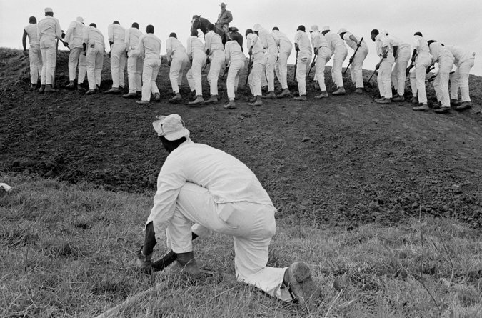
ALT Text: A group of young men shown at the Ferguson prison. Up on a nearby hill, a group of 23 imprisoned shovel dirt in a line. Dressed in white jumpsuits, one individual positioned close to the camera, kneels on one knee.

Caption: The Ferguson prison, for young men ages 17 to 21, in Huntsville, Tex., in 1968. Danny Lyon/Magnum Photos

It took only a few decades after the arrival of enslaved Africans in Virginia before white settlers demanded a new world defined by racial caste. The 1664 General Assembly of Maryland decreed that all Negroes within the province “shall serve durante vita,” hard labor for life. This enslavement would be sustained by the threat of brutal punishment. By 1729, Maryland law authorized punishments of enslaved people including “to have the right hand cut off ... the head severed from the body, the body divided into four quarters, and head and quarters set up in the most public places of the county.”
Soon American slavery matured into a perverse regime that denied the humanity of black people while still criminalizing their actions. As the Supreme Court of Alabama explained in 1861, enslaved black people were “capable of committing crimes,” and in that capacity were “regarded as persons” — but in most every other sense they were “incapable of performing civil acts” and considered “things, not persons.”
[To get updates on The 1619 Project, and for more on race from The New York Times, sign up for our weekly Race/Related newsletter.]
The 13th Amendment is credited with ending slavery, but it stopped short of that: It made an exception for those convicted of crimes. After emancipation, black people, once seen as less than fully human “slaves,” were seen as less than fully human “criminals.” The provisional governor of South Carolina declared in 1865 that they had to be “restrained from theft, idleness, vagrancy and crime.” Laws governing slavery were replaced with Black Codes governing free black people — making the criminal-justice system central to new strategies of racial control.
ALT Text: Prisoners dressed in white bend over picking cotton to place in the sacks fastened to their backs.
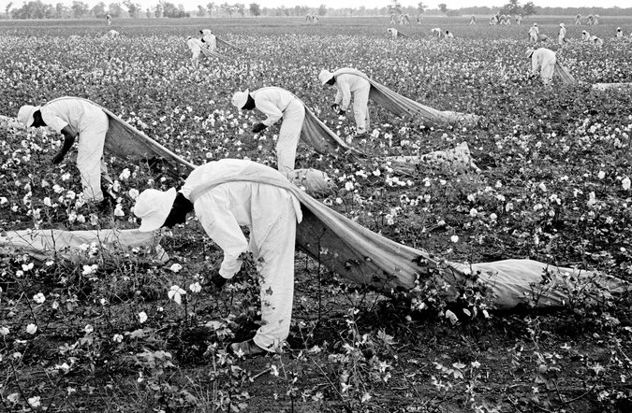
Caption: Prisoners from Ferguson picking cotton in 1968. Danny Lyon/Magnum Photos
These strategies intensified whenever black people asserted their independence or achieved any measure of success. During Reconstruction, the emergence of black elected officials and entrepreneurs was countered by convict leasing, a scheme in which white policymakers invented offenses used to target black people: vagrancy, loitering, being a group of black people out after dark, seeking employment without a note from a former enslaver. The imprisoned were then “leased” to businesses and farms, where they labored under brutal conditions. An 1887 report in Mississippi found that six months after 204 prisoners were leased to a white man named McDonald, dozens were dead or dying, the prison hospital filled with men whose bodies bore “marks of the most inhuman and brutal treatment ... so poor and emaciated that their bones almost come through the skin.”
Anything that challenged the racial hierarchy could be seen as a crime, punished either by the law or by the lynchings that stretched from Mississippi to Minnesota. In 1916, Anthony Crawford was lynched in South Carolina for being successful enough to refuse a low price for his cotton. In 1933, Elizabeth Lawrence was lynched near Birmingham for daring to chastise white children who were throwing rocks at her.
It’s not just that this history fostered a view of black people as presumptively criminal. It also cultivated a tolerance for employing any level of brutality in response. In 1904, in Mississippi, a black man was accused of shooting a white landowner who had attacked him. A white mob captured him and the woman with him, cut off their ears and fingers, drilled corkscrews into their flesh and then burned them alive — while hundreds of white spectators enjoyed deviled eggs and lemonade. The landowner’s brother, Woods Eastland, presided over the violence; he was later elected district attorney of Scott County, Miss., a position that allowed his son James Eastland, an avowed white supremacist, to serve six terms as a United States senator, becoming president pro tempore from 1972 to 1978.
This appetite for harsh punishment has echoed across the decades. Late in the 20th century, amid protests over civil rights and inequality, a new politics of fear and anger would emerge. Nixon’s war on drugs, mandatory minimum sentences, three-strikes laws, children tried as adults, “broken windows” policing — these policies were not as expressly racialized as the Black Codes, but their implementation has been essentially the same. It is black and brown people who are disproportionately targeted, stopped, suspected, incarcerated and shot by the police.

ALT Text: A group of students dressed in blue uniforms march through Shelby Training Center with hands clasped behind their backs
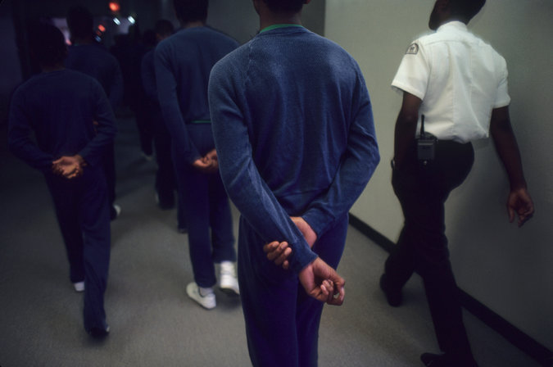
Caption: Students being led through the Shelby Training Center, owned by Corrections Corp. of America, CCA, a private juvenile detention facility in Memphis, in 1987. Ed Kashi/VII, via
Hundreds of years after the arrival of enslaved Africans, a presumption of danger and criminality still follows black people everywhere. New language has emerged for the noncrimes that have replaced the Black Codes: driving while black, sleeping while black, sitting in a coffee shop while black. All reflect incidents in which African-Americans were mistreated, assaulted or arrested for conduct that would be ignored if they were white. In schools, black kids are suspended and expelled at rates that vastly exceed the punishment of white children for the same behavior.
Inside courtrooms, the problem gets worse. Racial disparities in sentencing are found in almost every crime category. Children as young as 13, almost all black, are sentenced to life imprisonment for nonhomicide offenses. Black defendants are 22 times more likely to receive the death penalty for crimes whose victims are white, rather than black — a type of bias the Supreme Court has declared “inevitable.”
The smog created by our history of racial injustice is suffocating and toxic. We are too practiced in ignoring the victimization of any black people tagged as criminal; like Woods Eastland’s crowd, too many Americans are willing spectators to horrifying acts, as long as we’re assured they’re in the interest of maintaining order.
This cannot be the end of the story. In 2018, the Equal Justice Initiative, a nonprofit I direct, opened a museum in Montgomery, Ala., dedicated to the legacy of slavery and a memorial honoring thousands of black lynching victims. We must acknowledge the 400 years of injustice that haunt us. I’m encouraged: Half a million people have visited. But I’m also worried, because we are at one of those critical moments in American history when we will either double down on romanticizing our past or accept that there is something better waiting for us.
I recently went to New Orleans to celebrate the release of several of our Angola clients, including Matthew — men who survived the fields and the hole. I realized how important it is to stay hopeful: Hopelessness is the enemy of justice. There were moments of joy that night. But there was also heaviness; we all seemed keenly aware that we were not truly free from the burden of living in a nation that continues to deny and doubt this legacy, and how much work remains to be done.
Bryan Stevenson is the executive director of the Equal Justice Initiative and the author of “Just Mercy: A Story of Justice and Redemption.”

