Map: African and African American Population
Source: Prentice Hall African-American History Textbook
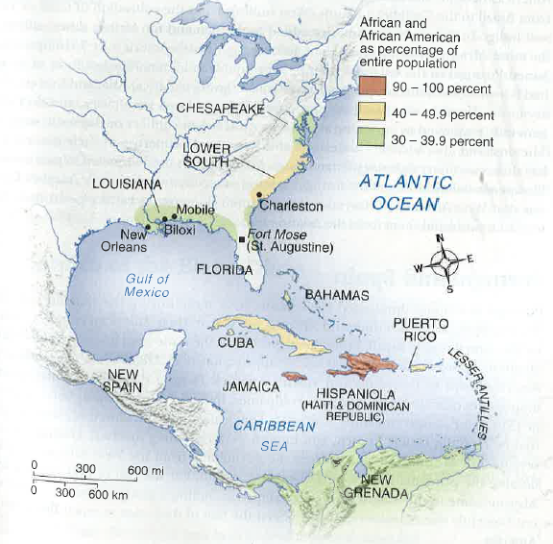

Map: Atlantic Slave Trade
Source: Prentice Hall African-American History Textbook
