Your Name: Date:
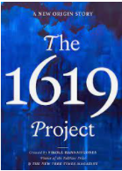

1619 Project Poetry
On a regular basis, we will be examining poetry from The 1619 Project: A New Origin Story and/or The 1619 Project literary timeline. We will use this poetry to deepen our understanding of the Black experience throughout history. For each poem you read, you will complete the table below.

Poem Title__________________________________Author_____________________

What lines in the poem stand out to you? | Why do those lines stand out to you?
What questions do you have about the poem? | What do you think is the overall meaning of the poem?
Why do you think this poem was included in The 1619 Project?

