Name: ______________________________________________

Directions: Complete the Think-Write-Discuss activity based on the images below. List 3 conclusions about the images.
Portrait of Queen Njinga  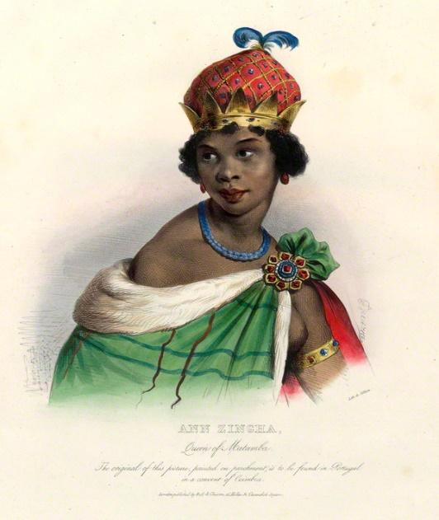 | Map of the country of Angola located in Africa  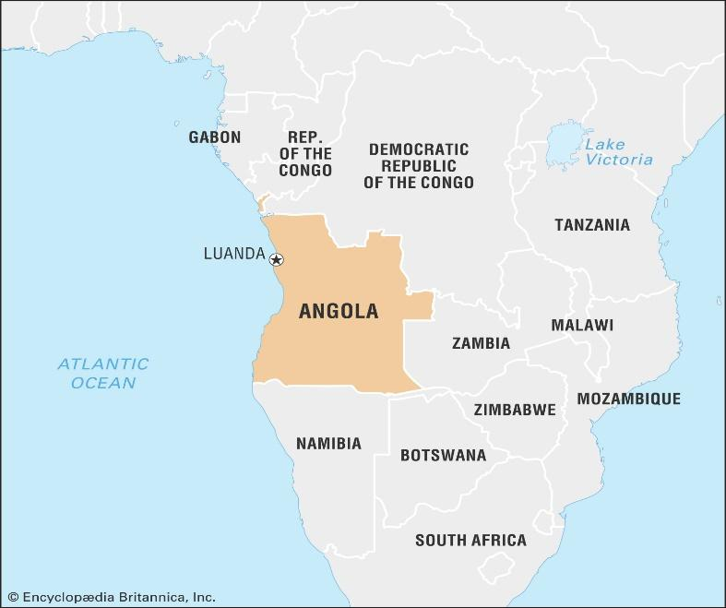 | An iron ballast/weight block  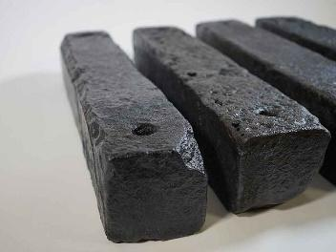  A child’s iron shackles  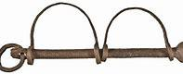
Source: The 1619 Project, New York Times Magazine, Curated by Mary Elliott; text by Mary Elliott and Jazmine Hughes, Aug. 19, 2019
List three conclusions about the images above. What do you think they have in common?
1.

2.

3.
Directions: Read and annotate the following passage.
- Underline one powerful sentence that you feel best explains the passage.
- Be prepared to discuss your selection and your response to the question below.

The 1619 Project Supplementary Broadsheet by Mary Elliott and Jazmine Hughes
Sometime in 1619, a Portuguese slave ship, the São João Bautista, traveled across the Atlantic Ocean with a hull
filled with human cargo: captive Africans from Angola, in southwestern Africa. The men, women and children,
most likely from the kingdoms of Ndongo and Kongo, endured the horrific journey, bound for a life of
enslavement in Mexico. Almost half the captives had died by the time the ship was seized by two English pirate
ships; the remaining Africans were taken to Point Comfort, a port near Jamestown, the capital of the English
colony of Virginia, which the Virginia Company of London had established 12 years earlier.
The colonist John Rolfe wrote to Sir Edwin Sandys, of the Virginia Company, that in August 1619, a “Dutch man
of war” arrived in the colony and “brought not anything but 20 and odd Negroes, which the governor and cape
merchant bought for victuals.” The Africans were most likely put to work in the tobacco fields that had recently
been established in the area. Forced labor was not uncommon — Africans and Europeans had been trading goods
and people across the Mediterranean for centuries — but enslavement had not been based on race. The
trans-Atlantic slave trade, which began as early as the 15th century, introduced a system of slavery that was
commercialized, racialized, and inherited. Enslaved people were seen not as people at all but as commodities to
be bought, sold and exploited. Though people of African descent — free and enslaved — were present in North
America as early as the 1500s, the sale of the “20 and odd” African people set the course for what would become
slavery in the United States.
Discussion Question:
- 1. In your opinion, why did John Rolfe refer to the Africans from Angola, as “20 and odd Negroes”?
- 2. Why is the arrival of the “20 and odd Negroes” historically significant?

- Listen to the 1619 podcast, episode 1: “The Fight for a True Democracy” (first 3-5 minutes, in which Nikole
Hannah-Jones describes the arrival of Africans in Point Comfort on the White Lion).

Document 1:
No. 1 / Slavery, Power, and the Human Cost 1455 - 1775
In the 15th century, the Roman Catholic Church divided the world in half, granting Portugal a monopoly on trade in West Africa and Spain the right to colonize the New World in its quest for land and gold. Pope Nicholas V buoyed Portuguese efforts and issued the Romanus Pontifex of 1455, which affirmed Portugal’s exclusive rights to territories it claimed along the West African coast and the trade from those areas. It granted the right to invade, plunder and “reduce their persons to perpetual slavery.” Queen Isabella invested in Christopher Columbus’s exploration to increase her wealth and ultimately rejected the enslavement of Native Americans, claiming that they were Spanish subjects.
Spain established an asiento, or contract, that authorized the direct shipment of captive Africans for trade as human commodities in the Spanish colonies in the Americas. Eventually other European nation-states — the Netherlands, France, Denmark and England — seeking similar economic and geopolitical power joined in the trade, exchanging goods and people with leaders along the West African coast, who ran self-sustaining societies known for their mineral-rich land and wealth in gold and other trade goods. They competed to secure the asiento and colonize the New World. With these efforts, a new form of slavery came into being. It was endorsed by the European nation-states and based on race, and it resulted in the largest forced migration in the world: Some 12.5 million men, women and children of African descent were forced into the trans-Atlantic slave trade. The sale of their bodies and the product of their labor brought the Atlantic world into being, including colonial North America. In the colonies, status began to be defined by race and class, and whether by custom, case law or statute, freedom was limited to maintain the enterprise of slavery and ensure power. Source: NY Times Magazine 1619 Project, Curated by Mary Elliott; All text by Mary Elliott and Jazmine Hughes, Aug. 19, 2019

Select 4 terms from the text that best describes what the European nations wanted to gain, or control based on the asiento or contract. | Based on the asiento or contract, list 4 things that the European nation states gained: | Explain the human cost associated with the asiento or contract. Explain what many Africans lost because of the agreement.
1.  2.  3.  4. | 1.  2.  3.  4.

Document 2:
No. 1 / Slavery, Power, and the Human Cost 1455 - 1775
In 1624, after her brother’s death, Ana Njinga gained control of the kingdom of Ndongo, in present-day Angola. At the time, the Portuguese were trying to colonize Ndongo and nearby territory in part to acquire more people for its slave trade, and after two years as ruler, Njinga was forced to flee in the face of Portuguese attack. Eventually, however, she conquered a nearby kingdom called Matamba.
Njinga continued to fight fiercely against Portuguese forces in the region for many years, and she later provided shelter for runaway slaves. By the time of Njinga’s death in 1663, she had made peace with Portugal, and Matamba traded with it on equal economic footing. In 2002, a statue of Njinga was unveiled in Luanda, the capital of Angola, where she is held up as an emblem of resistance and courage. Source: NY Times Magazine 1619 Project, Curated by Mary Elliott; All text by Mary Elliott and Jazmine Hughes, Aug. 19, 2019

Identify one motive or action taken by Queen Njinga to save Angola and her people. | What was the outcome or result of Queen Njinga actions?

