Silent Sam Written Response
Silent Sam is a confederate monument that until recently sat on the upper quad of UNC Chapel Hill’s campus. After years of protest and political debate the statue was torn down by protestors in August 2018. Today, the debate continues as to what should be done with the statue.
You can read more about the statue here.
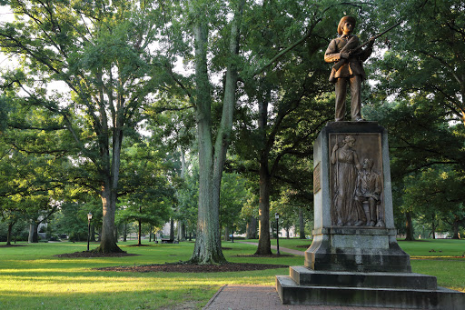
Some of the options that have been presented for the monument are:
- Return it to its original place on the quad at UNC
- Keep it in a building on campus with an accompanying sign explaining it's history
- Donate it and have it kept in a history museum off campus
- Sell it to a private buyer
- Destroy it

Write a short paragraph explaining what you think should be done with Silent Sam based on what you know about the statue and its history:

