Reparations Written Response

Reparations is the making of amends for a wrong one has done, by paying money to or otherwise helping those who have been wronged. There is a growing movement across the United States to pay reparations to the descendants of enslaved people.

Read the following article about reparations:

STUDENT OPINION

Does the United States Owe Reparations to the Descendants of Enslaved People?
The idea of economic amends for past injustices and persistent disparities is getting renewed attention. What do you think should happen?
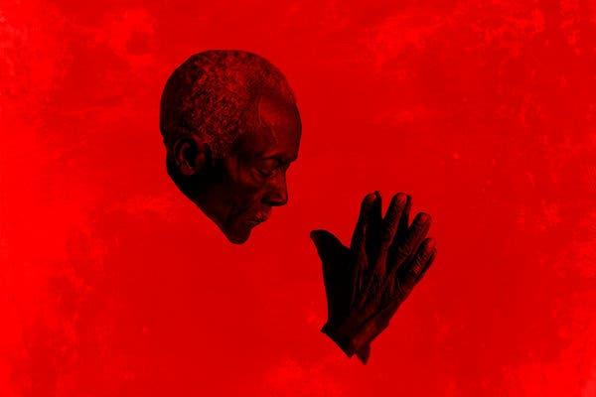
Shawn Theodore for The New York Times

By Nicole Daniels
Published Dec. 4, 2019

In 1988, President Ronald Reagan sought to “right a grave wrong” by signing legislation that apologized for the government’s forced relocation of 120,000 Japanese-Americans during World War II and established a $1.25 billion trust fund to pay reparations to those who were forced into internment camps and to their families.

However, the United States has never apologized for the nation’s treatment of enslaved people and their descendants. What do you think? Do you think that the descendants of enslaved people are owed anything for the wrongs of slavery?

In the article “What Reparations for Slavery Might Look Like in 2019,” Patricia Cohen explores different arguments and possibilities:

When James Forman, a civil rights pioneer who later served briefly as the Black Panther Party’s foreign minister, demanded $500 million in reparations in his 1969 Black Manifesto, he grounded his argument in an indisputable fact: Unpaid slave labor helped build the American economy, creating vast wealth that African-Americans were barred from sharing.

The manifesto called for white Christian churches and Jewish synagogues to pay for projects like a black university and a Southern land bank. “We have helped to build the most industrial country in the world,” it declared, at the same time that “racist white America has exploited our resources, our minds, our bodies, our labor.”

Other civil rights leaders, such as Bayard Rustin, were not in agreement. Mr. Rustin said, “If my great-grandfather picked cotton for 50 years, then he may deserve some money, but he’s dead and gone and nobody owes me anything.”

Many people argue that while slavery happened in the past, its legacy still continues today:

The question of reparations, however, extends far beyond the roughly four million people who were enslaved when the Civil War started, as Ta-Nehisi Coates explained in an influential essay published in The Atlantic in 2014. Legalized discrimination and state-sanctioned brutality, murder, dispossession and disenfranchisement continued long after the war ended. That history profoundly handicapped black Americans’ ability to create and accumulate wealth as well as to gain access to jobs, housing, education and health care.

For every dollar a typical white household holds, a black one has 10 cents. It is this cumulative effect that justifies the payment of reparations to descendants of slaves long dead, supporters say.

The article raises the question: How much money would recipients of reparations get? Economists, including William A. Darity Jr., an economist at Duke University and a leading scholar on reparations, have looked to other models to calculate possible answers:

Compensation programs can take many forms. In the United States, after a congressional study, people of Japanese descent who were forced into internment camps during World War II received $20,000 in 1988 and a formal apology.

Since 1952, Germany has paid more than $70 billion in reparations through various programs, primarily to Jewish victims of the Nazi regime, and continues to deliver hundreds of millions of dollars each year. Payments vary from a lump sum distributed to individuals to a monthly pension based on years working in a slave labor camp. Money is also given to organizations to cover home care for older survivors or for grants. A small portion goes for research, education and documentation.

A reparations program in the United States could likewise adopt a single method or several at once. Families could get a one-time check, receive vouchers for medical insurance or college, or have access to a trust fund to finance a business or a home. Mr. Darity argues that “for both substantive and symbolic reasons, some important component must be direct payment to eligible recipients.”

Other scholars have emphasized different features. Roy L. Brooks, a law professor at the University of San Diego and the author of “Atonement and Forgiveness: A New Model for Black Reparations,” has reservations about what he calls the “settlement model,” a legalistic approach that looks backward to compensate victims for demonstrable financial losses. He prefers what he calls the “atonement model,” emphasizing longer-term investments in education, housing and businesses that build up wealth.

In your opinion should the United States pay reparations to the descendants of enslaved people? Why or why not? And if so in what form/method? (Your answer should be at least 3 sentences).

