Excerpt from “20th Century Music”
Source: PBS History Detectives
1 The most important influence on 20th century music? African Americans and the musical culture they brought to this country - developed within the bonds of slavery.
2 Even before the 20th century began, blues music was evolving across the country out of the traditional African slave spirituals, work calls and chants. Of all the developing genres, the blues would be the most far-reaching, with its influence felt in everything from jazz to rock, country music to rhythm and blues, and classical music.
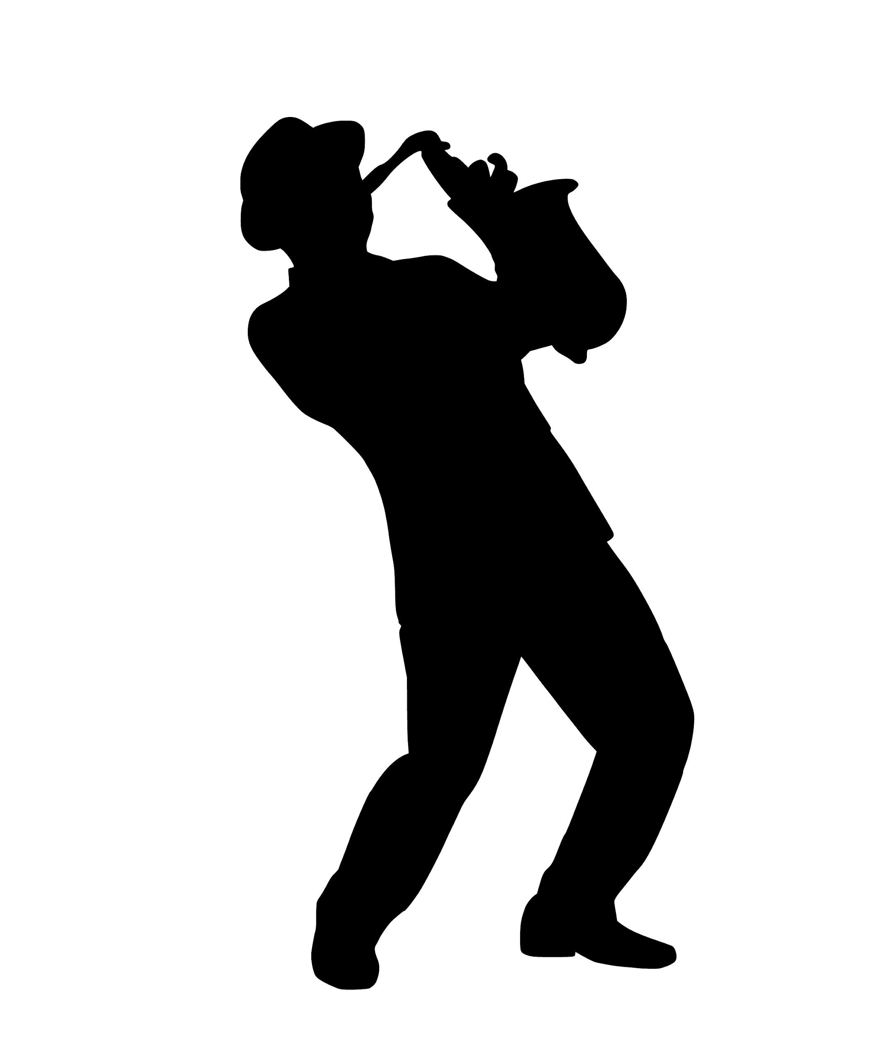
3 That said, jazz's influence on the world music scene would be nothing short of transformational. Jazz saw its early development in the African American communities all throughout the South - with rhythms reflecting the diversity of cultural influences from West Africa to the West Indies, from ragtime to the blues.
4 With similar roots to blues (and blues as one of its roots), jazz also took from another American art form - ragtime - to create its unique syncopated sound. Its early detractors were many, from Henry Ford to Thomas Edison, but racism was often the reason for cries of "it's immoral." Yet the insistent, danceable, heartfelt sounds quickly spread American culture to the far corners of the globe.
5 Its ever-mutating style turned itself into swing music, soul and cool jazz. Jazz's knock-on effect was further seen in rock and roll's development in the United States in the 1950s. Artists from Elvis Presley to Chuck Berry created their rock and roll using the musical influences of boogie-woogie and blues, along with jazz. Rock's popularity quickly spread around the world, with groups such as the Beatles and the Rolling Stones often crediting early 20th century American music such as blues for their inspiration.
6 Soul music, which grew up alongside rock and roll, also developed out of African American gospel, and rhythm and blues traditions. As the century wore on, rhythm and blues boys bands such as New Edition (which could have stayed merely a bubblegum pop band of black youth created for a mainly white audience) took control of their music and helped create the new jack swing movement. A fusion of hip hop and R & B, new jack swing helped lay the groundwork for the next two decades of popular music.
7 The end of the century saw the birth of hip-hop music and culture. In the mid-1970s in the Bronx, New York DJs began isolating percussion rhythms from songs and talking over and between the songs.
8 Rap music, with its semi-autobiographical lyrics and deep rhythms were just one more evolution in the blues tradition that had started at the beginning of the century, and one further, enormous transformation in the world of music created and nurtured in the African American community.

Influences in American Music

Blues  Blues music was created by Black Americans in the late 1800s-early 1900s. It was derived from spirituals and work songs. Blues songs often have repeating lines and the lyrics often talk about the troubles the singer has experienced.  Some well-known early Blues artists include: W.C. Handy and Ma Rainey. | Jazz  Jazz music was created by Black Americans in the late 1800s-early 1900s. It was derived from blues music and African rhythms. Jazz music has improvisations, which means doing something in the moment. Some Jazz music also has call-and-response patterns.  Some well-known early jazz artists include: Ella Fitzgerald and Duke Ellington.
Rock and Roll  Rock and roll originated in the mid 1950s. It was derived from a combination of jazz, rhythm & blues, gospel, hillbilly music and other forms. Rock and roll songs are usually upbeat and have lyrics about popular culture.  Some well-known early rock and roll artists include: Chuck Berry and Sister Rosetta Tharpe | Hip Hop  Hip hop is a cultural movement that originated in New York in the 1970s. The music is derived from blues, jazz and African rhythms. Hip Hop songs usually include rapping, which derived from West African griots, poetry and other influences.  Some well-known early rap artists include: Sugarhill Gang and MC Lyte

Exit Ticket

How has the music we hear today been influenced by the musical traditions of enslaved people? Use evidence from any of the texts and/or videos we have discovered to support your response.
_________________________________________________________________________________________________________________________________________________________________________________________________________________________________________________________________________

