Legacy of Slavery Cornerstone Task

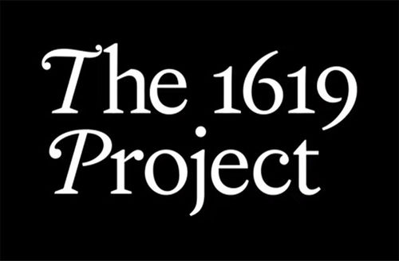

Essential Question:
What is the legacy of slavery in America in the 21st Century?

Overview | In this task, you will research the lasting impacts of slavery and write at least a two-page essay in which you explore and identify the legacy of slavery in the 21st Century. Your primary resource will be The 1619 Project.  What is The 1619 Project?  The 1619 Project is an ongoing project developed by The New York Times Magazine in 2019 with the goal of re-examining the legacy of slavery in the United States and timed for the 400th anniversary of the arrival in America of the first enslaved people from West Africa.  Read carefully through the Rubric on how you will be assessed for the Legacy of Slavery Cornerstone Task.
Step 1: Prior Knowledge
Directions: What do you already know about slavery and the Antebellum era? Use your notes on the Events Leading to Civil War. Summarize the information below.

Step 2: Sources and Notes
Directions: Your research must address the lasting impacts of slavery in the 21st Century. You should choose one topic to focus on (listed below). You must use at least 3 sources, including one podcast and one article. You will need to find 1 additional source for your topic on your own. Take detailed notes on the sources in your own words (do not copy and paste).

Topics | Articles | Podcasts
Economy | The Barbaric History of  Sugar in America | The Economy  Slavery Built
Health Care | How False Beliefs in Physical Racial Difference Still Live in Medicine Today | How the  Bad Blood Started
Music | Why is Everyone Always Stealing Black Music? | The Birth of  American Music
Prison System | Why American Prisons Owe Their Cruelty to Slavery | We need to talk about an injustice (Ted Talk)

Which topic do you plan to focus on?

Source | Notes
1.
2.
3.

Step 3: Thesis Statement
Directions: Write a 2-3 sentence thesis statement (or argument) in response to the following question: “What is the legacy of slavery in the 21st Century?” Make sure you answer this question with your chosen topic as the focus.

Extra Help: Thesis Statement

Step 4: Outline
Directions: Create an outline of your essay using the graphic organizer below. Each argument should include evidence that supports your thesis statement. You should also include direct quotes from the sources you used.

Extra Help: When you paste a quote, use in-text citations to cite the author. For example: “Government is necessary to man, and where obedience is not compelled, there is no government” (Johnson).

Historical Background

Argument & Elaboration | Topic sentence:  Quote from the first source:  Elaboration:
Argument & Elaboration | Topic sentence:  Quote from the second source:  Elaboration:
Argument & Elaboration | Topic sentence:  Quote from the third source:  Elaboration:
Conclusion

Step 5: Works Cited Page
Directions: Create a works cited page in MLA format using NoodleTools that includes at least 3 sources (including one article and one podcast). Paste it below.

Extra Help: Works Cited Page

Step 6: Writing the Essay
Directions: Write your essay in a separate Google Doc and attach it to this assignment in Google Classroom. Use your outline to help you. Your essay should be at least two pages, and in the proper MLA format (double-spaced, Times New Roman, 12 point font).

Extra Help: Model MLA Paper
Don’t forget to check your work against the Rubric.

