Singing in Slavery: Songs of Survival, Songs of Freedom
By Kenyatta D. Berry
Source: PBS.org Mercy Street Blog, Jan 25, 2017

1 In Balm in Gilead, Charlotte Jenkins, a former slave turned activist, arrives in Alexandria to help the growing population of “contrabands” make the transition to freedom. Upon arrival she quickly recognizes a small pox epidemic at one of the contraband camps. Working with Samuel Diggs and Mary Phinney, Charlotte establishes a small pox quarantine tent for sick contraband.
Songs of Survival: Middle Passage and Slavery
2 Singing as a form of communication is deeply rooted in the African American culture. It began with the African slaves who were kidnapped and shipped across the Atlantic during the Middle Passage. Slaves from different countries, tribes and cultures used singing as a way to communicate during the voyage. They were able to look for kin, countrymen and women through song. According to a white shipmate who made four voyages to Africa between 1760 and 1770. “They frequently sing, the men and woman answering another, but what is the subject of their songs [I] cannot say.”1 Although they could not understand what the Africans were saying the crew did pick up on the sorrowful tone of their songs.2
3 Music was a way for slaves to express their feelings whether it was sorrow, joy, inspiration or hope. Songs were passed down from generation to generation throughout slavery.
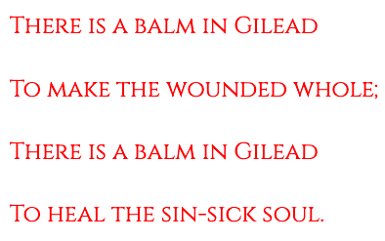
These songs were influenced by African and religious traditions and would later form the basis for what is known as “Negro Spirituals”. Col. Thomas W. Higginson of the 54th Massachusetts Regiment recognized the term Negro Spiritual in the Atlantic Monthly (June 1867). Higginson had heard the songs in camps and on marches with colored soldiers.3
4 Singing at contraband camps helped former slaves navigate the gray area between slavery and freedom. Members of the contraband camp sing “There is a Balm in Gilead” as Charlotte Jenkins arrives for the first time to the Mansion House Hospital. A traditional Negro spiritual, the balm in the Gilead is interpreted as a spiritual medicine that able to heal sinners.
5 Belinda mentions the Balm in Gilead when she notices Mary Phinney coughing while tending to the contraband patients in the Small Pox Quarantine Tent.
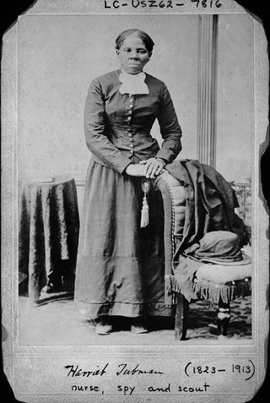
Harriet Tubman standing with hands on back of a chair. Library of Congress
(LC-USZ62-7816)
Songs of Freedom: The Underground Railroad
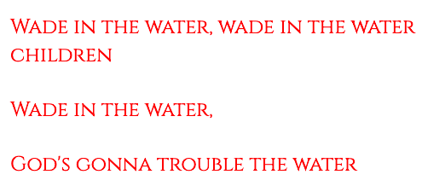
6 The “Moses of her people”, Harriett Tubman was the Conductor of the Underground Railroad. The exact number of people lead to freedom on the Underground Railroad is not known. But Tubman was able to create a network of stations and operators helped to lead escaped slaves North to freedom. One of the songs of the Underground Railroad was “Wade in the Water”. While it hasn’t been proven, it is believed that Harriett Tubman used this traditional Negro Spiritual as a way to warn slaves to get into the water to hide their scent from the slavecatching dogs on their trail.
Sources
- Marcus Rediker, "The Slave Ship: A Human History" (New York: Penquin, 2007), 282.
- Sowande M. Mustakeem, "Slavery at Sea: Terror, Sex and Sickness in the Middle Passage" (Illinois: University of Illinois Press, 2016), 120.
- Wesley, Charles H., and Patricia W. Romero. "Negro Americans in the Civil War; from slavery to citizenship." New York: Publishers Co., 1967
Balm in Gilead Lyrics
Refrain:  There is a balm in Gilead  to make the wounded whole.  There is a balm in Gilead  to heal the sinsick soul.  1. Sometimes I feel discouraged,  and think my work's in vain,  but then the Holy Spirit  revives my soul again.  (Refrain)  2. Don't ever feel discouraged,  for Jesus is your friend,  who, if you ask for knowledge,  will never fail to lend. | (Refrain)  3. If you cannot preach like Peter,  if you cannot pray like Paul,  you can tell the love of Jesus,  who died to save us all.

Wade in the Water Lyrics
(Wade in the water)  (Wade in the water)  Wade in the water  Wade in the water  Wade in the water, children  God is gonna trouble these waters  See that band all dressed in white  God is gonna trouble these waters  It look like a band of the Israelites  God is gonna trouble these waters  See that band all dressed in red  God is gonna trouble these waters  Look like a band that Moses led  God is gonna trouble these waters  My Lord delivered Daniel well  Daniel well, Daniel well  Didn't my Lord deliver Daniel well  Then why not every man?  Man went down to the river  Man went down to the river, Lord  Man went down to the river | Went down there for to pray  Man went down to the river  Man went down to the river, Lord  Man went down to the river  To wash his sins all away  Washed all day, washed all night  Washed till his hands were sore  Washed all day, washed all night  Till he couldn't wash a-no more  (Hey)  Man went down to the river  Man went down to the river, Lord  Man went down to the river  Went down there for to pray  Man went down to the river  Man went down to the river, Lord  Man went down to the river  Washed his sins all away  Wade in the water  Wade in the water, children  Wade in the water  God is gonna trouble these waters

Exit Ticket

In today’s reading, the author said that music was a way for enslaved people to express their feelings, “whether it was sorrow, joy, inspiration or hope”. Provide an example from Balm of Gilead and an example from Wade in the Water that displays sorrow, joy, inspiration and/or hope.
Balm of Gilead | Wade in the Water
This spiritual includes an example of: Circle one  Sorrow Joy Inspiration Hope | This spiritual includes an example of: Circle one  Sorrow Joy Inspiration Hope
Evidence  Write song lyric below | Evidence  Write song lyric below
Explanation  Explain how the lyric is an example of sorrow, joy, inspiration or hope | Explanation  Explain how the lyric is an example of sorrow, joy, inspiration or hope

