Djembe

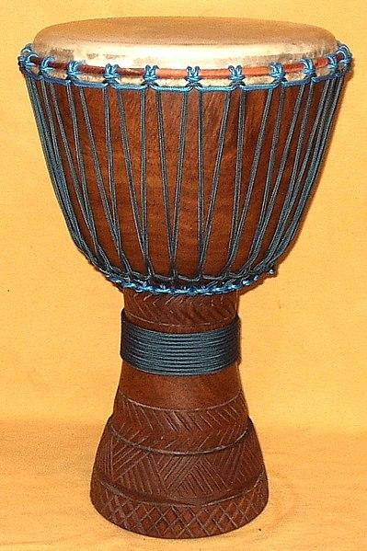

Annotation Guide

- Underline or highlight the major points. Summarize in the margins.

- Circle keywords or phrases that are confusing or unknown to you. Write synonyms in the margins.

- Use a question mark (?) for questions that you have during reading. Write your question in the margins.

- Use an exclamation mark (!) for things that surprise you and write a brief note about what caught your attention.

- Draw an arrow (-->) when you make a connection to something inside or outside of the text. Briefly write a note about your connection.

Excerpt from “Creating a Culture: the Music of Enslaved People”

When Africans were brought to America in chains, they brought their culture, traditions and music with them in their minds and hearts.
By Rebecca Bodenheimer
Source: Learning for Justice Teaching Hard History Text Library
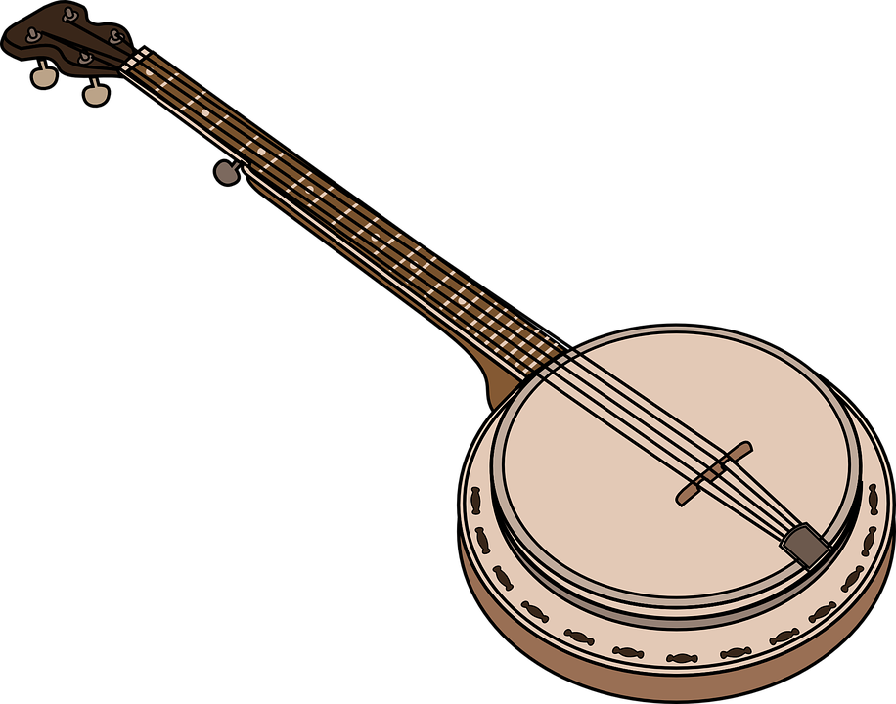
1 History books have often described enslaved people as a people without culture or traditions. However, although they couldn’t usually bring musical instruments with them during the Middle Passage (a term referring to the journey from Africa to the Americas on slavers’ ships), they carried their traditions in their memories. Enslaved people eventually recreated many music and dance traditions while in captivity and on the plantations, by working with the few materials they could get their hands on and making instruments in a slightly different form.
2 The most common musical instruments used by enslaved people were the banjo and the fiddle. While it eventually became associated with “white” country music, the banjo is actually modeled after a family of West African instruments, such as the kora. Banjo-like instruments were first recreated by enslaved people in the Caribbean in the 17th century, and they began to be used on plantations in the U.S. South in the 18th century. Enslaved people made banjos by hollowing out a gourd or calabash (similar to a large squash), attaching it to a pole for the neck of the instrument and making strings out of horsehair or animal intestines. Other instruments used by enslaved people were made by using different animal bones, like ribs and jawbones, in addition to sticks and other pieces of wood.
3 Africa is famous for being the birthplace of many types of drums. In fact, drums have historically been used as a form of communication, as in the tradition of “talking drums.” However, after a 1739 slave revolt in South Carolina used drums as a form of communication between enslaved people, the instruments were outlawed in most colonies. While they continued playing drums in secret, most of the time enslaved people invented substitutes to make rhythms for their music. The most common methods were handclapping, foot-stomping and “patting juba,” which meant switching back and forth between foot-tapping, handclapping and slapping the thigh with the hands. Sometimes patting juba was done by beating sticks on the floor to make a rhythm.
Comprehension Questions
Use textual evidence to answer the following questions.
- Why did most colonies outlaw drums?
____________________________________________________________________________________________________________________________________________________________________________________________________
- Where did the banjo originate?
___________________________________________________________________________________________________________________________________________________
- What is the main/central idea of the article?
___________________________________________________________________________________________________________________________________________________
A-E-I-O-U Chart
A - Adjective
List words that describe something you learned
E - Emotion
List words that describe how you feel about what you learned
I - Interesting
Write an interesting fact you learned
O - Oh?
Write something that surprised you
U - Um?
Write the questions you have

Exit Ticket

Enslaved Africans carried their traditions with them when they were brought to the colonies. Describe one way that African musical traditions have influenced the music we hear in America today. Use evidence from the article and/or the video to support your response.

_________________________________________________________________________________________________________________________________________________________________________________________________________________________________________________________________________

