Excerpt from “The Idea of America” by Nikole Hannah-Jones

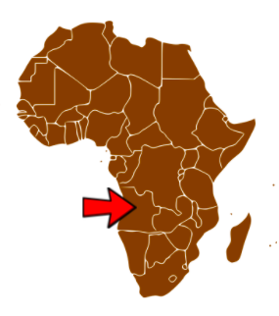
In August 1619, just 12 years after the English settled Jamestown, Va., one year before the Puritans landed at Plymouth Rock and some 157 years before the English colonists even decided they wanted to form their own country, the Jamestown colonists bought 20 to 30 enslaved Africans from English pirates. The pirates had stolen them from a Portuguese slave ship that had forcibly taken them from what is now the country of Angola. Those men and women who came ashore on that August day were the beginning of American slavery. They were among the 12.5 million Africans who would be kidnapped from their homes and brought in chains across the Atlantic Ocean in the largest forced migration in human history until the Second World War. Almost two million did not survive the grueling journey, known as the Middle Passage.
Unit Opener - Song Exploration
 | Song #1 | Song #2 | Song #3 | Song #4 | Song #5
What do you hear?
(instruments, rhythms, voices, etc)
How does this song make you feel?

What do you know about this song?

Do you notice any similarities between the songs? Do you notice any differences? Describe the similarities and/or differences below.

